FREE
Tear off Flyer Template
Write Name of Item Here
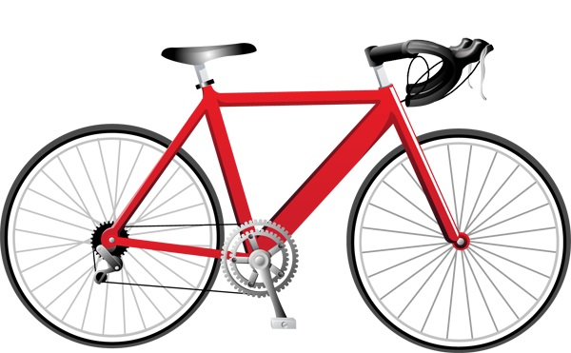
Your contact info here | Your contact info here | Your contact info here | Your contact info here | Your contact info here | Your contact info here | Your contact info here | Your contact info here

www.AllFreePrintable.com

