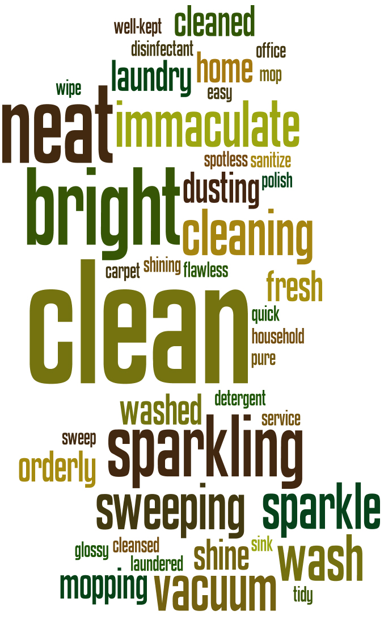

Mark’s Cleaning Service
123 Street Ave.
City, ST 12345
Phone: 123-456-7890
www.website.com

“The best cleaner in town!”

PLEASE TEAR-OFF A REMINDER TO CALL TODAY!
fssfddddddddddddddddddddddddddddddddddddddddddddddddddddddddddddddddddddddddd
Business Name
123 Address St, City ST 12345
Phone: 123-456-7890
Website: www.cleaningflyer.com
Business Name
123 Address St, City ST 12345
Phone: 123-456-7890
Website: www.cleaningflyer.com
Business Name
123 Address St, City ST 12345
Phone: 123-456-7890
Website: www.cleaningflyer.com
Business Name
123 Address St, City ST 12345
Phone: 123-456-7890
Website: www.cleaningflyer.com
Business Name
123 Address St, City ST 12345
Phone: 123-456-7890
Website: www.cleaningflyer.com
Business Name
123 Address St, City ST 12345
Phone: 123-456-7890
Website: www.cleaningflyer.com
Business Name
123 Address St, City ST 12345
Phone: 123-456-7890
Website: www.cleaningflyer.com
Business Name
123 Address St, City ST 12345
Phone: 123-456-7890
Website: www.cleaningflyer.com

