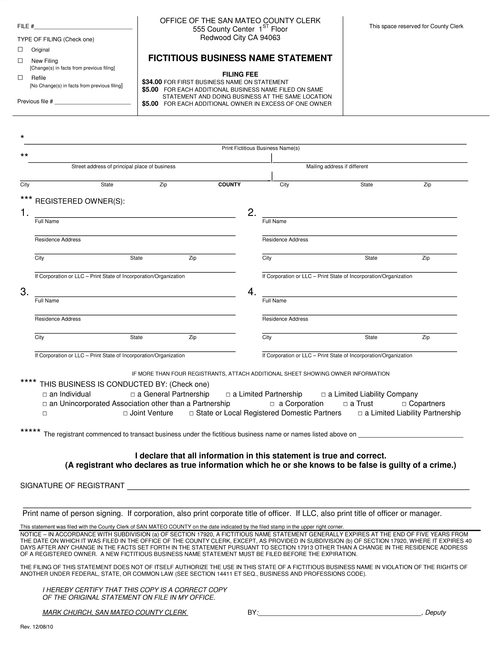

The following person(s) is (are) doing business as: | (Please submit original and 3 copies; and enclose a self-addressed stamped envelope for the return mail.)
The following person(s) is (are) doing business as: | No Erasures, Alterations and/or White-outs.

Married Couple

(Insert N/A above if you haven't started to transact business)
INSTRUCTIONS FOR COMPLETION OF STATEMENT

Business and Professions Code Section 17913:

- Where one asterisk appears in the form:
  - Insert the fictitious business name or names
  - Only those businesses operated at the same address and under the same ownership may be listed on one statement

- Where two asterisks appear in the form:

  - If the registrant has a place of business in this state, insert the street address and county of his or her principal place of business in this state
  - If the registrant has no place of business in this state, insert the street address and county of his or her principal place of business outside this state and file with the Clerk of Sacramento County (B&P 17915)
  - Mail Box and Post Office Box Numbers are not acceptable as a business address when used alone without a street address

- Where three asterisks appear in the form:

  - If the registrant is an individual, insert his or her full name and residence address

  - If the registrants are a married couple, insert the full name and residence address of both parties to the marriage
  - If the registrant is a general partnership, copartnership, joint venture, limited liability partnership, or unincorporated association other than a partnership, insert the full name and residence address of each general partner
  - If the registrant is a limited partnership, insert the full name and residence address of each general partner
  - If the registrant is a limited liability company, insert the name and address of the limited liability company, as set out in its articles of organization on file with the CA Secretary of State, and the state of organization
  - If the registrant is a trust, insert the full name and residence address of each trustee
  - If the registrant is a corporation, insert the name and address of the corporation, as set out in its articles of incorporation on file with the CA Secretary of State, and the state of incorporation
  - If the registrants are state or local registered domestic partners, insert the full name and residence address of each domestic partner

- Where four asterisks appear in the form:

  - Check whichever of the terms listed on the front of the form best describes the nature of the business

- Where five asterisks appear in the form:

  - Insert the date on which the registrant first commenced to transact business under the fictitious business name or names listed, if already transacting business under that name or names
  - Insert N/A if you have not yet commenced to transact business under the fictitious business name or names listed

Business and Professions Code Section 17914

The statement shall be signed as follows:
- If the registrant is an individual, by the individual
- If the registrants are husband and wife, by the husband or wife
- If the registrant is a general partnership, limited partnership, limited liability partnership, copartnership, joint venture, or unincorporated association other than a partnership, by a general partner
- If the registrant is a limited liability company, by a manager or officer
- If the registrant is a trust, by a trustee
- If the registrant is a corporation, by an officer
- If the registrant is a state or local registered domestic partnership, by one of the domestic partners

Business and Professions Code Section 17915

The fictitious business name statement shall be filed with the clerk of the county in which the registrant has his or her principal place of business in this state or, if the registrant has no place of business in this state, with the Clerk of Sacramento County. Nothing in this chapter shall preclude a person from filing a fictitious business name statement in a county other than that where the principal place of business is located, as long as the requirements of this subdivision are also met.

Business and Professions Code Section 17917

Publication for Original, New Filings (renewal with change in facts from previous filing), or Refile
- Within 30 days after a fictitious business name statement has been filed, the registrant shall cause it to be published in a newspaper of general circulation in the county where the fictitious business name statement was filed or, if there is no such newspaper in that county, in a newspaper of general circulation in an adjoining county. If the registrant does not have a place of business in this state, the notice shall be published in a newspaper of general circulation in Sacramento County. The publication must be once a week for four successive weeks and an affidavit of publication must be filed with the county clerk where the fictitious business name statement was filed within 30 days after the completion of the publication.

- If a refilling is required because the prior statement has expired, the refiling need not be published, unless there has been a change in the information required in the expired statement, provided the refiling is filed within 40 days of the date the statement expired.

Business and Professions Code Section 17922

Abandonment of Fictitious Business Name
- Upon ceasing to transact business in this state under a fictitious business name that was filed in the previous five years, a registrant who has filed a fictitious business name statement shall file a statement of abandonment of use of fictitious business name. The statement of abandonment shall be executed in the same manner as a fictitious business name statement, excluding the requirements of subdivisions (d), (e), and (f) of Section 17913 and shall be filed with the county clerk of the county in which the registrant has filed the fictitious business name statement. The statement shall be published in the same manner as a fictitious business name statement and an affidavit showing its publication shall be filed with the county clerk after the completion of publication.

Business and Professions Code Section 17930

Any person who executes, files, or publishes any statement under this chapter, knowing that such statement is false, in whole or
in part, shall be guilty of a misdemeanor and upon conviction thereof shall be punished by a fine not to exceed one thousand dollars ($1,000).
  OFFICE OF | MARK CHURCH
ASSESSOR-COUNTY CLERK- | MARK CHURCH
RECORDER & ELECTIONS | ASSESSOR-COUNTY CLERK-
RECORDER & ELECTIONS | RECORDER & CHIEF ELECTIONS OFFICER
COUNTY OF SAN MATEO

AFFIDAVIT OF IDENTITY – FICTITIOUS BUSINESS NAME STATEMENT

In accordance with Section 17913 of the California Business and Professions Code, the following identifying information is required to file a Fictitious Business Name Statement.

This certificate must be signed in the presence of a Notary (mail/drop-off) OR Authorized County Clerk Agent (in person) No Erasures, Alterations and/or White-outs.

Registrant Name

Name of Business

Registrant Address

Street Address

 | City | State | Zip Code
I, |  | , certify under penalty of perjury under the laws of the State of California that I am the
(Print Name)

registrant filing this Fictitious Business Name and am authorized to submit said statement to the County Clerk’s Office

for filing. I understand that if I willfully make false statement on this affidavit, I may be punished by a fine not to exceed

one thousand dollars ($1,000).

I declare that all information in this statement is true and correct.

Signed on this day of , 20

(Day) (Month)

(Registrant Signature)

If LLP, LP, LLC, Corporation, Non- Profit, Inc. and Foreign Association, a current Certificate of Status issued by the Secretary of State is required for Fictitious Business Name Statement filing [B&P Code Section 17913(f)].
FOR OFFICE USE ONLY: To be completed by Authorized County Clerk Agent for in-person filings only

ID #: Exp. Date: Signature:

***For Mail or Third Party Requests Only***

A notary public or other officer completing this certificate verifies only the identity of the individual who signed the document to which this certificate is attached, and not the truthfulness, accuracy, or validity of that document.

STATE OF CALIFORNIA County of

)

) ss
)

Subscribed and sworn to (or affirmed) before me on this |  |  |  | day of |  | , 20 |  | ,
by |  | (affiant), proved to me on the basis of presentation of satisfactory evidence to be
the person(s) who appeared before me.

(Notary Seal)

Signature of Notary Public

08-2018

555 County Center, Redwood City, CA 94063

P 650.363.4500 F 650.599.7458 email countyclerk@smcacre.org web www.smcacre.org

OFFICE OF | MARK CHURCH
ASSESSOR-COUNTY CLERK- | MARK CHURCH
RECORDER & ELECTIONS | ASSESSOR-COUNTY CLERK-
RECORDER & ELECTIONS | RECORDER & CHIEF ELECTIONS OFFICER
COUNTY OF SAN MATEO

TO BE COMPLETED BY AUTHORIZED AGENT

SUBMITTING IN PERSON

In accordance with Section 17913 of the California Business and Professions Code, the following identifying information is required to file a Fictitious Business Name Statement.

This certificate must be signed in the presence of an Authorized County Clerk Agent

No Erasures, Alterations and/or White-outs.

Agent Name

First Name Last Name

Fictitious Business Name:

I, |  |  |  |  |  | , declare that I am the authorized agent filing this Fictitious Business Name on
 |  | (Print Name)
behalf of the registrant.
Signed on this |  |  |  | day of |  |  |  | , 20
 |  |  | (Day) |  |  |  |  | (Month)
 |  |  |  |  |  |  |  |  |  |  |  |  | (Authorized Agent Signature)
 |  |  |  |  | To be completed by Authorized County Clerk Agent
Agent ID #: |  |  |  |  | Exp. Date: |  |  |  | Signature:


08-2018

555 County Center, Redwood City, CA 94063

P 650.363.4500 F 650.599.7458 email countyclerk@smcacre.org web www.smcacre.org
OFFICE OF | MARK CHURCH
ASSESSOR-COUNTY CLERK- | MARK CHURCH
RECORDER & ELECTIONS | ASSESSOR-COUNTY CLERK-
RECORDER & ELECTIONS | RECORDER & CHIEF ELECTIONS OFFICER
COUNTY OF SAN MATEO

TO BE COMPLETED BY REGISTRANT

This Form Authorizes an Agent to Submit FBN Statement(s) By Mail

On Behalf of the Registrant(s)

In accordance with Section 17913 of the California Business and Professions Code, the following identifying information is required to file a Fictitious Business Name Statement.

No Erasures, Alterations and/or White-outs.

Fictitious Business Name: ________________________________________________________________________

Registered Owner’s Name: _______________________________________________________________________

Agent Name: __________________________________________________________________________________

I, __________________________________________________________________________, declare that I am the

Print Registered Owner’s Name (Individual) / Authorized Officer (Legal Entity)

Registered Owner or Authorized Officer of this Fictitious Business Name and authorizes the Agent identified above to submit this filing on my/our behalf.

Signed on this ________ day of __________________, 20____

(Day) (Month)

_________________________________________

Registered Owner / Authorized Officer Signature

CERTIFICATE OF ACKNOWLEDGMENT

A notary public or other officer completing this certificate verifies only the identity of the individual who signed the document to which this certificate is attached, and not the truthfulness, accuracy, or validity of that document.

STATE OF CALIFORNIA County of

)

) ss

)

Subscribed and sworn to (or affirmed) before me on this ________ day of ______________________, 20_______, by

__________________________ (affiant), proved to me on the basis of presentation of satisfactory evidence to be the

person(s) who appeared before me.

(Notary Seal)

Signature of Notary Public

08-2018

555 County Center, Redwood City, CA 94063

P 650.363.4500 F 650.599.7458 email countyclerk@smcacre.org web www.smcacre.org

