Weight Loss

TRACKER


Start Date:__________

Starting Weight:_________

Goal Weight:___________

Lost

not

PERFECTION
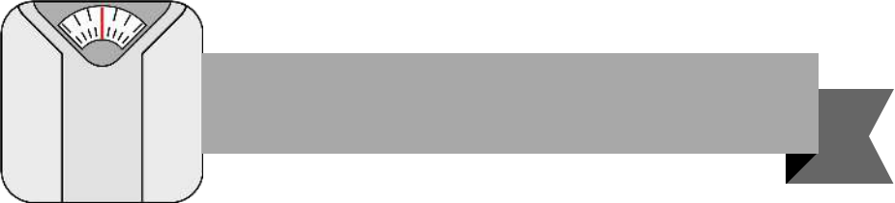
Weight Loss Tracker
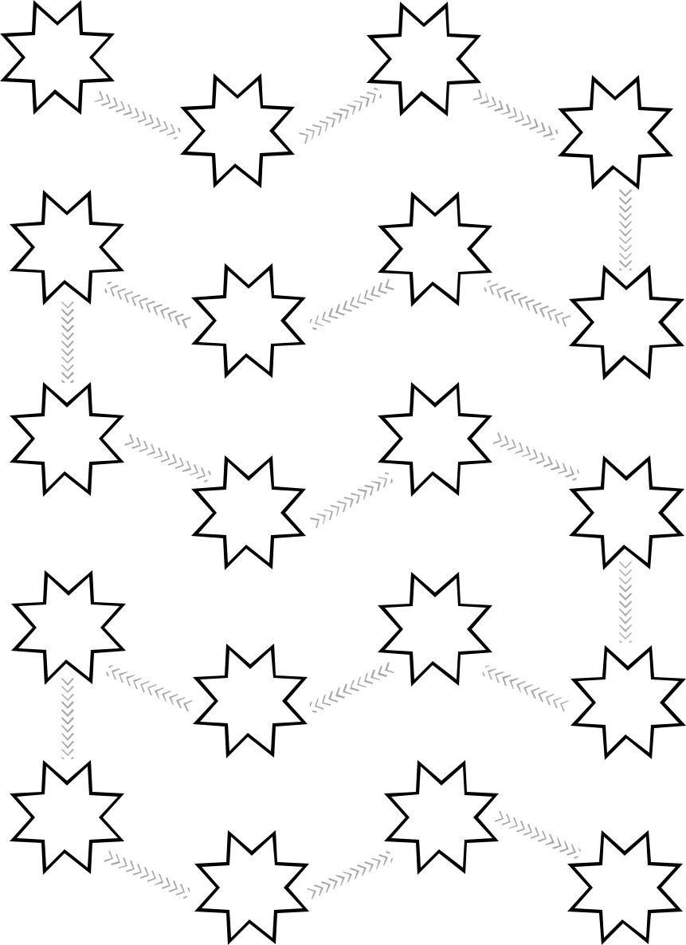

GOAL!


Motivational Quotes


Measurements

TRACKER
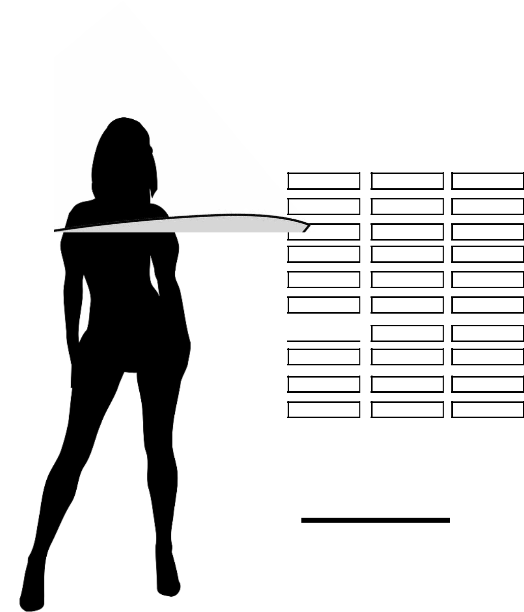

Neck:

Right Arm:

Left Arm:
Bust:

Waist:

Hips

Right Thigh: 

Left Thigh:

Right Calf:

Left Calf:

Total

In/Cm Lost:

A Year
of
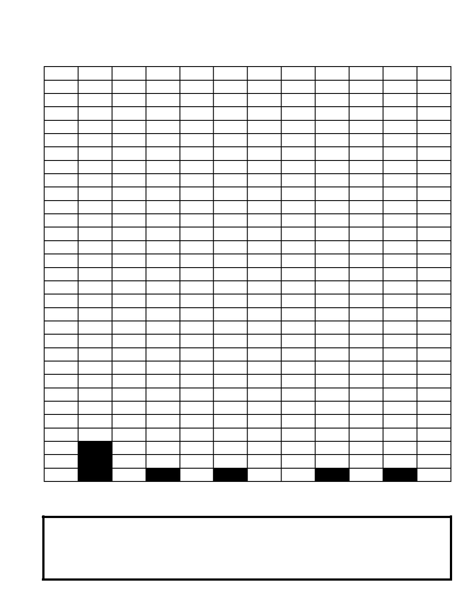

Jan Feb Mar Apr May Jun Jul Aug Sep Oct Nov Dec

1

2

3

4

5

6

7

8

9

10

11

12

13

14

15

16

17

18

19

20

21

22

23

24

25

26

27

28

29

30

31

Key

