Weight Loss Tracker

START
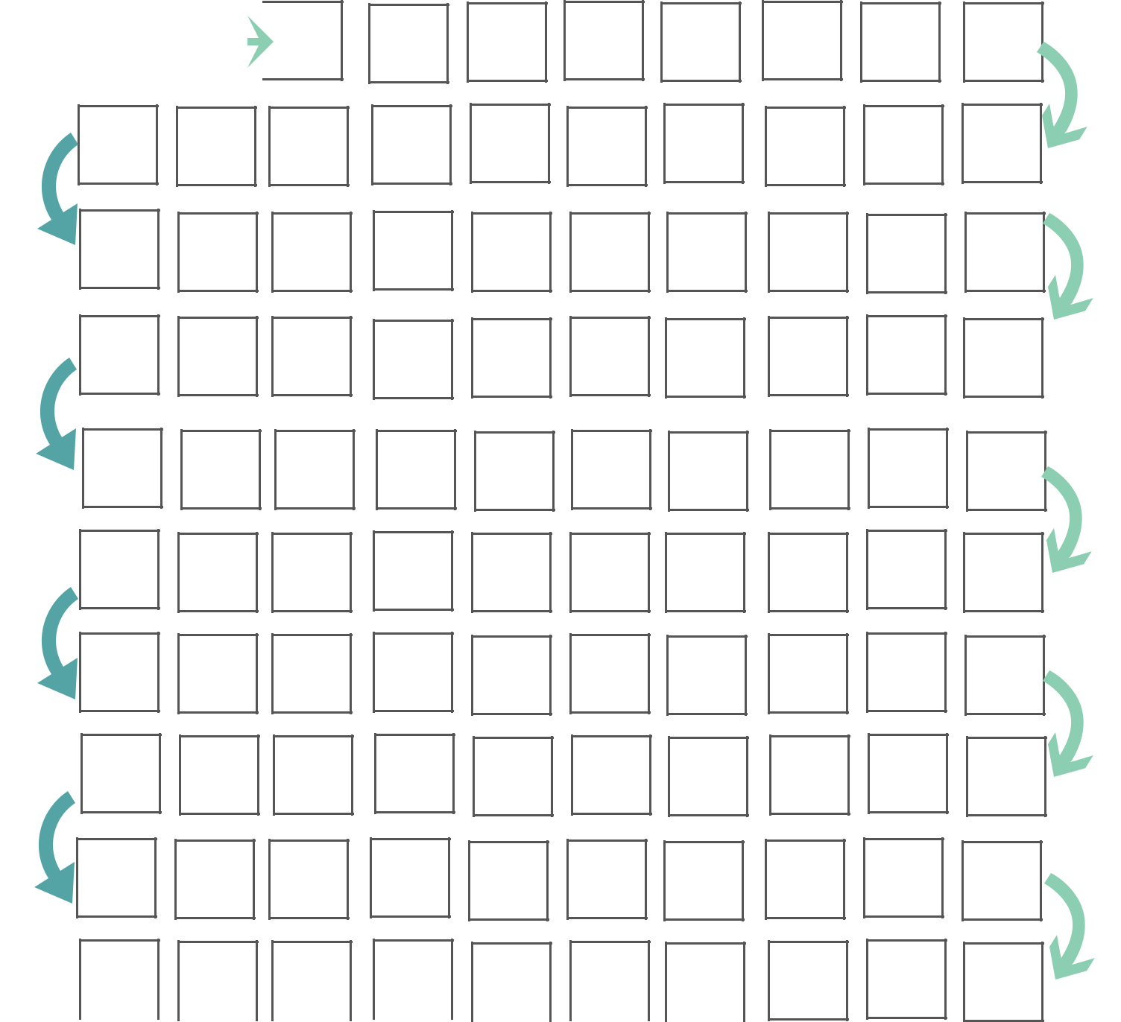

 FINISH

© Lemonlimeadventures.com

WEIGHT LOSSGOALS

JAN | FEB | MAR | APR
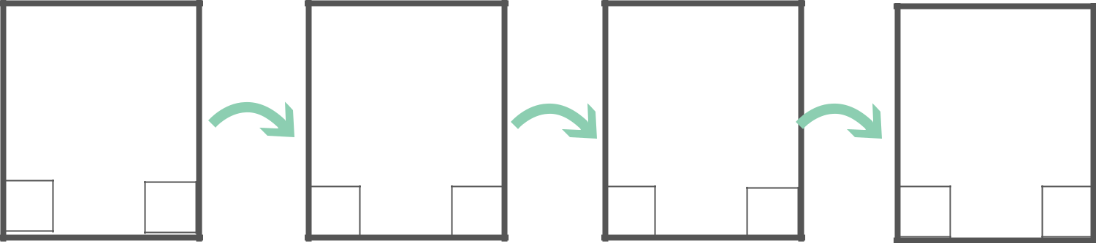

MAY | JUN | JUL | AUG

SEP | OCT | NOV | DEC
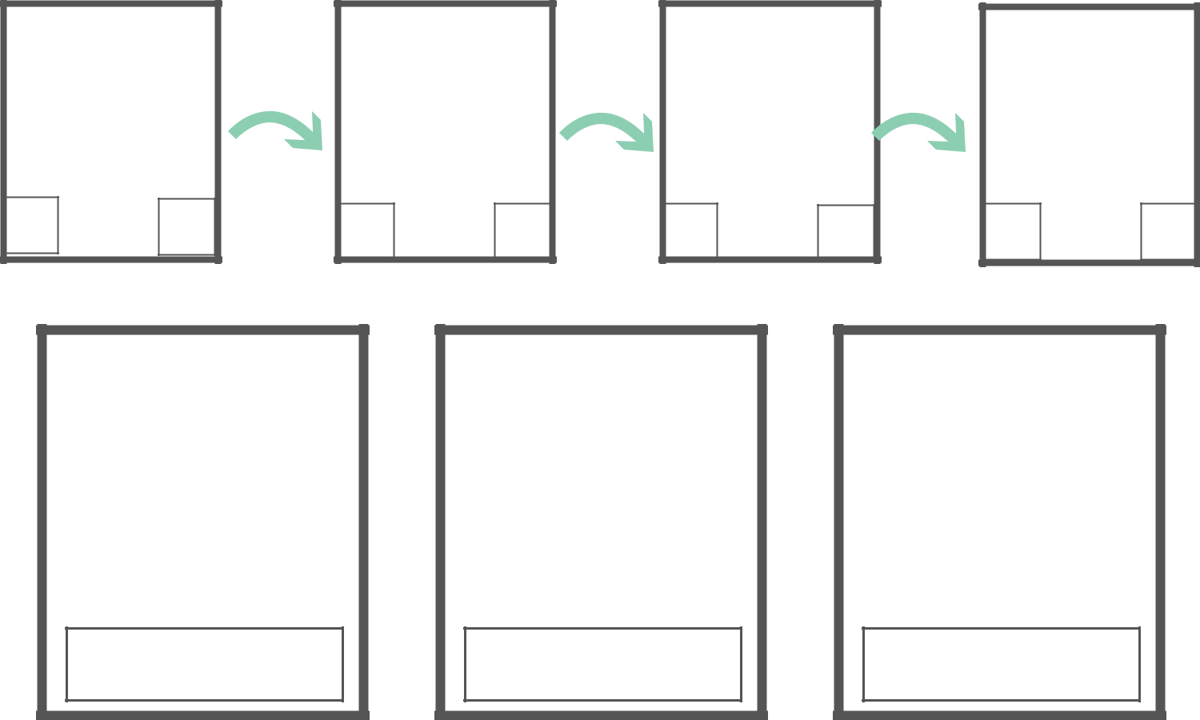

GOAL MET | GOAL MET | GOAL MET

© Lemonlimeadventures.com

