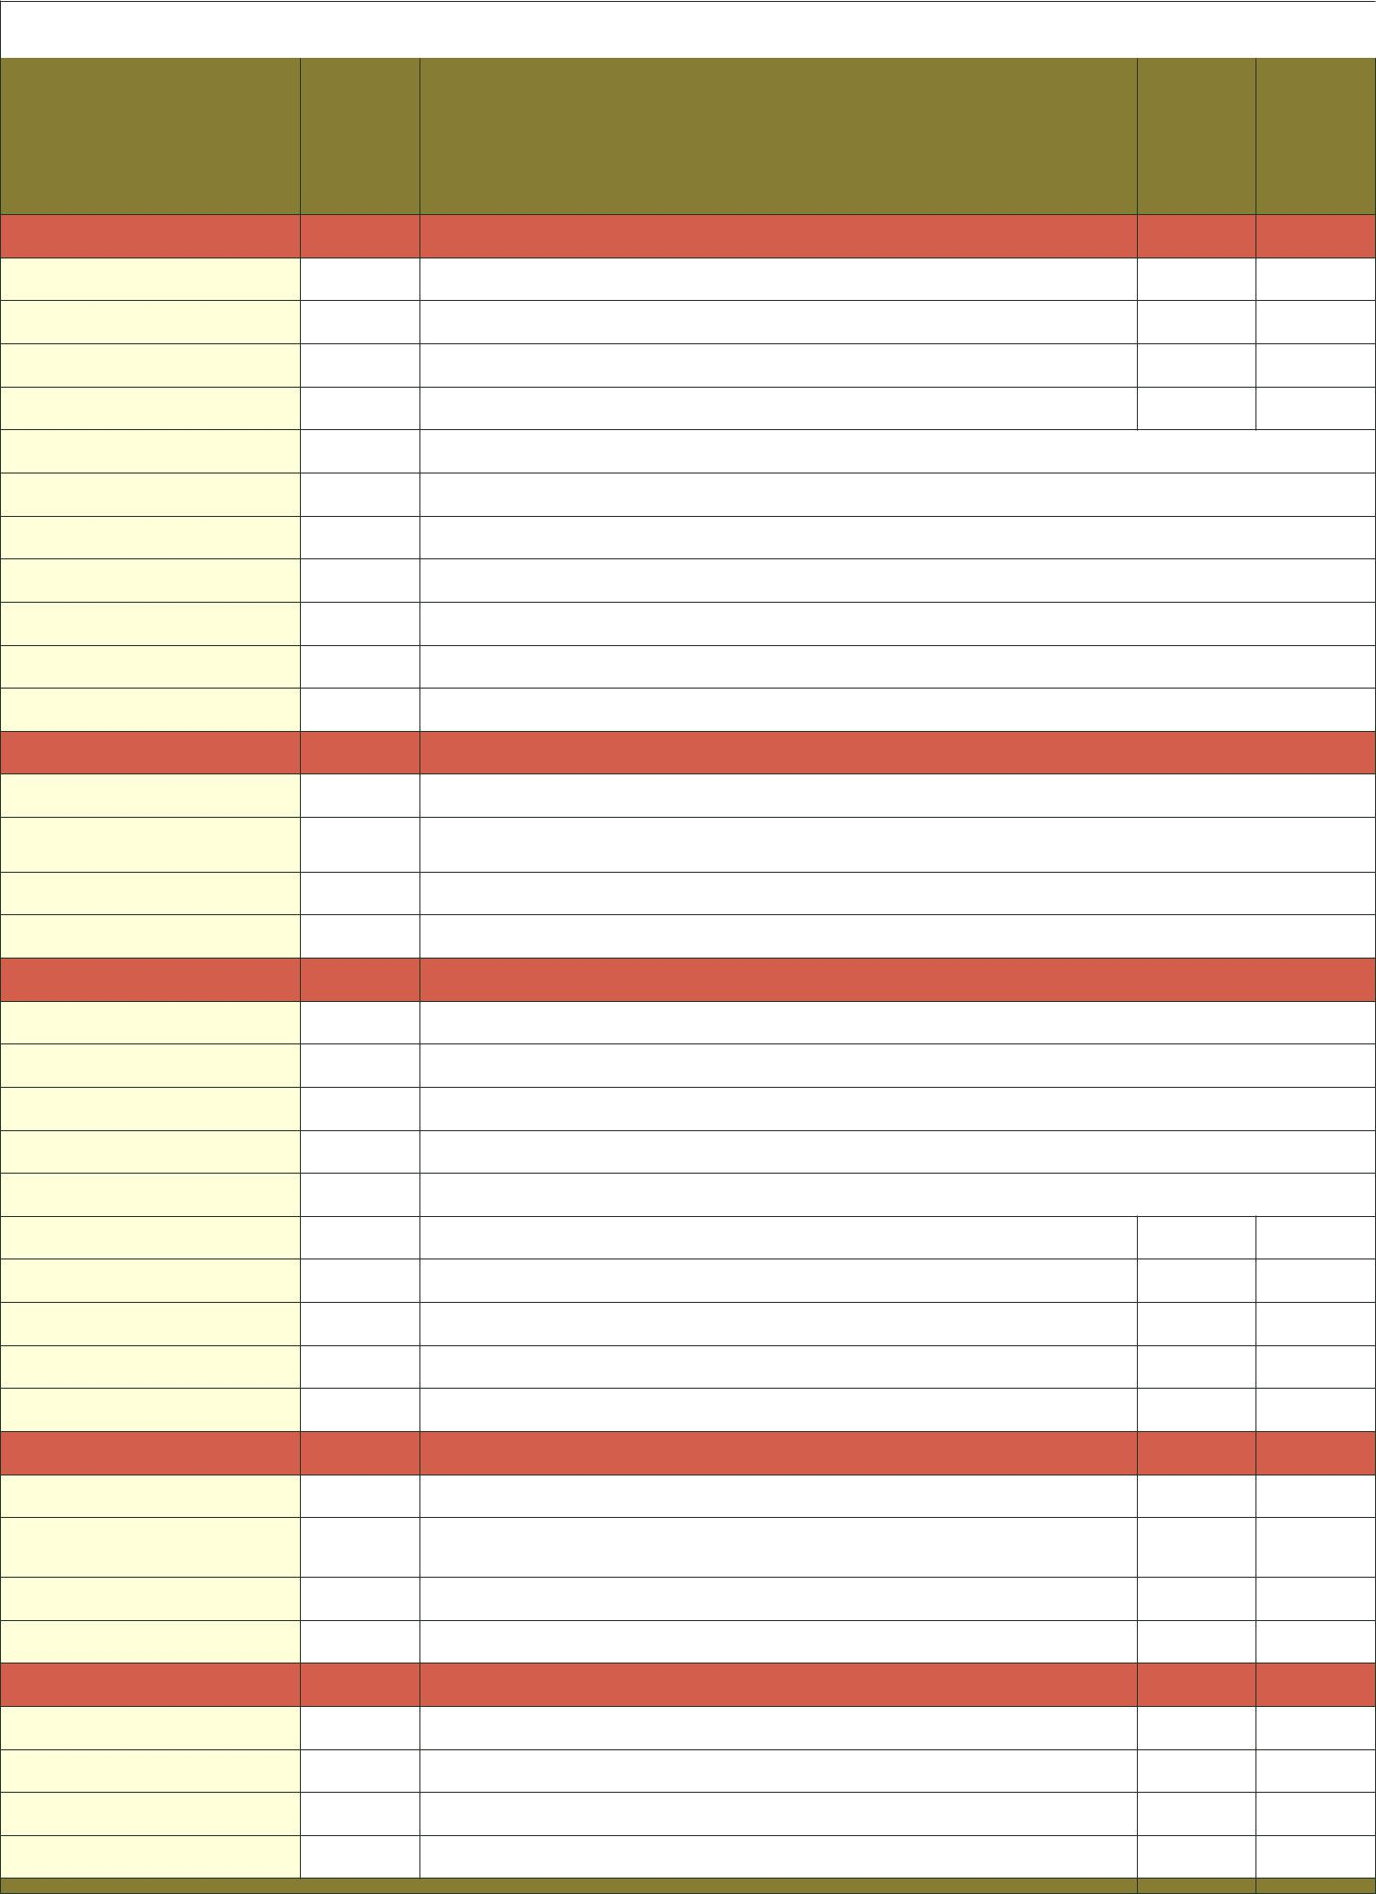
Format Converters Comparison Chart

Model

video inputs

Maximum Resolutions

Mount

Model | Model1 | Model | 1T-FC-326 | 1T-YPbPr-HDMI | 1T-DVI-HDMI | 1T-HDMI-DVI | 1T-FC-524 | 1T-FC-425

 |  |  |  |  |  | UXGA | UXGA | UXGA | UXGA
 |  |  |  |  | �
 |  |  | �
 |  |  |  |  |  |  | �
 |  |  |  |  |  |  | (Coaxial)
2.0, 7.1 |  |  |  |  | � | �
 | � (BNC)
½ Rack
Optional

