CROSS TIMBERS COMMUNITY HEALTH CENTER

110 West Reynosa

De Leon, TX 75486

(265) 839-5687

DOCTOR EXCUSE SLIP

Date: ________________________

This is to clarify that _____________________________ (has had) an appointment at

________________________ o' clock.

___________________________________ please excuse this absent.

_____________ May return to work on _______________________.

____________ No P.E until released.

______________ May return to work without limitations.

______________________________

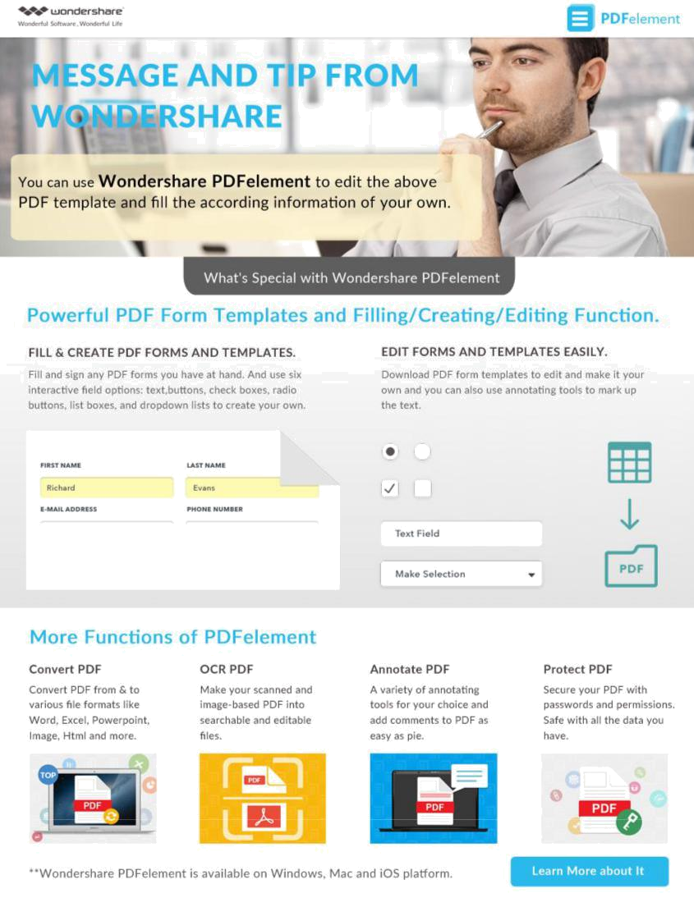
Physicians Signature

