
Time Blocking

Week of

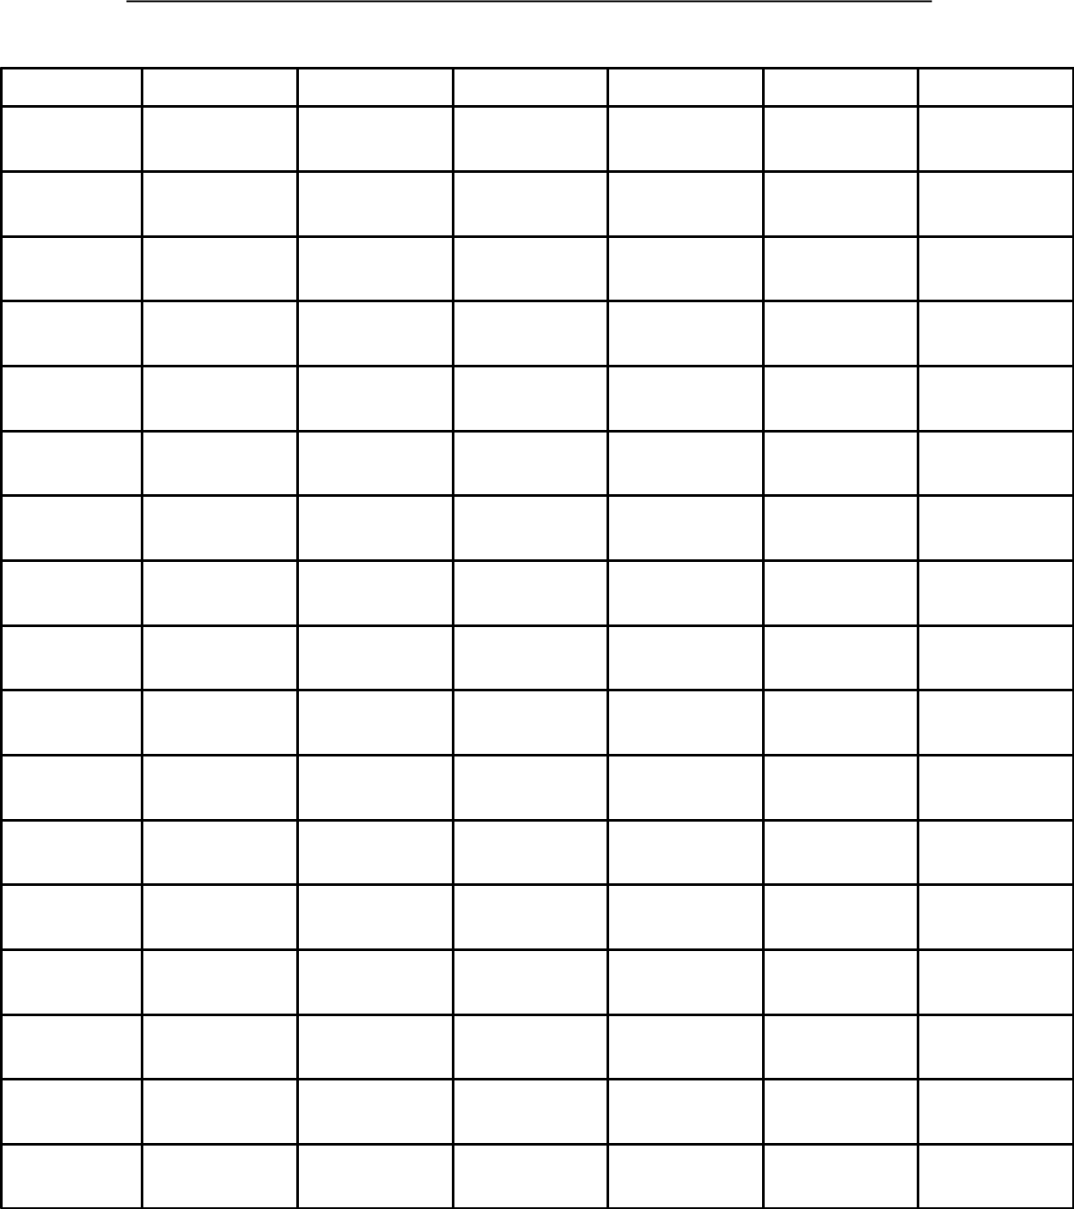

Monday | Tuesday | Wednesday | Thursday | Friday | Saturday

6:00 am

7:00 am

8:00 am

9:00 am

10:00 am

11:00 am

12:00 pm

1:00 pm

2:00 pm

3:00 pm

4:00 pm

4:00 pm

6:00 pm

7:00 pm

8:00 pm

9:00 pm

10:00 pm

