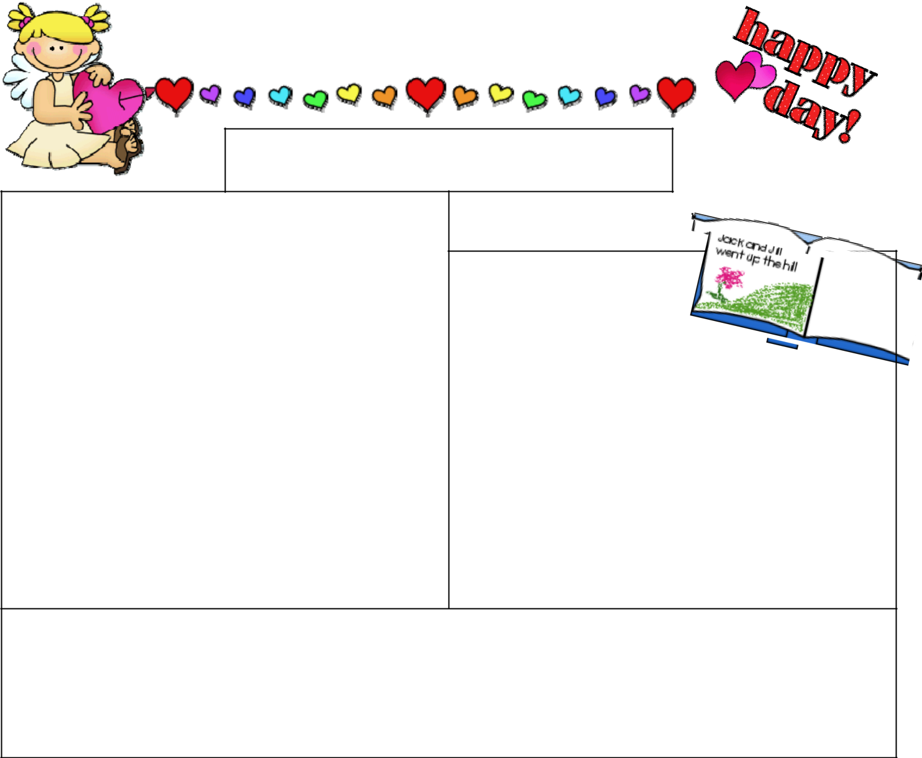
Preschool News

Themes

Stories

Activities
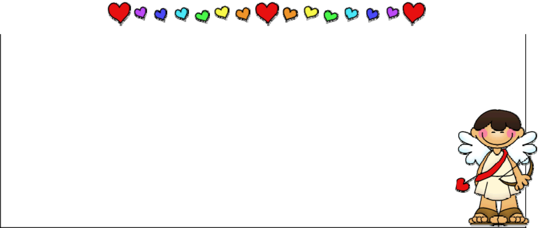

Announcements | Important Dates

Reminders

graphics© www.thistlegirldesigns.com © www.2care2teach4kids.com

