Medication Schedule
- List all prescriptions, over-the-counter drug, vitamins and herbs.
- Bring this to every doctor’s appointment and if you go to the emergency room or hospital Date:
Name and Dose of Your Medicine | This Medicine  is for  my____________ | How Much and How Often? |  |  |  | Reminder:  When do I take it?
 |  |  | 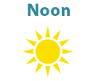 |  | 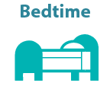

If you have any problems with you medicine – do not wait. Talk to your health care provider right away.

Name of Primary Primary Care Provider
Patient Name:_______________________ Care Provider: ___________________ Phone Number:_____________________

