Oregon Counts 2020

Sample Letters to the

Editor

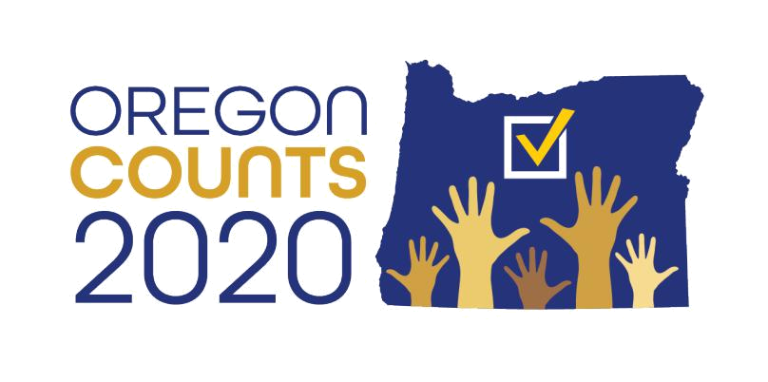

1

Oregon Counts 2020 | Sample Letters to the Editor

Instructions for Letters to the Editor

Instructions:

- Identify yourself, name, where you live, occupation or another identifier.

- Keep it at 200 words. (Check with your local paper to confirm word count requirement)

- Tell people why the 2020 Census is important to you. (Personal stories make a huge impact. Are you a parent? Are you a student? Do you want better roads, health care, business opportunities and/or jobs?)

- Tell people all the critical information. (Confidentiality of the Census, benefits to the community, financial benefits, security, why the Census is important to you )
- Tell people where they can get more information.

- Tell people what to expect. (Example: People should be receiving it in the mail in March, it’s confidential, and it can be done online, via paper form or over the phone.)
- Keep it simple.

- Once you submit, email 2020Census@Oregon.Gov and let us know you’ve submitted a letter!

2

Oregon Counts 2020 | Sample Letters to the Editor

Sample Letters to the Editor

General:

My name is __________ and I work in the _______ field and I live in________. The United

States Census begins in March and it’s critical every Oregonian participates and is counted. The U.S. Census ensures critical federal dollars reach all Oregonian communities. It happens every 10 years and guides how $1.5 trillion dollars annually will be spent on roads, transportation, health care, housing, and so much more. Local governments use the census for public safety and emergency preparedness. Real estate developers use the census to build new homes and revitalize neighborhoods. Businesses use the data to decide where to build factories, offices, and stores which help create jobs. Oregonians must participate and be counted. It’s vital we get out the count and ensure every Oregonian participates. This year it’s especially important to make sure your neighbors, family, and friends all participate and be sure to be counted. When you participate, your data is confidential and federal law protects your census response. 2020 will be easier than ever to participate because you will be able to respond to the census online. It’s important to me that we have an accurate count because _______________. For more information for to: Oregon2020Census.gov.

For Students:

My name is ________ and I’m a student at ________. The United States Census begins in

March and it’s important that we have an accurate count here in Oregon. The federal government distributes $1.5 trillion annually to state and local governments, nonprofits, businesses, and households across the nation. That money is allocated in a way that has big consequences for our future. As students, we rely on ensuring we have an opportunity to find good paying jobs after college. Businesses rely on this data to determine where to build their next businesses. That’s why I want to make sure I’m counted during this census. As college students, we rely on public transportation and the federal government uses this data to determine where the money should go for transportation dollars. That’s why I want to make sure I’m counted so not only do I reap

3

Oregon Counts 2020 | Sample Letters to the Editor

the benefits and rewards, but years from now another college student could also benefit from having my voice counted. And as a college student, I’m planning to participate because 2020 is going to be easier than past years-- it’s all online. In March, the United States Census Bureau will send me and you a personalized code to participate online. I’m making a plan to participate with my friends and using the school computers to partake in the 2020 Census. And don’t worry, the data is confidential and federal law protects your census responses. I’m committed to making sure my voice is counted. Will you join me? For more information go to: Oregon2020Census.gov.

For Business Owners:

My name is ________________ and I’m a business owner at ____________. The United

States Census begins mailing census forms to households beginning in mid-March and it is so critical that we have a complete and accurate 2020 Census count here in Oregon. Businesses like mine rely on data derived from the census to analyze market shifts, to make informed business decisions about where to open new shops, where to invest in the community, and where there will be an eligible workforce of community leaders to help build our business. That’s why it is so important that every Oregonian participates in the upcoming 2020 Census. Oregonian businesses have a vested interested in making sure everyone is counted, but you should too. Oregon businesses hire Oregon workers that help build a stronger Oregon. Together, if we all commit to taking part in the 2020 Census, we can commit to building a stronger and more robust Oregon. Join me and look for the Census Bureau’s mail in mid-March and participate online as soon as you get it. These vital resources play a huge part in our entire state. For more information go to: Oregon2020Census.gov

4

Oregon Counts 2020 | Sample Letters to the Editor

