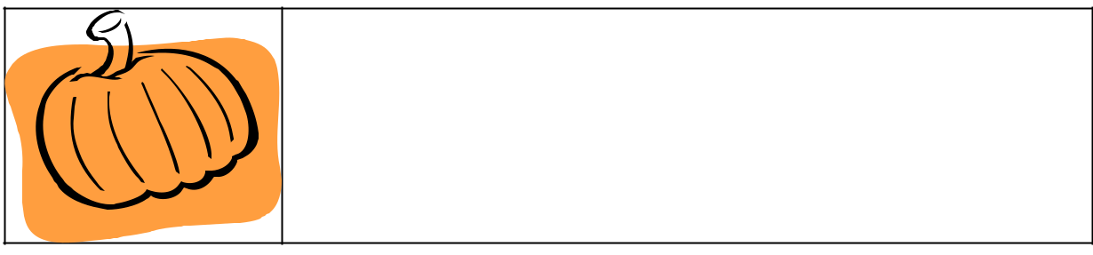
Classroom News
Month: October
 | Teacher:_________ Student:________
This Month | Looking Ahead

Reminders | Something Special

Behavior Box

Respect | 12345
Effort | 12345
Attitude | 12345
Preparation | 12345

Poor 1 2 3 4 5 Excellent

