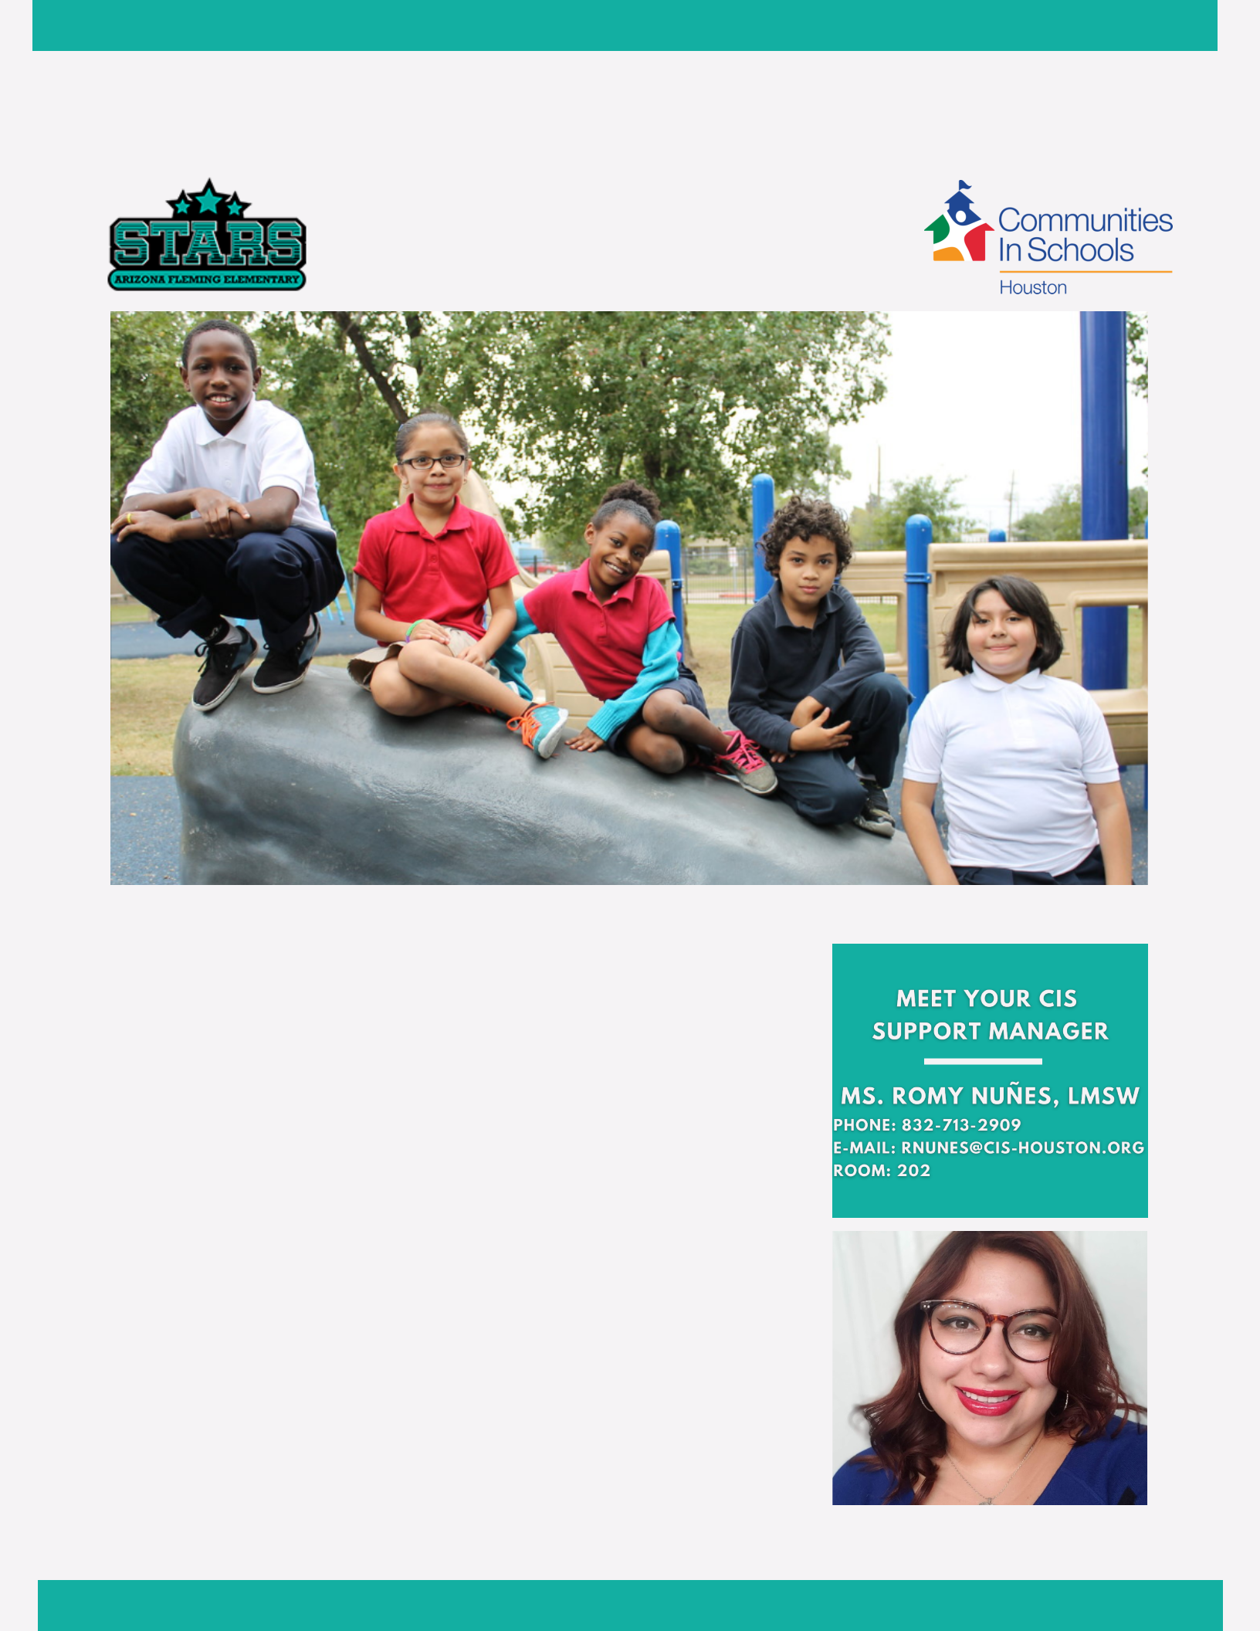
OCTOBER 2020 VOL. 1

ARIZONA FLEMING STARS NEWSLETTER

CIS Monthly Newsletter
Helping Arizona Fleming Stars
Shine Bright!

www.cishouston.org

PROGRAMS DON'T CHANGE

PEOPLE...RELATIONSHIPS DO

by Romy Nuñes, LMSW

H ello A rizona Flem ing Sta r Students & Fa m ilies,

I a m excited to pa rtner w ith A rizona Flem ing Elem enta ry for the first tim e a nd becom e a pa rt of the Sta r Fa m ily! I a m looking forw a rd to em pow ering the success of a ll STA R students a nd fa m ilies through C om m unities in Schools of H ouston (C IS) integra ted supports.

I ha ve resided in Fort Bend C ounty for the pa st 15 yea rs, a nd I a m a product of the Fort Bend ISD school system . I hold a M a ster of Socia l W ork (M SW ) degree from Ba ylor U niversity. I a m a Licensed M a ster Socia l W orker (LM SW ) w ith a specia liza tion in Physica l a nd M enta l H ea lth a nd a concentra tion in Im m igra tion Policy.

C IS a nd I believe in the pow er of rela tionships! To surround students w ith a com m unity of support, build m ea ningful rela tionships, a nd to em pow er students to sta y in school a nd a chieve in life. I look forw a rding to m eeting you a ll soon!

Ia PAGE 1 CIS MONTHLY NEWSLLETTER
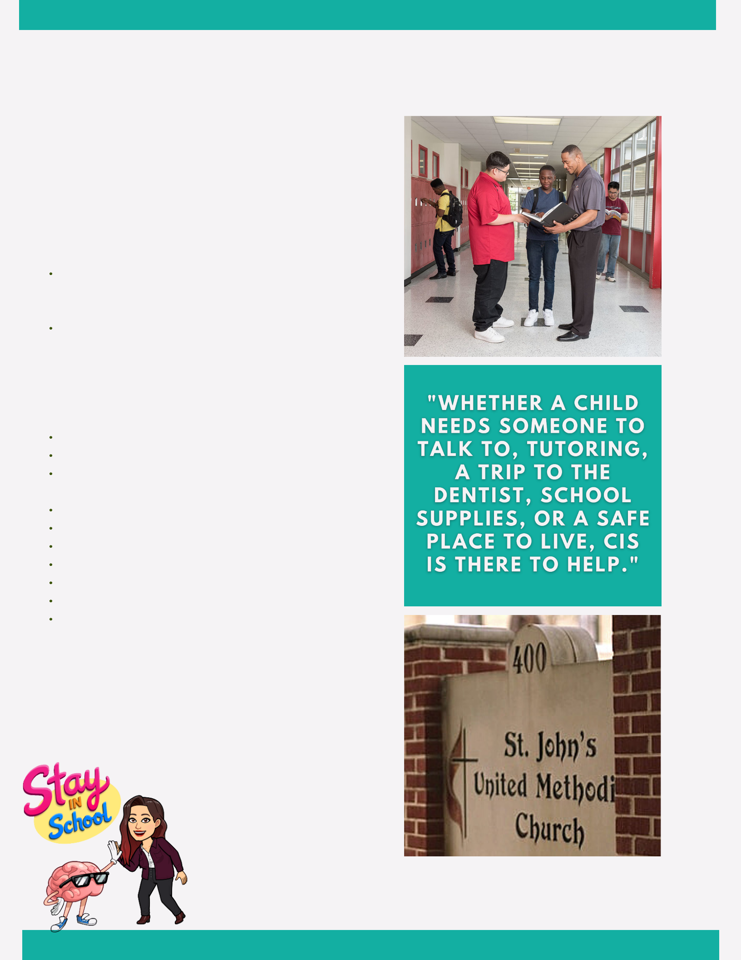
COMMUNITIES IN SCHOOLS

OF HOUSTON (CIS)

by Romy Nuñes, LMSW

WHO IS CIS

- e (Student Support M a na ger) a re on ca m pus to help students overcom e a ny ba rriers or

obsta cles tha t m a y interfere w ith succeeding in school

W e a re a trusted individua l on the ca m pus for

students to turn to for supportive guida nce

a nd counseling in a sa fe environm ent

W e w ork together w ith fa m ilies, the school,

a nd in the com m unity to do w ha tever it ta kes

to keep kids in school a nd on tra ck to

gra dua te

CIS PROVIDES:

A trusted person to ta lk to Tutoring a nd help w ith hom ew ork

A ssista nce w ith food , clothing , a nd school supplies

Support groups w ith other students

Positive rela tionship developm ent

A ccess to ca ring m entors

C ollege inform a tion

Referra ls to em ergency fina ncia l a ssista nce C om m unity service opportunities

A ccess to a dditiona l com m unity resources

COMMUNITY PARTNER HIGHLIGHTS:

Specia l tha nks to St. John's U nited M ethodist

C hurch for generously dona ting 30 ba ckpa cks w ith

school supplies to our A FE Sta rs!

Plea se conta ct m e a t 8 32 - 8 9 9 - 5511 for school supply a ssista nce.

SO M E O FTHE W AYS ICAN SUPPO RT THE AFE CO M M UNITY ARE BY PRO VIDING SUPPO RTIVE

GUIDANCE AND CO UNSELING TO STUDENTS, LINKING STUDENTS TO HEALTH AND HUM AN SERVICES (FO O D,

CLO THING, BASIC NEEDS), ENGAGING PARENTS AND FAM ILIES, PRO VIDING ACADEM IC SUPPO RT,

CO LLEGE/ CAREER READINESS, AND ENCO URAGING SCHO O L-W IDE, CULTURALENRICHM ENT AT AFE.

PAGE 2 CIS MONTHLY NEWSLLETTER

