Nathan Hale School | September, 2011 Issue


6th Grade Classroom Newsletter
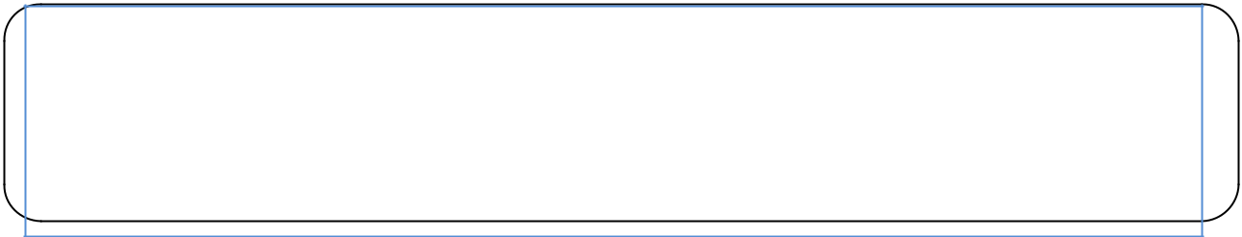

Welcome back to school! This is going to be another exciting and successful school year. We look forward to having a terrific year! 6th grade handbooks have been sent home and we have extra copies available. We are looking forward to meeting all parents on Parents Back to School Night which will take place in October. If you need to contact us please don’t hesitate to email or call. (203) 946-8669
Tricia.loffredo@new-haven.k12.ct.us Katharine.liphardt@new-haven.k12.ct.us
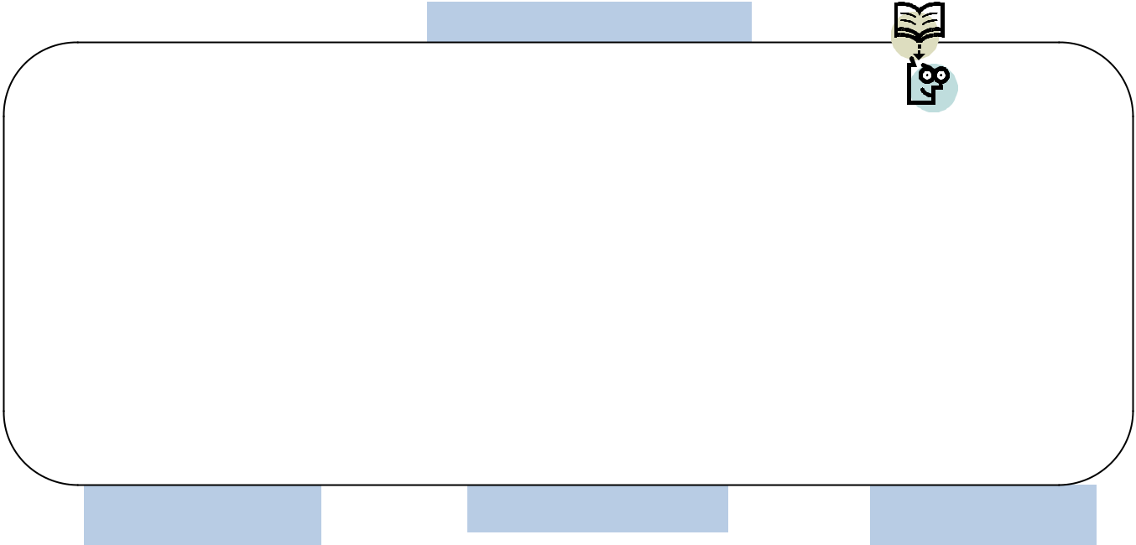

Math

Current Topics of Study

Students will be learning a lot of new material this year. We will begin with a city assessment and number sense topics. Please make sure your child is studying his/her multiplication and division facts every night. It is essential that every 6th grader knows their multiplication facts.


Lang. Arts
In writing, students will be learning and writing to expository writing prompts. In reading, students will begin a fiction text called No More Dead Dogs and participating in literature circles. Students need to be reading for a minimum of 20 minutes a night and have a book at home and in school at all times. Working together as a team will lead to success.

Social Studies | Science
During the first
marking period, | In science we
students will be | will be
studying a unit on | studying
slavery. Students | about our
will learn about the | planet. We
history of slavery | will also be
and about | studying
individuals who | water as a
lived during the | resource.
1800’s.

Projects/Assignments

Homework assignments will
be posted on Eboard.com.
Directions will be provided
for all parents. Please make
sure you check Miss
Loffredo’s and Mrs.

Liphardt’s homework

assignments.

Upcoming Trips/Events

**SPMT : Sept 21st at
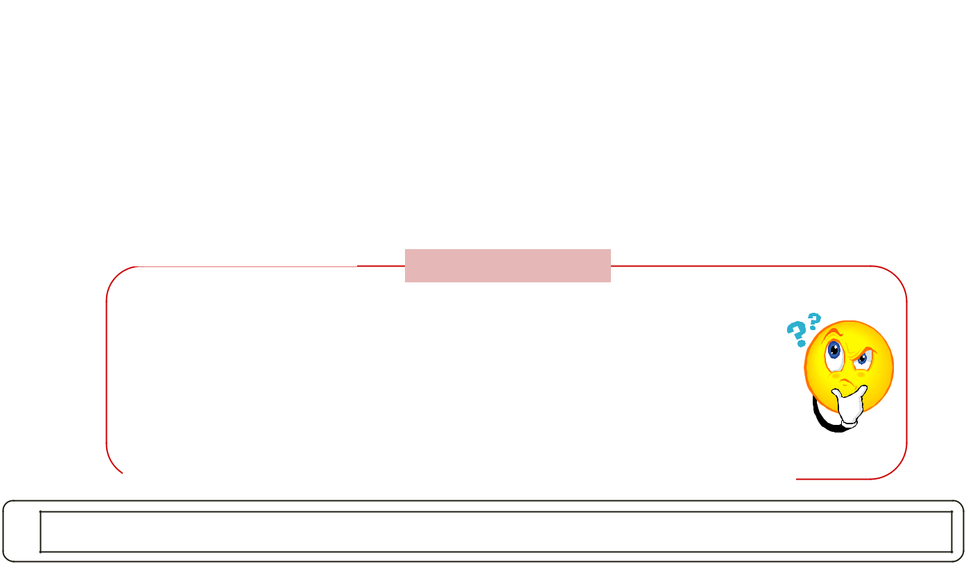
2:00
**Family Picnic: 9/21
@ 5:00
**September 29 & 30:
No School Rosh
Hashanah

***October 11: Parents Back to School Night for 6th grade 5:00-6:30

HOT Questions

Recognitions

We would like to welcome Eric Sarango and Kameron Irizarry to our school. We are thrilled that they are now a part of our Nathan Hale Family!

*What do you think the life of a slave was like? Why?
*What are some things you and your family can do to help conserve water? Explain what you think will happen in the future if we do not conserve water?
*What does it mean to be a COMER school?
*What is your strongest and weakest Comer Pathway? Give at least 3 examples why.

Developmental Pathways: Physical Language Psychological Cognitive Social Ethical

