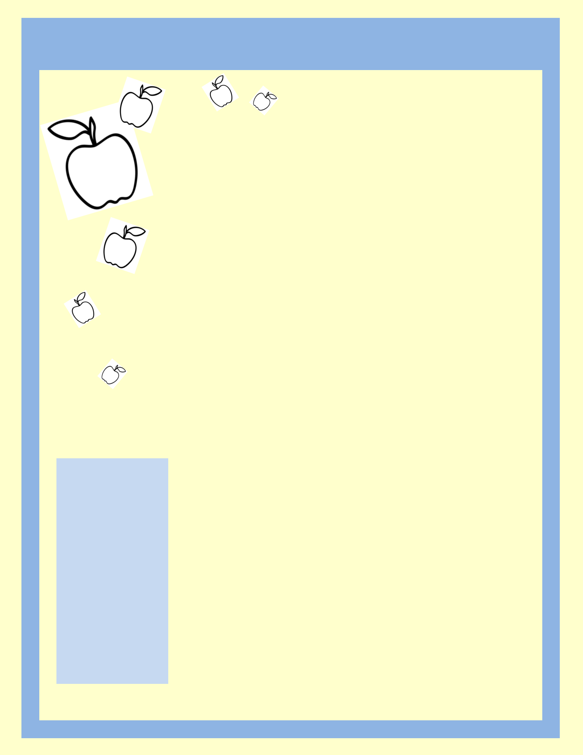
Grade 5 Classroom Newsletter

S e p t e m b e r 2 0 1 8 | Principal: Mr. Peter Marchand
S e p t e m b e r 2 0 1 8 | Grade 5 Classroom Teachers:
 | Mrs. T. Walters and Mrs. M. Gallo

Dear Parents and Guardians

It is with great pleasure that we welcome you to our Grade 5 classes! We are very excited to start this year with all the students as well as parents/guardians within the Our Lady of Providence school community. We hope you had a safe and enjoyable summer and are prepared to embark on an amazing journey this school year! We would like to welcome our new Principal, Mr. Marchand to our great community and know that we will be having some new and exciting experiences with him this school year!

We are looking forward to dedicating our time together this school year to your child, who has been entrusted in our care. Our hope, along with you is that they will develop academically and spiritually throughout the school year in a safe and encouraging learning environment.

We work closely with the other staff

here at OLOP to ensure your child
receives the best education possible.

This includes a partnership with all teachers, consultants, the special education team and administration.

Please feel free to contact your child’s teacher, Mrs. Walters or Mrs. Gallo, at any time to introduce yourself or to address any questions or concerns you may have. We both believe that constant communication will be a key factor in the success of your child this year.

The best form of communication is through your child’s school agenda. Your child will bring home an agenda daily and it is his/her responsibility to copy important dates or reminders about their school day or school work. He/she will be given time in class and asked to ensure that dates and reminders are in daily. Please encourage him/her to use it. Parents/Guardians are asked to sign it regularly. Finally, if you write a note in your child’s agenda please encourage them to notify the teacher of the message.

Supplies

A positive outlook and mindset to the school year ☺

A cloth bin

$5 for agenda pencil case lined paper

pencil crayons calculator

indoor running shoes

outdoor running shoes

appropriate gym
Classroom Information

To ensure our classroom runs smoothly and safely there are several procedures that need to put into place. The following list outlines these procedures:

- Readiness - Each student must come to school prepared to learn. This includes completing their homework and bringing the proper supplies to school daily.

- Entry – Students will be asked to enter the school through the junior doors of the school. They will hang their items on the hooks. They will be kindly asked to be seated and begin to follow the instructions on the board.

- Tardiness – If students are late, they will be asked to sign in at the main office and collect a late slip. They are also asked to enter class quickly and quietly without any disruptions.

- Prayers and Intentions – Each day we will begin class with prayers and special intentions. Also, there will be a short prayer before lunch and before dismissal.

- Classroom Jobs – At the beginning of each week or month students will be asked to check the classroom job board. Students will rotate through these jobs on a monthly or weekly basis.

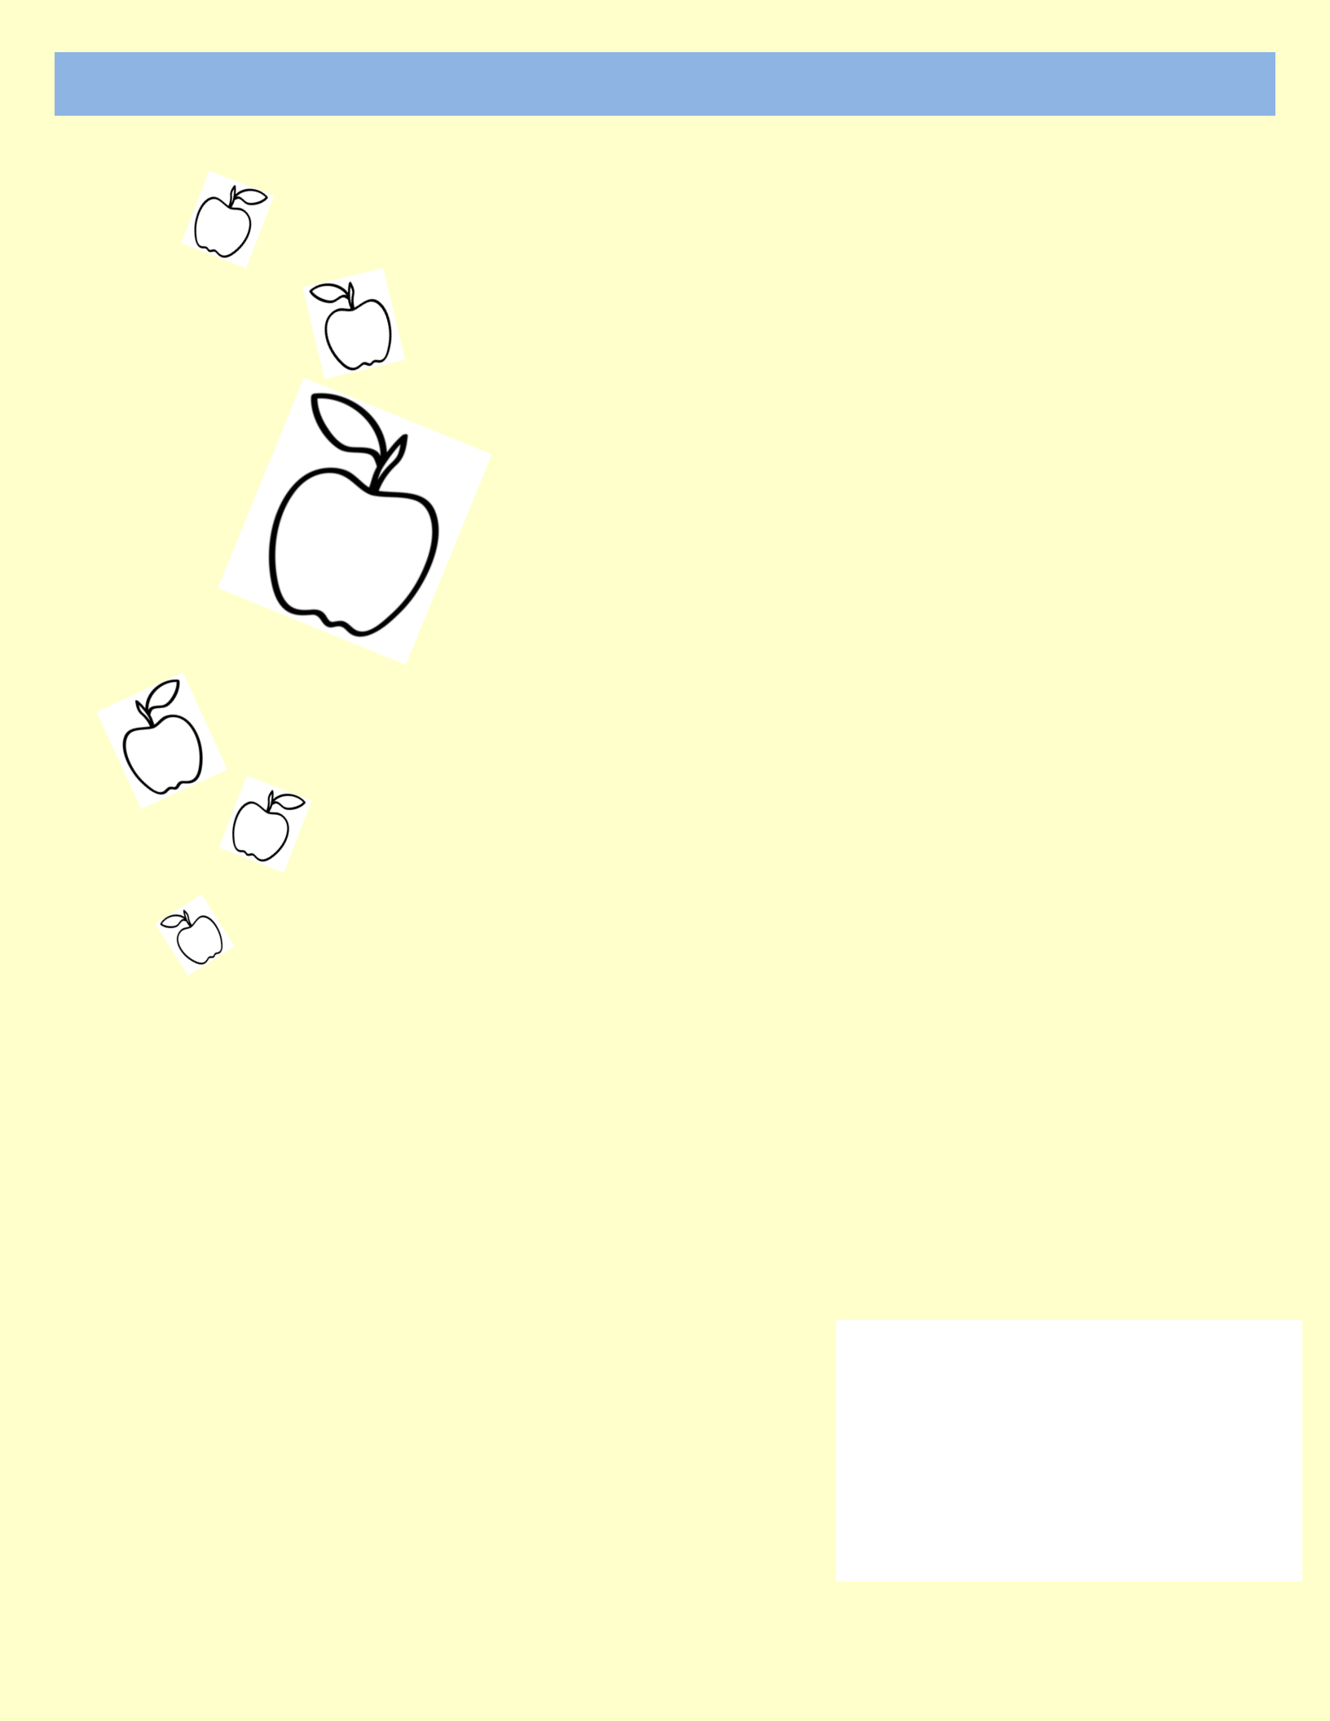
Grade 5 Classroom Newsletter

Classroom Information - Continued

“Everything is possible for him who believes”

Mark 9:23

- Homework - Homework will be checked regularly. It is important that students record their homework in their agendas at the end of the day. If students are absent homework will be collect for them within the classroom. Upon return, students may collect this incomplete work found within the folder on his/her desk. If students have difficulty with their homework they must come speak to the teacher in order to seek help. Parents and guardians will be contacted if students do not complete their homework.

- Allergies/Diabetes/Asthma – Please be mindful that the school is peanut free when preparing your child’s lunch. If your child has a medical condition of any kind, please communicate this to the teacher or call the school to speak the secretary so that the necessary paperwork and plans can be made.

- Textbooks – Students will each be given an assigned textbook. Student must have these with them in class daily. These books must be returned at the end of the year in the condition they were received in.

- Questions – Students are asked to please raise their hand if they have a question during class. Speaking out in class is disrespectful to others and is not tolerated. Equal opportunity in the classroom is key and needs to be respected by all.

- Classroom Courtesy – When in class, students are asked to please remain in their seats. If students need to use the washroom or sharpen their pencil, they are asked to kindly raise their hands.

- Water bottles – Reusable water bottles are important for each student to have. This helps to ensure that students are refreshed and there are refill stations for students to use.

- Physical Education – Students are asked to have an appropriate change of clothes and indoor

shoes for gym. Students will not be able to participate if they do not come prepared. If a student is injured or ill, a note must be given to the teacher from a parent/guardian or doctor.

- Organization – Students must stay organized throughout the school year; this includes the students’ desks. Throughout the year there will be designated time allotted to classroom organization.

- REMIND – Is an app that we hope to have up and running as soon as possible. This app will allow students as well as parents/guardians to stay updated with classroom activities! This app is an effective tool used by teachers to assist students in managing their workload as well as to allow constant communication between home and school! More information will follow.

- Class Dismissal – It is very important that students remember that teachers will dismiss them at the end of the day and not the bell. By following this procedure, it will ensure all students exit the classroom safely.

Once again, if you have any questions or concerns please do not hesitate to contact us at school. We are looking forward to developing a strong relationship with both you and your child throughout this school year!

Sincerely,

Mrs. T. Walters and Mrs. M. Gallo

