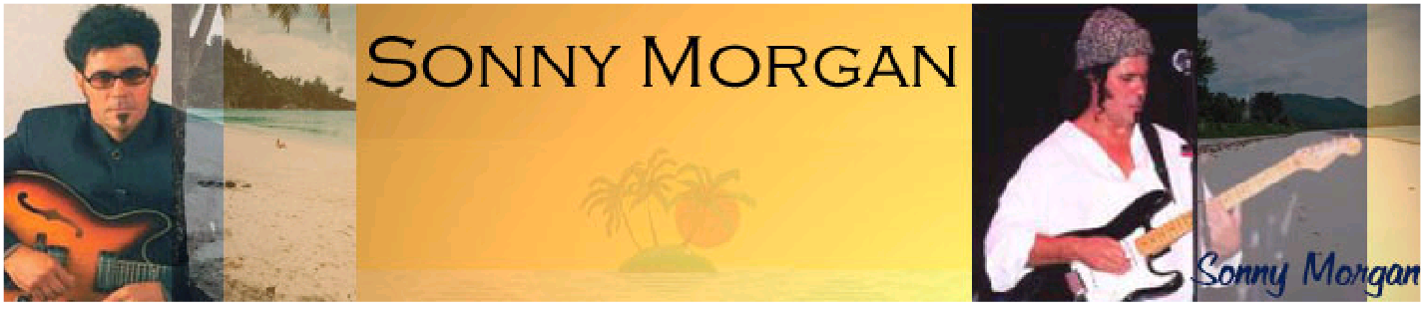
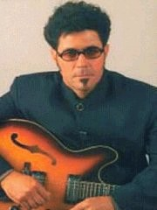
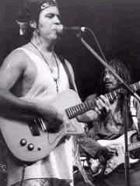

Sonny Morgan Electronic Press Kit - PDF Version

Biography

Sonny Morgan was born in the Seychelles, but moved to Australia aged 13 years old - and now splits his time between Perth WA and the Seychelles.
Anybody visiting the Seychelles will hear his music on the radio, in the hotels or in the local houses as his music is a 'major export' for the Islands and demonstrates the traditional Indian Ocean Sega music style.
Early hits for Sonny include Timimi and Theme for Aldabra, both to listen to, let your mind drift to a 'sunny climate' and give you the ambient feel of the Seychelles.

Long term listeners to Sonny can hear the evolution in his music over the last 20 years, whilst he has kept the original Sega style to his lyrics, the music has taken on a 21st century beat. His music is no-longer only appreciated in the Indian Ocean, but succeeding in the US and European markets.

Sonny is renowned for his unique style, although his music has a Reggae/Sega beat, it has a 'Steve Harley' depth to his lyrics and a Latin American foot tapping feel.

Some of his Early tracks have now been remixed with the 'Seggae' style making them even more popular to the global market. 'Architect' can be found in both styles, its original Sega version still very popular around the Indian Ocean and the new Sunshine version in the USA and in Europe.

From Seychelles to LA, London to Perth, Sonny's music is growing in audience each day.
Images

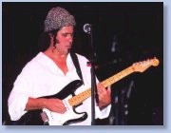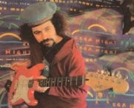

Music

Please note that the mp3 clips presented here are "lo-fi" to keep bandwidth down. Should you wish to obtain CDs or higher quality mp3 versions, then please use the "Contact Sonny" link at the bottom of this page with details of your requirements.

This mp3 sample contains extracts from the "Architect" CD - Architect, War War War, Morning Glory, Fool's Paradise, Clean Cut Shaven, Rasta Man, Preacher Man and United Together - Listen here (duration: 10:09 - file size: 1.74MB)
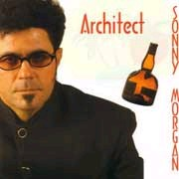

This mp3 sample contains extracts from the "Sega nights" CD - Karya, It All Started in Africa, Respect of the People, Sega you Want - Sega you Get, Swe Sa, I need to know you're Real and When He Dance - Listen here (duration: 7:29 - file size: 1.28MB)
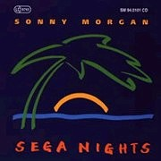

Video

Sonny has two full-length videos of tracks available on DVD ("Fool's Paradise" and "Rasta Man"). Also available is an "in concert" DVD called "New Culture".

A short extract of "Rasta Man" is also available in WMV/AVI format. A Low-Res version of this clip can be viewed by using the link below (will open in a new window).

View Rasta Man Video NOW! (format: wmv duration: 1:17 - file size: 2.17MB)

Contact Sonny using the link at the bottom of the page for all enquiries regarding DVD/Video.

Awards & Reviews

Some of Sonny's awards are listed below:

- WAMI Song Contest 2005 - Finalist in "World Music" Category
- UNISONG International Song Contest 2004 - 4th Place in "World/Reggae" Category
- UNISONG International Song Contest 2001 - Winner of the "R&B/RAP/Hip-Hop" Category

- UNISONG International Song Contest 2000 - Honourable Mention in "World Music" Category
- WAMI Song Contest 2000 - Winner of the "World Music" Category Below are some extracts from reviews:
"Vintage album crowns Sonny Morgan's 20 year music odyssey: Just as a fine wine mellows with age, Sonny Morgan's music simply gets better as the years roll on...the La-Digue born musician has risne from humble beginnings to become one of the hottest properties in the music arena"
Seychelles Weekend Nation - reviewing "This World is for Everyone"

"An infectious mix of reggae and sega, Sonny's music radiates the warmth of the Seychelles as well as the rhythms of Africa."
Kulcha

"Sonny's audience is growing everyday and with music that lets you sit back, relax and enjoy the sounds of the Seychelles, it's not hard to see why."
West Australian

"Another top-notch album from maestro Morgan...Everything about the album 'Tropical Experience' (released in the UK as 'Architect') smacks of profesionalism...powerful lyrics and exquisite musical arrangements."
The People

"More success for Sonny Morgan and Island Massive as they take the Fly By Night club by storm."
The People

"This superb album oozes with catchy tunes and cross rhythmic music, blending funk, reggae, sega & latin rhythms."
Album review - "Theme for Aldabra"

Discography

Sonny Morgan has released numerous CDs - Major releases are listed below:

- THIS WORLD IS FOR EVERYONE
- ARCHITECT/TROPICAL EXPERIENCE
- ISLAND PEOPLE
- COCO DE MER
- NEW CULTURE
- THEME FOR ALDABRA
- SEGA NIGHTS
- REGGAE COLLECTION
- ISLAND MASSIVE

Sonny also features on various compilations, such as:

- Roots Reggae Vibration Chapter 1

Calendar/Gigs

Sonny is a regular performer at venues of all sizes. He has performed at major outdoor festivals in front of audiences of up to 15,000 around the Indian Ocean, Australia and Europe.

Sonny also performs at highly regarded venues such as "Kulcha" and the "Fly By Night Club" in Perth/Fremantle, and has toured in Europe.

At present, Sonny is preparing for his next studio project.

Please use the email link at the bottom of this page for any booking enquiries.

Contact

Direct
Contact Sonny direct for enquiries, bookings etc
email : sonny (at) sonnymorgan (dot) com - (use the email link at the bottom of this page)

Australia:

Kismana Music
PO Box 1254, Bentley, 6983, Western Australia Phone : + 61 8 9367 9340
email : info@kismana.com.au Website : www.kismana.com.au

UK:

Gotham Records
P O Box 6003, Birmingham, B45 0AR, England Phone: +44 121 477 9553 Fax: +44 121 693 2954
E-mail: mail@gotham-records.com

Web site: http://www.gotham-records.com

USA:

Noma Music
877-980-7700 Toll Free U.S.
818-883-1878 Local Los Angeles 001-883-1878 International
email : promotion@nomamusic.com Web site : http://www.nomamusic.com

Sonny Morgan Website | This EPK created by : BlueCat

