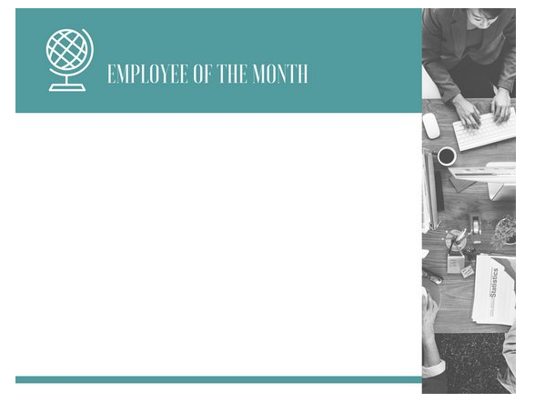

Signature

For his outstanding performance in his position as __________

Granted this award on this day ______, 2017

This certificate is heartily awarded to

_____________________