VISION AND MISSION STATEMENTS

EXAMPLES AND TEMPLATES

Use this template to develop a vision statement for your group or community at a coalition meeting. Ask members to fill out the template below; identify the common theme(s). Use the themes to craft a shared vision statement.

EXAMPLE – Vision Statement
Think about your group or community. Write a vision statement using the example below as a guide.
Group or Community Name | Where are we going? | What can we achieve? | What kind of a place do we want the community to be?
Healthy Valley | To improve to a better level of living | Great place to live, work, play, grow, be happy | The best in the area, state, anywhere
Draw a picture that depicts your vision:  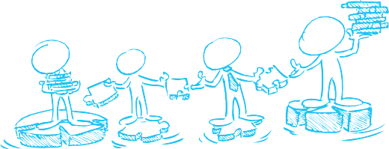 |  | Use descriptive words or phrases that represent the idea, community, etc.:  Commitment of residents, vision for all
Vision Statement | We the citizens of the Healthy Valley are committed to a vision in which our community is the best place to live, work, play, grow, and enjoy life.

Template for a Vision Statement
Think about your group or community. Write a vision statement, using the template as a guide.
Group or Community Name | Where are we going? | What can we achieve? | What kind of a place do we want the community to be?
Draw a picture that depicts your vision: |  | Use descriptive words or phrases that represent the idea, community, etc.:
Vision Statement

CORE PROCESS STEP 3 – PLAN AND COLLABORATE: VISION AND MISSION STATEMENTS EXAMPLES AND TEMPLATES 1

Review the example of a mission statement. Use the template below to develop a mission statement for your group or community at a coalition meeting. Ask members to fill out the template below. Use the themes to craft a shared vision statement.

EXAMPLE - Mission Statement
Think about your group or community. Write a mission statement using the example below as a guide.
Group or Community Name | What do you do? | For whom do you do it? | How will you get it done?
Healthy Valley Initiative | Help and support creating and maintaining a healthy Marion County | People of Healthy Valley and surrounding community | Through leadership  By involving all the major stakeholders
 |  |  | An ongoing, sustainable collaborative process
 |  |  | Support community needs assessments, targeted interventions, and outcome evaluations
Mission Statement | The Healthy Valley Initiative will assist the people of Healthy Valley and surrounding areas in improving their lives by maintaining a healthy Marion County environment through  a sustainable, collaborative process that supports community needs assessments, targeted interventions, and outcome evaluations.

Template for a Mission Statement
Think about your group or community. Write a mission statement using the template as a guide.
Group or Community Name | What do you do? | For whom do you do it? | How will you get it done?
Mission Statement

2 THE SOUTH DAKOTA GOOD & HEALTHY COMMUNITY ASSESSMENT AND IMPROVEMENT PLANNING TOOLKIT

