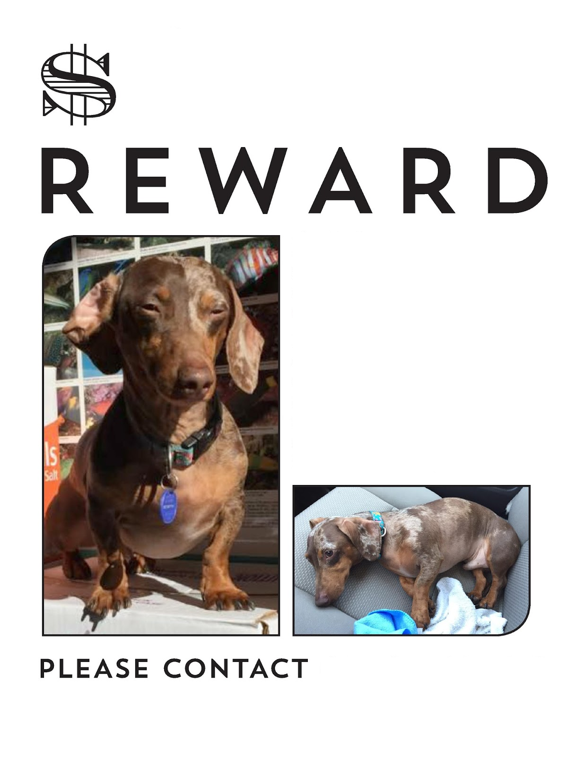

Details of the lost Dog

Type contact number

Type amount here