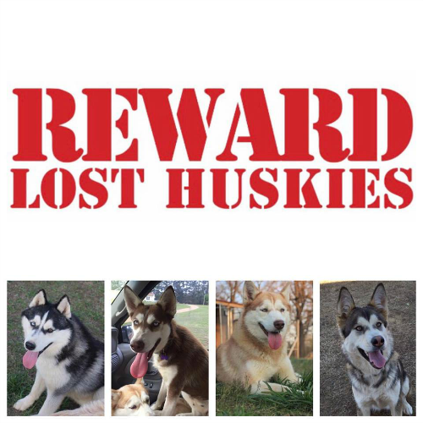

**Replace dog picture**

**FOUND**  call 77-78-877