LOST
Big Black Jaguar
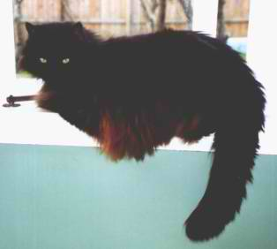
Please help us find Homer
Missing, from Lambeth Rd, Sandringham (last seen Sunday afternoon 9 September).
Homer is a big black long haired neutered male adult cat.
He is a loyal, gentle and much loved family pet who never misses his breakfast or dinner
- so he may be trapped in your garage, under your house, in a cupboard, car, locked rooms etc.
Please check for him – he rarely meows so you wouldn’t hear him necessarily.
Any sightings, from this weekend, or subsequent, please advise us
Gavin or Kim on 555 5555 or mobile 025 123 456 – Thank you
"See www.petsonthenet.co.nz
keyword: Homer
for more information."

