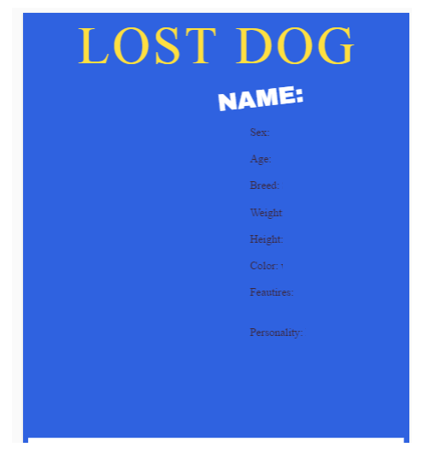

CALL 433-335-3434

Your text here

DOG PHOTO