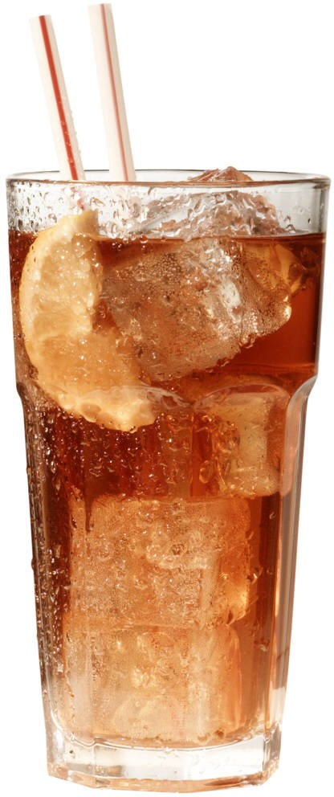

Industry Analysis:

Soft Drinks

Meghan Deichert, Meghan Ellenbecker, Emily Klehr, Leslie Pesarchick, & Kelly Ziegler

Strategic Management in a Global Context February 22, 2006

**Industry Analysis: Soft Drinks**

Barbara Murray (2006c) explained the soft drink industry by stating, “For years the story

in the nonalcoholic sector centered on the power struggle between…Coke and Pepsi. But as the

pop fight has topped out, the industry's giants have begun relying on new product flavors…and

looking to noncarbonated beverages for growth.” In order to fully understand the soft drink

industry, the following should be considered: the dominant economic factors, five competitive

sources, industry trends, and the industry’s key factors. Based on the analyses of the industry,

specific recommendations for competitors can then be created.

**Dominant Economic Factors**

Market size, growth rate and overall profitability are three economic indicators that can

be used to evaluate the soft drink industry. The market size of this industry has been changing.

Soft drink consumption has a market share of 46.8% within the non-alcoholic drink industry,

illustrated in Table 1. Datamonitor (2005) also found that the total market value of soft drinks

reached $307.2 billion in 2004 with a market value forecast of $367.1 billion in 2009. Further,

the 2004 soft drink volume was 325,367.2 million liters (see Table 2). Clearly, the soft drink

industry is lucrative with a potential for high profits, but there are several obstacles to overcome

in order to capture the market share.

The growth rate has been recently criticized due to the U.S. market saturation of soft

drinks. Datamonitor (2005) stated, “Looking ahead, despite solid growth in consumption, the

global soft drinks market is expected to slightly decelerate, reflecting stagnation of market

prices.” The change is attributed to the other growing sectors of the non-alcoholic industry

including tea and coffee (11.8%) and bottled water (9.3%). Sports drinks and energy drinks are

also expected to increase in growth as competitors start adopting new product lines.

1

Profitability in the soft drink industry will remain rather solid, but market saturation

especially in the U.S. has caused analysts to suspect a slight deceleration of growth in the

industry (2005). Because of this, soft drink leaders are establishing themselves in alternative

markets such as the snack, confections, bottled water, and sports drinks industries (Barbara

Murray, 2006c). In order for soft drink companies to continue to grow and increase profits they

will need to diversify their product offerings.

The geographic scope of the competitive rivalry explains some of the economic features

found in the soft drink industry. According to Barbara Murray (2006c), “The sector is

dominated by three major players…Coca-Cola is king of the soft drink-empire and boasts a

global market share of around 50%, followed by PepsiCo at about 21%, and Cadbury Schweppes

at 7%.” Aside from these major players, smaller companies such as Cott Corporation and

National Beverage Company make up the remaining market share. All five of these companies

make a portion of their profits outside of the United States. Table 3 shows that the US does not

hold the highest percentage of the global market share, therefore companies need to be able to

compete globally in order to be successful.

Table 4 indicates that Coca-Cola has a similar distribution of sales in Europe, North

America, and Asia. On the other hand, the majority of PepsiCo’s profits come from the United

States (see Table 5). Compared to PepsiCo, Cadbury Schweppes has a stronger global presence

with their global mix (see Table 7). Smaller companies are also trying to establish a global

presence. Cott Corporation is a good example as indicated in Table 8. The saturation of the US

markets has increased the global expansion by soft drink leaders to increase their profits.

The ease of entry and exit does not cause competitive pressure on the major soft drink

companies. It would be very difficult for a new company to enter this industry because they

2

would not be able to compete with the established brand names, distribution channels, and high

capital investment. Likewise, leaving this industry would be difficult with the significant loss of

money from the fixed costs, binding contracts with distribution channels, and advertisements

used to create the strong brand images. This industry is well established already, and it would be

difficult for any company to enter or exit successfully.

Three leading companies have prominent presence in the soft drink industry. The leaders

include the Coca-Cola Company, PepsiCo, and Cadbury Schweppes. According to the Coca-

Cola annual report (2004), it has the most soft drink sales with $22 billion. The Coca-Cola

product line has several popular soft drinks including Coca-Cola, Diet Coke, Fanta, Barq’s, and

Sprite, selling over 400 drink brands in about 200 nations (Murray 2006a). PepsiCo is the next

top competitor with soft drink sales grossing $18 billion for the two beverage subsidiaries,

PepsiCo Beverages North America and PepsiCo International (PepsiCo Inc., 2004). PepsiCo’s

soft drink product line includes Pepsi, Mountain Dew, and Slice which make up more than one-

quarter of its sales. Cadbury Schweppes had soft drink sales of $6 billion with a product line

consisting of soft drinks such as A&W Root Beer, Canada Dry, and Dr. Pepper (Cadbury

Schweppes, 2004).

**Financial Analysis**

The carbonated beverage industry is a highly competitive global industry as illustrated in

the financial statements. According to John Sicher of *Beverage Digest* (2005), Coca-Cola was

the number one brand with around 4.5 billion cases sold in 2004. Pepsi followed with 3.2 billion

cases, and Cadbury had 1.5 billion cases sold. However, the market share shows a different

picture. Coca-Cola and PepsiCo control the market share with Coca-Cola holding 43.1% and

Pepsi with 31.7% (see Graph 1); however these market shares for both Coca-Cola and PepsiCo

3

have slightly decreased from 2003 to 2004. Coca-Cola’s volume has also decreased 1.0% since

2003, whereas PepsiCo’s volume has increased 0.4% (see Graph 1). Diet Coke posted a 5%

growth, but Coca-Cola’s other top 10 brands declined (Sicher, 2005). Overall, Coca-Cola’s

market position has declined in 2004. The strategic group map (see Graph 1) also shows the

growth of Cott Corp. of 18% which is significantly higher than that of Coca-Cola and PepsiCo.

The American Beverage Association (2006) states that in 2004, the retail sales for the

entire soft-drink industry were $65.9 billion. Barbara Murray (2006e) analyzed the industry

averages for 2004 and average net profit margin was 11.29%. The current ratio average was

1.11 and the quick ratio average was 0.8. These figures help analyze the financial statements of

the major corporations in the industry.

As shown in Table 13, Coca-Cola has seen their net profit margin increase from 20.7% to 22.1%

from 2003 to 2004. According to Coca-Cola’s annual report (2004), 80% of their sales are from

soft drinks; therefore the total sales amount was used for their financial analysis. These figures

show that their profits are increasing, but at a slow rate. This is in line with what is happening in

the soft drink industry. The market is highly competitive and growth has remained at a stable

level. The slight increase in Coca-Cola’s profit margin is most likely from their new energy

drink product line. This industry is currently expanding rapidly, and is allowing the major

beverage companies to increase their profits.

Table 13 also shows Coca-Cola’s working capital was around $1.1 billion in 2004. This

is a large increase from 2003 at only $500 million. This shows that they have sufficient funds to

pursue new opportunities. However, their current ratio and quick ratio are a cause for concern.

A current ratio of 2 or better is considered good and Coca-Cola’s was 1.102. This number shows

that they may not have enough funds to cover short term claims. The quick ratio for 2004 was at

4

0.906 and is considered good when it is greater than 1. This illustrates that Coca-Cola may not

have the ability to pay short term debt without selling inventory. These two numbers are a

concern because they are not able to satisfy their short term obligations. The current and quick

ratios are in line with the industry averages, however (Murray, 2006e), Coca-Cola needs to

improve these ratios in order focus on long-term plans (Coca-Cola Company, 2004).

PepsiCo’s financial statements cannot be analyzed for only the soft drinks industry

because they do not distinguish between businesses. Over half their profits are from snacks or

other beverage items; however there are sales and profit figures for their two beverage

subsidiaries. These sales figures grew from almost $16.5 billion in 2003 to $18 billion in 2004

(Pepsi Co. Inc., 2004). Their operating profit margin also increased 1% from 2003 to 2004 as

illustrated in Table 13. This shows that beverage profits are increasing for them, but also at a

slow rate. The increase could be due to the increase in market share that the Pepsi products

gained in 2004 (Sicher 2004). The PepsiCo. Annual Report (2004) stated that beverage volume

increased 3% in 2004, but was driven by the high growth of the non-carbonated beverage

industry.

Cadbury’s current and quick ratios are very similar to those of Coca-Cola. The current

ratio and quick ratio for Cadbury Schweppes for 2004 were both 0.917 (see Table 13). Again,

the current ratio should be 2 or more, and the quick ratio should be over 1. This illustrates that

Cadbury also has difficulty paying short term debt and claims. Cadbury’s net profit margin has

increased by 0.7% from 2003 to 2004. This can be attributed to their market share growth in

2004 of 0.2% (Sicher, 2005). One ratio that is concerning is their debt to equity ratio for 2004 in

Table 13. They have almost two times as much debt as they do to equity, which means that their

funds are mainly provided by creditors as opposed to owners. This is concerning because they

5

owe a lot of money, and must make a decent profit to be able to pay it off. The industry average

for debt to equity is 81%, and Cadbury is far from that number (2006e). Also, Cadbury has a

negative working capital for both 2003 and 2004, meaning they have more liabilities than assets.

This shows that they do not have any funds to pursue new opportunities, as their current assets

are being used to pay off liabilities (Cadbury, 2004).

Overall, the financial statements of the three top competitors in the soft drink industry

show that the industry is highly competitive and has little growth. Net profit margins increased

for all three corporations, however only at a small rate. It also seems that all three companies

lack sufficient current and quick ratios, but are all within a reasonable range of the industry

average (2006e). This may be due to expanding their product lines to include energy drinks and

non-carbonated beverages in order to increase profits and diversify their business. The soft

drinks market is now in the matured stage of the life cycle. Growth in the industry has remained

stagnant, and the financial statements of the major corporations in the industry illustrate that their

sales and income are following this trend.

The companies are in good financial positions; gross profits and net profit margins are

continuing to increase each year. The leverage and activity ratios are all within reasonable

range. However, one area all three corporations need to improve on is the liquidity ratios. Their

quick and current ratios are low and need to be increased so they are able to meet short-term

obligations.

**Five Competitive Forces for Coca-Cola Company**

The soft drink industry is very competitive for all corporations involved, with the greatest

competition being that from rival sellers within the industry. All soft drink companies have to

6

think about the pressures; that from rival sellers within the industry, new entrants to the industry,

substitute products, suppliers, and buyers.

The competitive pressure from rival sellers is the greatest competition that Coca-Cola

faces in the soft drink industry. Coca-Cola, Pepsi Co., and Cadbury Schweppes are the largest

competitors in this industry, and they are all globally established which creates a great amount of

competition. Though Coca-Cola owns four of the top five soft drink brands (Coca-Cola, Diet

Coke, Fanta, and Sprite), it had lower sales in 2005 than did PepsiCo (Murray, 2006c).

However, Coca-Cola has higher sales in the global market than PepsiCo. In 2004, PepsiCo

dominated North America with sales of $22 billion, whereas Coca-Cola only had about $6.6

billion, with more of their sales coming from overseas, as shown in Table 4 and Table 5.

PepsiCo is the main competitor for Coca-Cola and these two brands have been in a power

struggle for years (Murray, 2006c).

Brand name loyalty is another competitive pressure. The Brand Keys’ Customer Loyalty

Leaders Survey (2004) shows the brands with the greatest customer loyalty in all industries. Diet

Pepsi ranked 17th and Diet Coke ranked 36th as having the most loyal customers to their brands.

Refer to List 15 for the brand loyalty rankings of the various competitors. The new competition

between rival sellers is to create new varieties of soft drinks, such as vanilla and cherry, in order

to keep increasing sales and enticing new customers (Murray, 2006c).

New entrants are not a strong competitive pressure for the soft drink industry. Coca-Cola

and Pepsi Co dominate the industry with their strong brand name and great distribution channels.

In addition, the soft-drink industry is fully saturated and growth is small. This makes it very

difficult for new, unknown entrants to start competing against the existing firms. Another barrier

to entry is the high fixed costs for warehouses, trucks, and labor, and economies of scale. New

7

entrants cannot compete in price without economies of scale. These high capital requirements

and market saturation make it extremely difficult for companies to enter the soft drink industry;

therefore new entrants are not a strong competitive force (Murray, 2006c).

Substitute products are those competitors that are not in the soft drink industry. Such

substitutes for Coca-Cola products are bottled water, sports drinks, coffee, and tea. Bottled water

and sports drinks are increasingly popular with the trend to be a more health conscious

consumer. There are progressively more varieties in the water and sports drinks that appeal to

different consumers’ tastes, but also appear healthier than soft drinks. In addition, coffee and tea

are competitive substitutes because they provide caffeine. The consumers who purchase a lot of

soft drinks may substitute coffee if they want to keep the caffeine and lose the sugar and

carbonation. Specialty blend coffees are also becoming more popular with the increasing

number of Starbucks stores that offer many different flavors to appeal to all consumer markets.

It is also very cheap for consumers to switch to these substitutes making the threat of substitute

products very strong (Datamonitor, 2005).

Suppliers for the soft drink industry do not hold much competitive pressure. Suppliers to

Coca-Cola are bottling equipment manufacturers and secondary packaging suppliers. Although

Coca-Cola does not do any bottling, the company owns about 36% of Coca-Cola Enterprises

which is the largest Coke bottler in the world (Murray, 2006a). Since Coca-Cola owns the

majority of the bottler, that particular supplier does not hold much bargaining power. In terms of

equipment manufacturers, the suppliers are generally providing the same products. The number

of equipment suppliers is not in short supply, so it is fairly easy for a company to switch

suppliers. This takes away much of suppliers’ bargaining power.

8

The buyers of the Coca-Cola and other soft drinks are mainly large grocers, discount

stores, and restaurants. The soft drink companies distribute the beverages to these stores, for

resale to the consumer. The bargaining power of the buyers is very evident and strong. Large

grocers and discount stores buy large volumes of the soft drinks, allowing them to buy at lower

prices. Restaurants have less bargaining power because they do not order a large volume.

However, with the number of people are drinking less soft drinks, the bargaining power of

buyers could start increasing due to decreasing buyer demand (Murray, 2006a).

Porter’s Five Forces Model identifies the five forces of competition for any company.

The recognition of the strength of these forces helps to see where Coca-Cola stands in the

industry. Of the five forces, rivalry within the soft drink industry, especially from PepsiCo, is

the greatest source of competition for Coca-Cola.

**Industry Changes**

The soft drink industry is affected by macroenvironmental factors of the industry that will

lead to change. First, the entry/exit of major firms is a trend in the industry that will likely lead

to change. More specifically, merger and consolidation has been prevalent in the soft drinks

market, causing some firms to exit the industry and then re-enter themselves. Several leading

companies have been looking to drive revenue growth and improve market share through the

increased economies of scale found through mergers and acquisitions. One specific example is

how PepsiCo acquired Quaker Oats, who bought Gatorade which will help expand PepsiCo’s

energy drink sector (Datamonitor, 2005). This trend has increased competition as firms’

diversification of products is increasing.

A second trend in the macroenvironment is globalization. With the growing use of the

internet and other electronic technologies, global communication is rapidly increasing. This is

9

allowing firms to collaborate within the country market and expand into world markets. It has

driven competition greatly as companies strive to be first-movers. Specifically, the global soft

drink market’s compound annual growth rate (CAGR) is expected to expand to 3.6% from 2004

to 2009 (Datamonitor, 2005).

Third, changing societal concerns, attitudes, and lifestyles are important trends. In the

United States and Europe, people are becoming more concerned with a healthy lifestyle.

“Consumer awareness of health problems arising from obesity and inactive lifestyles represent a

serious risk to the carbonated drinks sector” (Datamonitor, 2005, p. 15). The trend is causing the

industry’s business environment to change, as firms are differentiating their products in order to

increase sales in a stagnant market. Thus, the long-term industry growth rate, the fourth trend,

shows low growth in recent years. Since 2000, the CAGR is 1.5 per cent (Datamonitor, 2005).

The low growth rates are of concern for soft drink companies, and several are creating new

strategies to combat the low rates.

This leads to the fifth trend of growing buyer preferences for differentiated products.

Because soft drinks have been around since as early as 1798 (American Beverage Association,

2006), buyers want innovation with the products they buy. In today’s globalizing society, being

plain is not good enough. According to Barbara Murray (2006c), “The key for all of these

beverage companies is differentiation. The giants have new formulations and appearances.

Whatever the strategy, be it a new color, flavor, or formula, companies will strive to create the

greatest brand awareness in the minds of the consumer in the hopes of crowding out its

competitors.” Thus, the last trend, product innovation, is necessary to combat buyers need for a

variety of tastes. Firms are already differentiating by taste, with the Coca-Cola company as an

example. The firm’s product line includes regular Coca-Cola, Diet Coke, Diet cherry Coke,

10

cherry Coke, Vanilla Coke, Coca-Cola with Lime, Coca-Cola with lemon and many more

(Murray, 2006a).

**Key Success Factors**

Key factors for competitive success within the soft drink industry branch from the trends

of the macroenvironment. Primarily, constant product innovation is imperative. A company

must be able to recognize consumer wants and needs, while maintaining the ability to adjust with

the changing market. They must keep up with the changing trends (Murray, 2006c).

Another key factor is the size of the organization, especially in terms of market share.

Large distributors have the ability to negotiate with stadiums, universities and school systems,

making them the exclusive supplier for a specified period of time. Additionally, they have the

ability to commit to mass purchases that significantly lower their costs. They must implement

effective distribution channels to remain competitive. Taste of the product is also a key factor

for success.

Furthermore, established brand loyalty is a large aspect of the soft drink industry. Many

consumers of carbonated beverages are extremely dedicated to a particular product, and rarely

purchase other varieties. This stresses the importance of developing and maintaining a superior

brand image.

Price, however, is also a key factor because consumers without a strong brand preference

will select the product with the most competitive price. Finally, global expansion is a vital factor

in the success of a company within the soft drink industry. The United States has reached

relative market saturation, requiring movement into the global industry to maintain growth

(Datamonitor, 2005).

**Recommendations**

11

Looking towards the future, the most important recommendation to Coca-Cola is

continuing product innovation and expansion of their product line. The soft-drinks industry is

fully saturated with competitors. Also, the industry is no longer expanding, and market share is

actually decreasing as more consumers are looking to healthier options. By continually

introducing new products, Coca-Cola will be able to increase their profits and allow the company

to continue to grow. Also, having a diverse product line will make the corporation very stable,

which is appealing to investors and creditors.

A second recommendation would be to sustain or increase the global market share.

Coca-Cola is very well-established globally, and is the global soft-drinks leader. This is very

important to sustain because it is the source of the majority of their profits. If they lose global

market share, their profits will decline dramatically.

A final recommendation for Coca-Cola is to maintain and try to increase their brand

loyalty. Diet Coke has the second highest brand loyalty of all the soft-drink competitors’ brands,

and solid advertising campaigns will help maintain the brand loyalty. They can also strive to

obtain higher brand loyalty in all other brands, not solely Diet Coke. The brand loyalty is

important because it will allow Coca-Cola to sustain profits and maintain their market share.

12

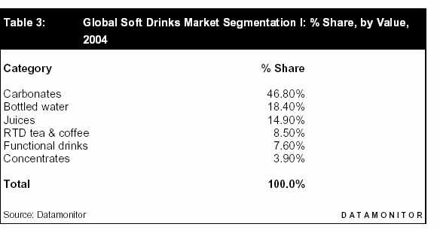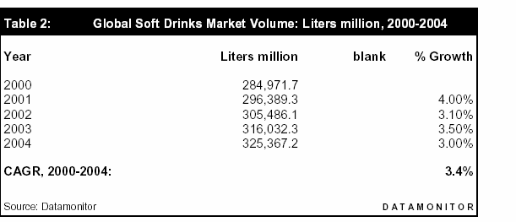

**Appendix**

**Table 1:** Datamonitor (2005, May). *Global Soft Drinks: Industry Profile*.

Reference Code: 0199-0802.

New York.

**Table 2:** Datamonitor (2005, May). *Global Soft Drinks: Industry Profile*.

Reference Code: 0199-0802.

New York.

13

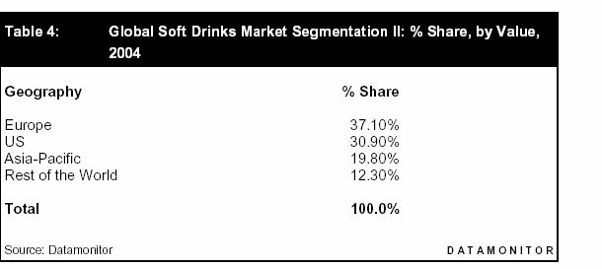

**Table 3:** Datamonitor (2005, May). *Global Soft Drinks: Industry Profile*. New York.

Reference Code: 0199-0802.

**Table: 4** Murray, Barbara. (2006a). The Coca-Cola Company. Hoovers. Retrieved February 13, 2006, from <http://premium.hoovers.com/subscribe/co/factsheet.x> html?ID=10359

**%**

**of total**

33

30

21

10

5

1

100

**Coca-Cola 2004 Sales**

**$ mil.**

**Europe/Eurasia/Middle East North America**

**Asia**

**Latin America Africa Corporate Total**

7,195

6,643

4,691

2,123

1,067

243

21,962

**Table 5:** Murray, Barbara. (2006b).

Pepsi Co. Hoovers. Retrieved February 13, 2006,

From <http://premium.hoovers.com/subscribe/co/profile.xhtml?ID=11166>

**%**

**of total**

63

9

6

4

18

100

**Pepsi Co. 2004 Sales**

**$ mil.**

**US**

**Mexico UK**

**Canada**

**Other countries Total**

18,329

2,724

1,692

1,309

5,207

29,261

14

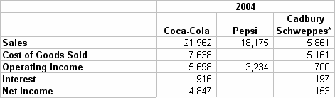

**Table 6:** Murray, Barbara. (2006b). Pepsi Co. Hoovers. Retrieved February 13, 2006, From <http://premium.hoovers.com/subscribe/co/profile.xhtml?ID=11166>

**%**

**$ mil. of total**

**Pepsi Co. 2004 Sales**

**PepsiCo International Frito-Lay North America**

**PepsiCo Beverages North America Quaker Foods North America Total**

9,862

9,560

8,313

1,526

29,261

34

33

28

5

100

**Table 7:** Murray, Barbara. (2006d).

Cadbury Schweepes Inc. Hoovers. Retrieved

February 13, 2006, from <http://premium.hoovers.com/subscribe/co/profile.x> html?ID=41767

**% of total**

33

25

16

16

10

100

**Cadbury Schweppes 2004 Sales**

**Americas Beverages**

**Europe, Middle East, Africa Americas Confectionery Asia/Pacific**

**Europe Beverages Total**

**Table 8:** Walker, Tim (2006). Cott Corporation. Hoovers.

Retrieved February 13, 2006,

from

<http://premium.hoovers.com/subscribe/co/profile.xhtml?ID=42846>

**%**

**of total**

74

12

11

3

100

**Cott Corporation 2004 Sales**

**$ mil.**

**US**

**Canada**

**UK & Europe International Total**

1,221.8

189.5

186.9

48.1

1,646.3

**Table 9:**

Select Financial Data from 2004 Income Statements. (in millions)

*2004 Annual Reports*.

*only 50% of total sales included, the part attributed to beverage sales

15

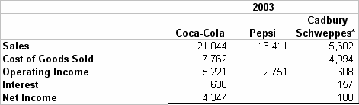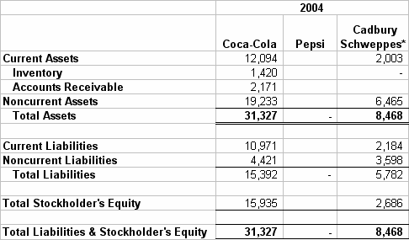

**Table 10:** Select Financial Data from 2003 Income Statements. *2004 Annual Reports.*

(in millions)

*only 50% of total sales included, the part attributed to beverage sales

**Table 11:** Select Financial Data from 2004 Balance Sheets. *2004 Annual Reports.*

(in millions)

*only 50% of total sales included, the part attributed to beverage sales

16

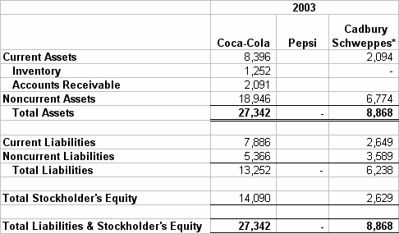

**Table 12:** Select Financial Data from 2003 Balance Sheets. *2004 Annual Reports.*

(in millions)

*only 50% of total sales included, the part attributed to beverage sales

17

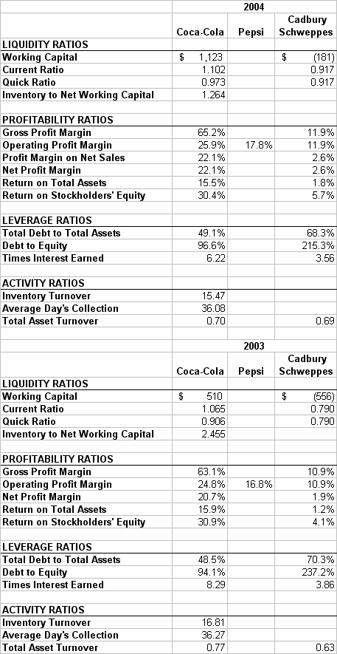

**Table 13:**

Financial Analysis.

*Annual Reports.*

18

Strategic Group Map goes here!

19

**List 1:** Brand Keys' Customer Loyalty Leaders survey (2004) *Brandweek.com*

**Brand Loyalty Rankings**

**This year/Brand/Last Year**

1. Google.com (2)
2. Avis (1)
3. Verizon Long Distance (4)
4. KeySpan Energy (9)
5. Samsung Mobile Phone (7)
6. Hyatt Hotels (19)
7. Sprint Long Distance (3)
8. Canon Office Copier (8)
9. Yahoo.com (14)
10. Miller Genuine Draft (5)
11. Ritz-Carlton Hotels (17)

12. PSE&G (15)

1. Amazon.com (12)
2. Marriott Hotels (13)
3. Swissotel (NR)
4. Discover Card (27) 17. Diet Pepsi (31)
5. Budweiser (16)
6. Motorola Mobile Phone (10)
7. Coors (NR)
8. Netscape.com (59)
9. Sony Ericsson Mobile Phone (93)
10. Capital One Credit Card (29)
11. L. L. Bean Catalogue (20)
12. Wal-Mart (33)
13. Skechers (NR)
14. New Balance Athletic Shoe (22)
15. Miller Lite (87)
16. Starbucks (6)
17. Radisson (48)
18. BP Gasoline (79)
19. Inter-Continental Hotels (NR)
20. Sears Catalogue (30)
21. Verizon Wireless (37)
22. Schwab.com (26) 36. Diet Coke (47)
23. Mobil Gasoline (25)
24. T-Mobile Wireless (76)
25. Bell South Long Distance (28)
26. Adidas Athletic Shoe (23)
27. ETrade.com (42)
28. J. Crew Catalogue (54)
29. FedEx (50)
30. Westin Hotels (73)
31. Excite.com (35)
32. Hilton Hotels (36)
33. HotBot.com (34)
34. Sanyo Mobile Phone (NR)
35. MSN.com (38)
36. AltaVista.com (51)

20

1. AT&T Long Distance (24)
2. Spring PCS Wireless (60) 53. Pepsi (61)
3. Target (62)
4. Jet Blue Airways (67)
5. Bud Light (32)
6. Sears Store (40)
7. Sheraton Hotels (46)
8. Land's End Catalogue (55)
9. Hampton Inn Hotels (NR)
10. Nokia Mobile Phone (11)
11. MCI Long Distance (83)
12. Holiday Inn Hotels (NR)
13. Ameritrade.com (104)
14. Best Western Hotels (NR)
15. Lycos.com (39)
16. Wyndham Hotels (68)
17. Xerox Office Copier (82)
18. Today (NBC) (56)

70. NFL (70)

71. MLB (58)

1. AOL.com (88)
2. Fox & Friends (Fox News Channel) (NR)
3. Southwest Airlines (64)
4. Exxon Gasoline (43)
5. DHL/Airborne Express (45)
6. BarnesandNoble.com (152)
7. AskJeeves.com (113)
8. Embassy Suites (86)
9. Nextel Mobile Phone (148)
10. SBC Long Distance (21)
11. TDWaterhouse.com (49)
12. Apple Computers (66)
13. Budget Rent A Car (71)
14. Subway (91)
15. Coors Light (81)
16. Texaco Gasoline (18)
17. Poland Spring (NR)
18. Chevron Gasoline (44)
19. J.C. Penney (75)
20. Expedia.com (85)
21. Fidelity.com (65)
22. Qwest Long Distance (41)
23. Visa Card (100) 95. UPS (127)
24. Aquafina (NR)
25. Gateway Computers (53)
26. Hertz (84)
27. Amstel Light (97)
28. Amoco Gasoline (101)
29. Nike (94)
30. Ramada Hotels (NR)
31. T. Rowe Price Mutual Fund (74)
32. Cingular Wireless (107)
33. Con Edison (57)
34. Enterprise Rent-A-Car (90)

21

1. Nextel Wireless (134)
2. Delta Air Lines (72)
3. American Morning (CNN) (63)
4. Arrowhead (NR)
5. Dell Computers (69)
6. Fleet Bank (157)

113. NBA (98)

1. New York Life Insurance (139)
2. Pizza Hut (105)
3. National Discount Brokers (102)
4. MerrillLynch.com (95)
5. NEC (NR)
6. Panasonic Mobile Phone (124)
7. Fidelity (96)
8. Dasani (NR)
9. Papa John's (118)
10. CDNow.com (153)
11. Datek.com (77)
12. Siemens Mobile Phone (52)
13. IBM Computers (110)
14. Best Buy (154)
15. Reebok Fitness Shoes (103)
16. Sunoco Gasoline (121)
17. Wendy's (115)
18. Wachovia Bank (89)
19. Good Morning America (ABC) (120)
20. Buy.com (142)
21. Corona (132)
22. CheapTickets.com (NR)
23. HP Computers (92)
24. PNC Bank (NR)
25. Shell Gasoline (119)
26. Dunkin' Donuts (109) 140. Coca-Cola (129)
27. Citibank (112)
28. Early Show (CBS) (151)
29. AT&T Wireless (99)
30. Travelocity.com (138)
31. Bank of New York (158)
32. Bank of America (NR)
33. Continental Airlines (114)
34. CSFB.com (125)
35. Toshiba Computers (NR)
36. JP Morgan Chase Bank (106)
37. Krispy Kreme Doughnuts (117)
38. American Express Credit Card (135)
39. Deer Park (NR)
40. Sony Vaio (111)
41. Fodors.com (128)
42. Domino's Pizza (122)
43. Compaq Computers (80)

158. KFC (116)

1. Little Caesars (140)
2. Putnam (126)
3. Burger King (136)
4. Vanguard Mutual Fund (78)

22

1. United Air Lines (137)
2. Evian (NR)
3. Heineken (155)
4. Minolta Office Copier (159)
5. Travelers Insurance (144)
6. McDonald's (141)
7. National Car Rental (145)
8. Sharp Office Copier (169)
9. Hotels.com (147)
10. Janus Mutual Fund (123)
11. Ricoh Office Copier (164)
12. Godfather's (130)
13. Roundtable Pizza (131)
14. MetLife Insurance (162)
15. First USA (NR)

178. Fila (172)

179. Arby's (161)

1. American Airlines (143)
2. USPS Parcel Delivery (156)
3. Prudential Insurance (163)
4. Dollar Rent A Car (167)
5. Bank One (NR)
6. Hardee's (165)
7. Mountain Dew (168)
8. PriceLine.com (160)
9. Chuck E. Cheese Pizza (146)
10. MasterCard (150)
11. US Airways (166)
12. Aetna Insurance (174) 192. 7 Up (170)
13. Dr Pepper (176)
14. Alamo Rent-a-Car (178)
15. Jack in the Box Restaurant (171)
16. Taco Bell (173)
17. The Hartford Insurance (175)

198. Beck's (179)

199. White Castle (177)

200. NHL (180) 201. Diet 7 Up (108)

202. Kmart (182)

203. Diet Dr Pepper (133)

23

**Works Cited**

American Beverage Association (2005). *Soft Drink Facts*. Retrieved February 21, 2006 from

<http://www.ameribev.org/variety/facts.asp>

Cadbury Schweppes. (2004). *2004 Annual Report.* Retrieved February 17, 2006 from

[http://www.cadburyschweppes.com](http://www.cadburyschweppes.com/)

Datamonitor. (2005, May). *Global Soft Drinks: Industry Profile*. New York. Reference Code:

0199-0802.

Hein, Kenneth. (2004). *Brand Loyalty 2004.* Retrieved February 12, 2006 from

<http://www.brandkeys.com/news/press/102504Brandweek.Loyalty.pdf>

Murray, Barbara. (2006a). The Coca-Cola Company. Hoovers. Retrieved February 13, 2006,

from <http://premium.hoovers.com/subscribe/co/factsheet.xhtml?ID=10359>

Murray, Barbara. (2006b). Pepsi Co. Hoovers. Retrieved February 13, 2006, from

<http://premium.hoovers.com/subscribe/co/profile.xhtml?ID=11166>

Murray, Barbara. (2006c). Carbonated Beverages. Hoovers. Retrieved February 13, 2006, from

<http://premium.hoovers.com/subscribe/ind/overview.xhtml?HICID=1049>

Murray, Barbara. (2006d). Cadbury Schweppes Inc. Hoovers. Retrieved February 13, 2006,

from <http://premium.hoovers.com/subscribe/co/profile.x>html?ID=41767

Murray, Barbara. (2006e). Comparison Data. Hoovers. Retrieved February 13, 2006, from

<http://premium.hoovers.com/subscribe/co/fin/comparison.xhtml?ID=10359>

PepsiCo Inc. (2004). *2004 Annual Report.* Retrieved February 17, 2006 from

[http://www.pepsico.com](http://www.pepsico.com/)

Sicher, J. D. (2005). *Beverage Digest/Maxwell ranks U.S. soft drink industry for 2004.* Retrieved

February 10, 2006 from <http://www.beverage-digest.com/pdf/top-10_2005.pdf>

24

The Coca-Cola Company. (2004). *2004 Annual Report.* Retrieved February 17, 2006 from

[http://www.cocacola.com](http://www.cocacola.com/)

Walker, Tim. (2006). Cott Corporation. Hoovers. Retrieved February 13, 2006, from

<http://premium.hoovers.com/subscribe/co/profile.xhtml?ID=42846>

25