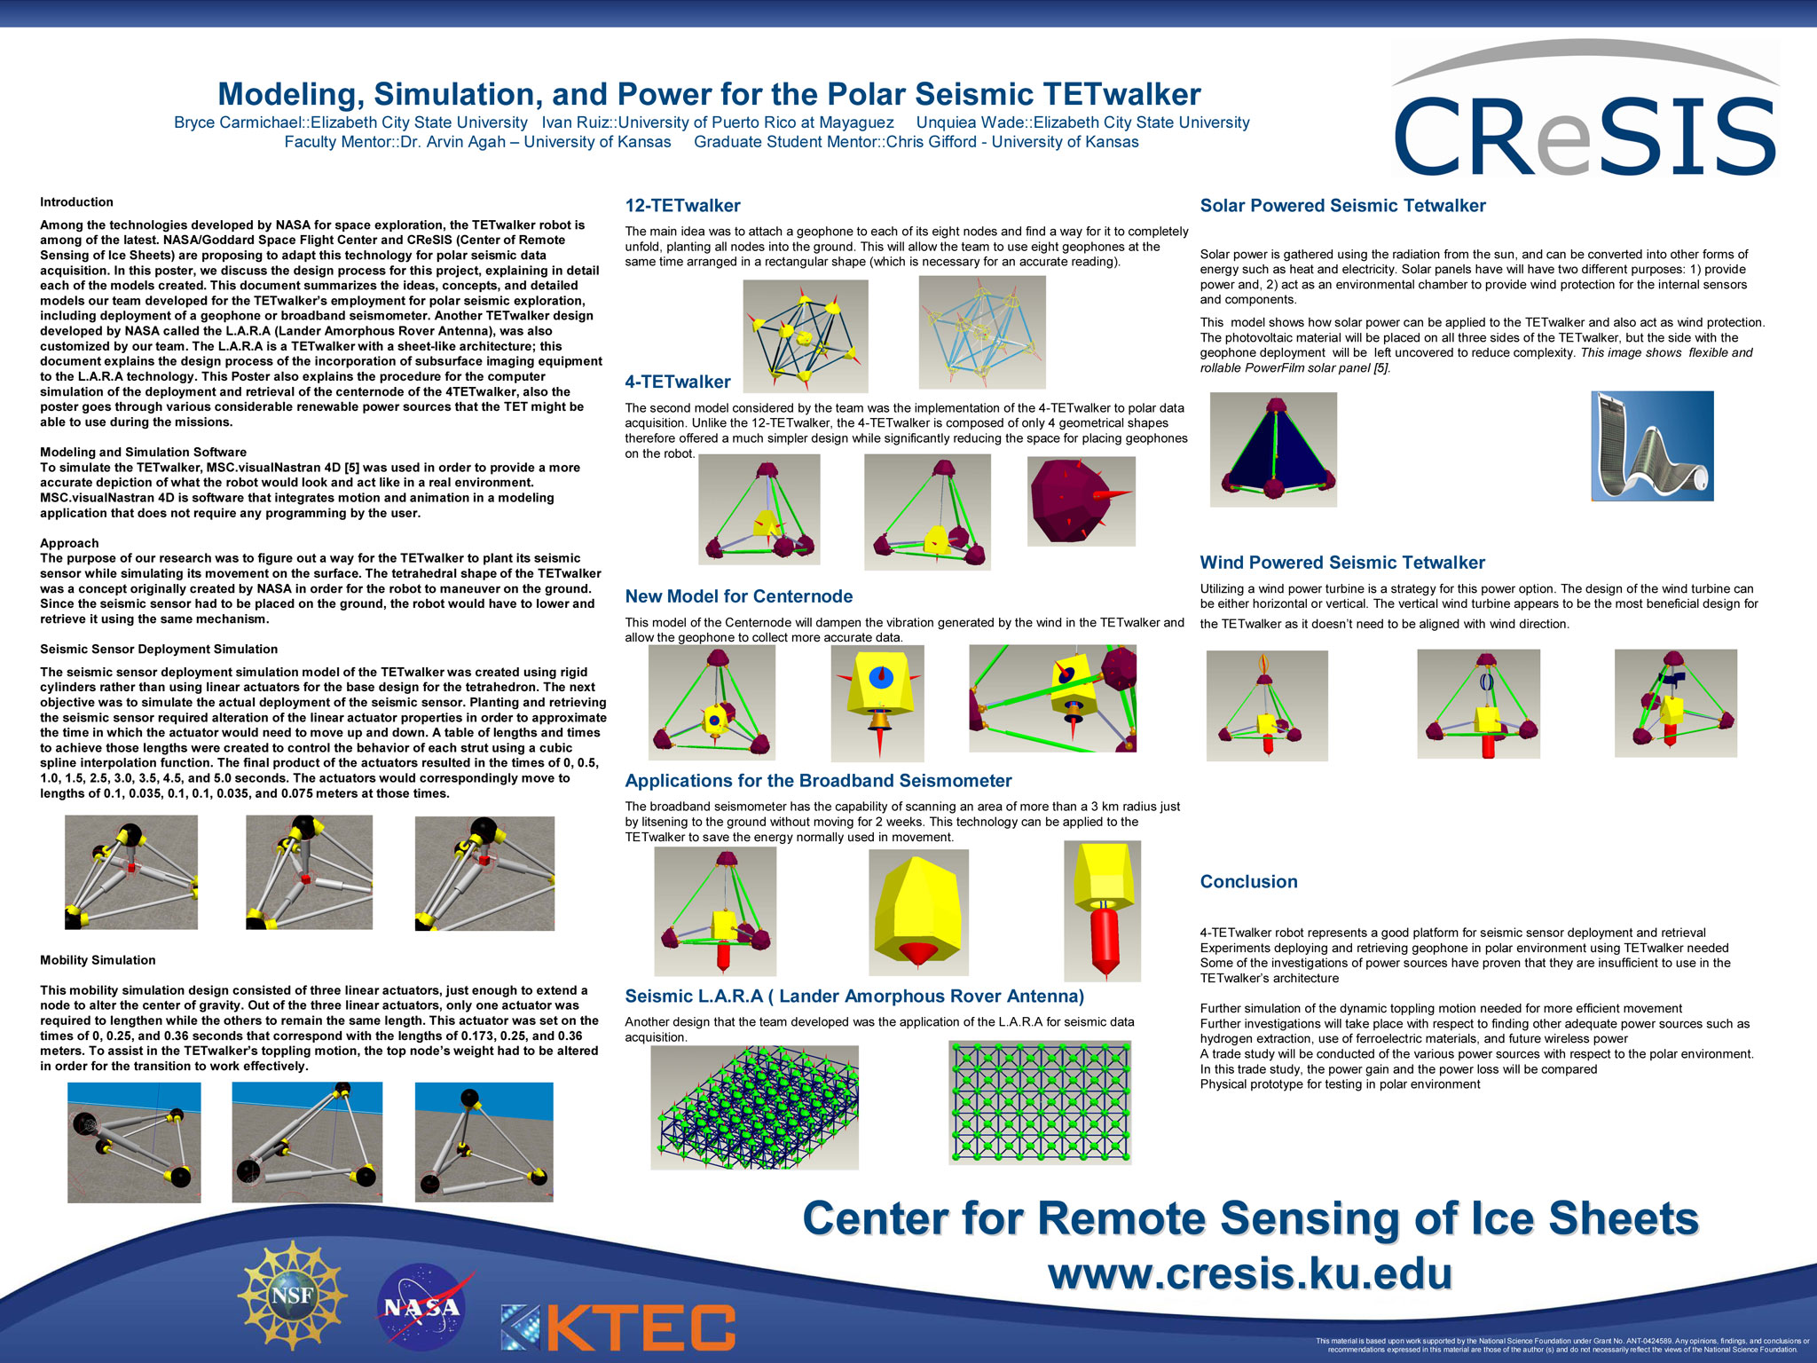

**TET walker**

**Conclusion**

***Research Poster***

Modelling, Simulation, and Power for the Polar Seismic TET walker

Bryce Carmichael::Elizabeth City State University Ivan Ruiz::University of Puerto Rico at Mayaguez Unquiet Wade::Elizabeth City State University

Faculty Mentor Dr. Arvin Agar - University of Kansas Graduate Student Mentor::Chris Gifford - University of Kansas

Cresis

Add your text here to describe the things. Add your text here to describe the things. Add your text here to describe the things. Add your text here to describe the things. Add your text here to describe the things. Add your text here to describe the things. Add your text here to describe the things. Add your text here to describe the things. Add your text here to describe the things. Add your text here to describe the things. Add your text here to describe the things. Add your text here to describe the things. Add your text here to describe the things. Add your text here to describe the things. Add your text here to describe the things. Add your text here to describe the things. Add your text here to describe the things. Add your text here to describe the things. Add your text here to describe the things. Add your text here to describe the things. Add your text here to describe the things. Add your text here to describe the things. Add your text here to describe the things. Add your text here to describe the things. Add your text here to describe the things. Add your text here to describe the things. Add your text here to describe the things. Add your text here to describe the things. Add your text here to describe the things. Add your text here to describe the things. Add your text here to describe the things. Add your text here to describe the things. Add your text here to describe the things. Add your text here to describe the things. Add your text here to describe the things. Add your text here to describe the things. Add your text here to describe the things. Add your text here to describe the things. Add your text here to describe the things. Add your text here to describe the things. Add your text here to describe the things. Add your text here to describe the things.

Add your text here to describe the things. Add your text here to describe the things. Add your text here to describe the things. Add your text here to describe the things. Add your text here to describe the things. Add your text here to describe the things. Add your text here to describe the things. Add your text here to describe the things. Add your text here to describe the things. Add your text here to describe the things. Add your text here to describe the things. Add your text here to describe the things. Add your text here to describe the things. Add your text here to describe the things.

Add your text here to describe the things. Add your text here to describe the things. Add your text here to describe the things. Add your text here to describe the things. Add your text here to describe the things. Add your text here to describe the things. Add your text here to describe the things. Add your text here to describe the things. Add your text here to describe the things. Add your text here to describe the things. Add your text here to describe the things. Add your text here to describe the things. Add your text here to describe the things. Add your text here to describe the things. Add your text here to describe the things. Add your text here to describe the things. Add your text here to describe the things. Add your text here to describe the things. Add your text here to describe the things. Add your text here to describe the things. Add your text here to describe the things. Add your text here to describe the things. Add your text here to describe the things. Add your text here to describe the things. Add your text here to describe the things. Add your text here to describe the things. Add your text here to describe the things. Add your text here to describe the things. Add your text here to describe the things. Add your text here to describe the things. Add your text here to describe the things. Add your text here to describe the things. Add your text here to describe the things. Add your text here to describe the things. Add your text here to describe the things. Add your text here to describe the things. Add your text here to describe the things. Add your text here to describe the things. Add your text here to describe the things. Add your text here to describe the things. Add your text here to describe the things. Add your text here to describe the things. Add your text here to describe the things. Add your text here to describe the things. Add your text here to describe the things.

Add your text here to describe the things. Add your text here to describe the things. Add your text here to describe the things. Add your text here to describe the things. Add your text here to describe the things. Add your text here to describe the things. Add your text here to describe the things. Add your text here to describe the things. Add your text here to describe the things. Add your text here to describe the things. Add your text here to describe the things. Add your text here to describe the things. Add your text here to describe the things. Add your text here to describe the things. Add your text here to describe the things. Add your text here to describe the things. Add your text here to describe the things. Add your text here to describe the things. Add your text here to describe the things. Add your text here to describe the things. Add your text here to describe the things. Add your text here to describe the things. Add your text here to describe the things. Add your text here to describe the things. Add your text here to describe the things. Add your text here to describe the things. Add your text here to describe the things. Add your text here to describe the things. Add your text here to describe the things. Add your text here to describe the things. Add your text here to describe the things. Add your text here to describe the things. Add your text here to describe the things. Add your text here to describe the things.

Add your text here to describe the things. Add your text here to describe the things. Add your text here to describe the things. Add your text here to describe the things. Add your text here to describe the things. Add your text here to describe the things. Add your text here to describe the things. Add your text here to describe the things. Add your text here to describe the things. Add your text here to describe the things. Add your text here to describe the things. Add your text here to describe the things. Add your text here to describe the things. Add your text here to describe the things. Add your text here to describe the things. Add your text here to describe the things. Add your text here to describe the things. Add your text here to describe the things. Add your text here to describe the things. Add your text here to describe the things. Add your text here to describe the things. Add your text here to describe the things. Add your text here to describe the things. Add your text here to describe the things. Add your text here to describe the things. Add your text here to describe the things. Add your text here to describe the things. Add your text here to describe the things. Add your text here to describe the things. Add your text here to describe the things. Add your text here to describe the things. Add your text here to describe the things. Add your text here to describe the things. Add your text here to describe the things. Add your text here to describe the things. Add your text here to describe the things. Add your text here to describe the things. Add your text here to describe the things. Add your text here to describe the things. Add your text here to describe the things. Add your text here to describe the things. Add your text here to describe the things. Add your text here to describe the things. Add your text here to describe the things. Add your text here to describe the things.

Add your text here to describe the things. Add your text here to describe the things. Add your text here to describe the things. Add your text here to describe the things. Add your text here to describe the things. Add your text here to describe the things. Add your text here to describe the things. Add your text here to describe the things. Add your text here to describe the things. Add your text here to describe the things. Add your text here to describe the things. Add your text here to describe the things. Add your text here to describe the things. Add your text here to describe the things. Add your text here to describe the things. Add your text here to describe the things. Add your text here to describe the things. Add your text here to describe the things. Add your text here to describe the things. Add your text here to describe the things. Add your text here to describe the things. Add your text here to describe the things. Add your text here to describe the things. Add your text here to describe the things. Add your text here to describe the things. Add your text here to describe the things. Add your text here to describe the things. Add your text here to describe the things. Add your text here to describe the things. Add your text here to describe the things. Add your text here to describe the things. Add your text here to describe the things. Add your text here to describe the things. Add your text here to describe the things. Add your text here to describe the things. Add your text here to describe the things. Add your text here to describe the things. Add your text here to describe the things. Add your text here to describe the things. Add your text here to describe the things. Add your text here to describe the things. Add your text here to describe the things. Add your text here to describe the things. Add your text here to describe the things. Add your text here to describe the things.

Add your text here to describe the things. Add your text here to describe the things. Add your text here to describe the things. Add your text here to describe the things. Add your text here to describe the things. Add your text here to describe the things. Add your text here to describe the things. Add your text here to describe the things. Add your text here to describe the things. Add your text here to describe the things. Add your text here to describe the things. Add your text here to describe the things. Add your text here to describe the things. Add your text here to describe the things. Add your text here to describe the things. Add your text here to describe the things. Add your text here to describe the things. Add your text here to describe the things. Add your text here to describe the things. Add your text here to describe the things. Add your text here to describe the things. Add your text here to describe the things. Add your text here to describe the things. Add your text here to describe the things. Add your text here to describe the things. Add your text here to describe the things.

Add your text here to describe the things. Add your text here to describe the things. Add your text here to describe the things. Add your text here to describe the things. Add your text here to describe the things. Add your text here to describe the things. Add your text here to describe the things. Add your text here to describe the things. Add your text here to describe the things. Add your text here to describe the things. Add your text here to describe the things. Add your text here to describe the things. Add your text here to describe the things. Add your text here to describe the things. Add your text here to describe the things. Add your text here to describe the things. Add your text here to describe the things. Add your text here to describe the things. Add your text here to describe the things. Add your text here to describe the things. Add your text here to describe the things. Add your text here to describe the things. Add your text here to describe the things. Add your text here to describe the things. Add your text here to describe the things. Add your text here to describe the things. Add your text here to describe the things. Add your text here to describe the things. Add your text here to describe the things. Add your text here to describe the things. Add your text here to describe the things. Add your text here to describe the things. Add your text here to describe the things. Add your text here to describe the things. Add your text here to describe the things. Add your text here to describe the things. Add your text here to describe the things. Add your text here to describe the things. Add your text here to describe the things. Add your text here to describe the things. Add your text here to describe the things. Add your text here to describe the things. Add your text here to describe the things. Add your text here to describe the things. Add your text here to describe the things. Add your text here to describe the things. Add your text here to describe the things. Add your text here to describe the things. Add your text here to describe the things. Add your text here to describe the things. Add your text here to describe the things. Add your text here to describe the things. Add your text here to describe the things. Add your text here to describe the things. Add your text here to describe the things. Add your text here to describe the things. Add your text here to describe the things. Add your text here to describe the things. Add your text here to describe the things. Add your text here to describe the things. Add your text here to describe the things. Add your text here to describe the things. Add your text here to describe the things. Add your text here to describe the things. Add your text here to describe the things. Add your text here to describe the things. Add your text here to describe the things. Add your text here to describe the things. Add your text here to describe the things. Add your text here to describe the things. Add your text here to describe the things. Add your text here to describe the things. Add your text here to describe the things. Add your text here to describe the things. Add your text here to describe the things. Add your text here to describe the things. Add your text here to describe the things. Add your text here to describe the things. Add your text here to describe the things. Add your text here to describe the things. Add your text here to describe the things. Add your text here to describe the things. Add your text here to describe the things. Add your text here to describe the things.

Add your text here to describe the things. Add your text here to describe the things. Add your text here to describe the things. Add your text here to describe the things.

**Introduction**