THE STEP I WILL TAKE TODAY IS...

- I wish to speak to a staff member about a personal issue (include contact information on reverse side).

MY DECISION

Today, for the first time, I place my trust in Christ for salvation.
- I choose to recommit my life to Christ.
- I would like to talk to someone about:
  - becoming a Christian  being baptized

PRAYER REQUESTS & PRAISES
- Check here if confidential

or submit online at centralsf.org/prayer

CONNECT

I would like to join an Adult LifeGroup.
- I may be interested in volunteering in the areas I have checked below:
Children’s Ministries Student Ministries College/Young Adult Prayer Ministries Central Downtown

Worship Ministries Tech Ministries

First Impressions Team (circle area of interest)

Usher, Welcome Center, Valet Parking, Central Perk Café, Greeter, Hospitality
Care Ministries (circle area of interest) Homebound/Hospital Visitation, Communion

Facilities (circle area of interest)

Mowing, Painting, Carpentry, Set-up, General
SATURDAY, JUNE 29 - SUNDAY, JUNE 30 , 2019

Welcome to Central Church
Lead Pastor: Jeff Wheeler Saturday Worship Leader: Zach Saltmarsh
Sunday Worship Leader: Allison DeJong & Zach Saltmarsh

WORSHIP SET LIST
LION AND THE LAMB, WE BELIEVE, BUILD MY LIFE HOLY, HOLY, HOLY (SAVIOR KING)
The End
Part 4: The Church Age-Revelation 2 Jesus those He !

The structure for each of these seven letters is very similar:
- of letter (7 churches)
- of Jesus (7 churches)
- of behavior (6/7 churches) “I know your…”
- of behavior (5/7 churches)
- to repent (5/7 churches)
- of judgment (5/7 churches)
- to obey the Spirit (7 churches) “He who has ears to hear…”
- of blessing (7 churches) “He who…I will…”

As we read each of these letters we must ask:
Am I this kind of ? Are we this kind of ?

- Ephesus: the church. (Rev. 2:1-7)

- Smyrna: the church. (Rev. 2:8-11)

- Pergamum: the church. (Rev. 2:12-17)

FAMILY WORSHIP NEXT WEEKEND
Next weekend is a Family Worship Weekend, meaning kids in kindergarten through 4th grade will join their families in the Worship Center during services. Kid Central will still offer programming for kids age 5 and under.

STILL NEEDED: EAGLE LAKE HOST HOMES
Our Eagle Lake Day Camps are led by college students with a heart for impacting kids for Christ. Those college kids need host homes, so if you’re interested in hosting 2-4 students July 8-12, email Tara Camp at tara.camp@ centralsf.org for more details.

COLLEGE AND YOUNG ADULT COMBINED WORSHIP NIGHT
We normally separate our College and Young Adult ministries but this summer we’re combining for worship nights every other Monday. Our next meeting
is July 1 at 7:00pm in the Hearth Room. Free snacks, free worship, and free hanging out with awesome people. What more do you need?

CONQUER SERIES FOR MEN STARTS THIS WEEK
It’s not always an easy topic to discuss, but we started the Conquer Series at Central to help men gain freedom from pornography and other sexual sin.
This course has been offered multiple times and each group has had incredible discussions and opportunities for healing. The group meets each week for 10 weeks starting July 1 from 6:30 to 8:30pm. Visit centralsf.org/conquer for the full details.

VOLUNTEER APPRECIATION PICNIC
Central will host a Volunteer Appreciation Picnic on Sunday, July 28th at 5:00pm. This will be an awesome night of food, games, inflatables, and entertainment for all ages. If you’ve volunteered in any capacity at Central in the past year, you should be receiving an email from the leader of your volunteer area with an RSVP link and the full details. We can’t wait to have a blast with you on July 28th!

NEXT STEP LUNCH – JULY 14
If you want to learn about connecting at Central AND enjoy a free lunch while

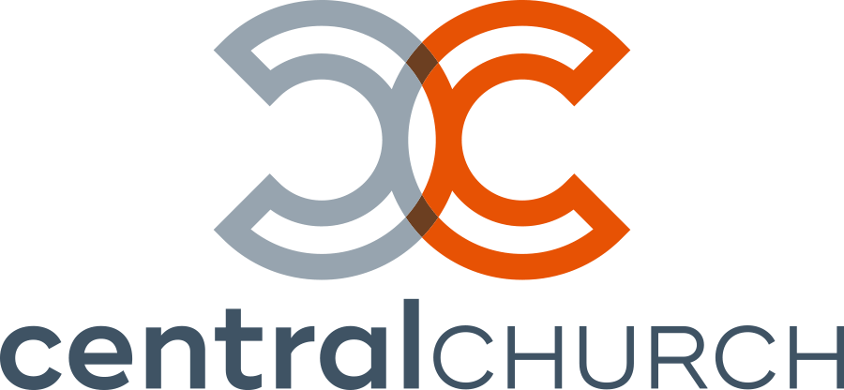

C OMMUNICATION CARD
Saturday, June 29 - Sunday, June 30, 2019

- First-time guest  Returning guest
- Regular attendee
- Update my contact information
- Sign me up for Central email updates

NAME(S)

HIS EMAIL HER EMAIL HOME ADDRESS

you do it, join us from 12:15pm to 1:30pm on Sunday, July 14 for our Next Step Lunch in the Hearth Room. Childcare will be provided. Please register by noon
on Saturday, July 13 by visiting centralsf.org/connect.
APT.

STUDENT CENTRAL SUMMER ACTIVITIES
Student Central will kick off summer activities starting Wednesday, July 17. Join us for a night of fun, teaching, and all the other stuff you love about Student Central. Middle School meets 6:30-7:45pm and High School meets 8:00- 9:15pm. Students: Invite your friends and we’ll see you on the 17th!
CITY STATE ZIP CODE HOME PHONE

HIS CELL

HER CELL

MY AGE GROUP:
❑ 13-17  College  18-24  25-29
❑ 30-39  40-49  50-59  60+

Want to know about everything happening at Central?
NAME AND GRADE/AGE OF CHILDREN AT HOME:

Visit centralsf.org/info.

-------------------- A T T E N D A N C E & S T E W A R D S H I P --------------------
Weekend Info | June 22-23, 2019 Ministry & Missions
WEEKLY INCOME GOAL | $81,927
ACTUAL INCOME | $60,602
YTD BUDGET INCOME | $3,850,582
YTD ACTUAL INCOME | $4,257,731
YTD INCOME VS EXPENSE 5/31/19 | $1,060,925

All Campus Attendance 1,839 All Campus Kids’ Attendance 340
Total Attendance 2,179
---------------- To give online, visit centralsf.org/giving. ----------------

