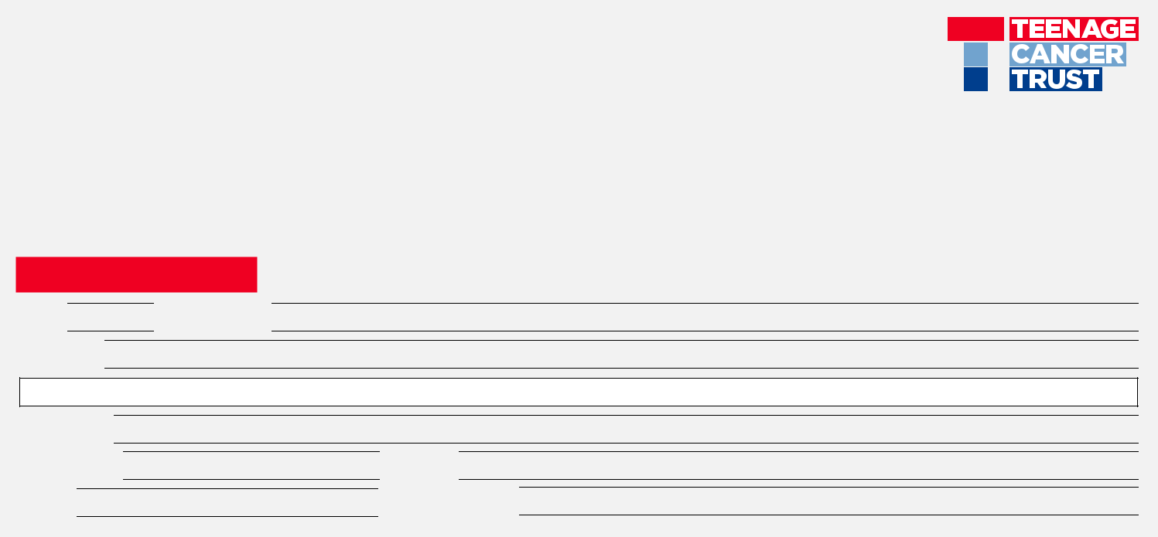
VOLUNTEERING APPLICATION FORM

If you are aged under 18 please fill in this version of the form and ask a parent or guardian to sign it, and email to: volunteers@teenagecancertrust.org
or post to: Teenage Cancer Trust, Third floor, 93 Newman Street, London, W1T 3EZ

ABOUT YOU

Title  Full Name Address

Postcode

Telephone  Mobile

Email Date of Birth
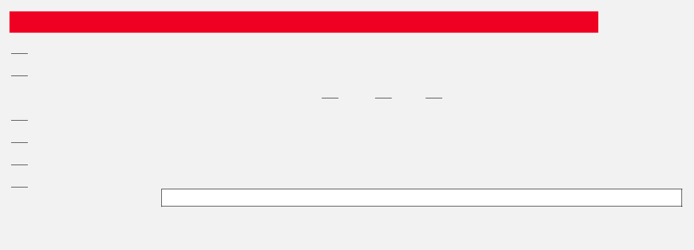

WHY HAVE YOU DECIDED TO VOLUNTEER FOR US?

Please tick any that apply

 I’ve been inspired by a young person with cancer

I have/had cancer

Are/were you supported by Teenage Cancer Trust?  Yes No Prefer not say I have been affected by cancer

I wanted to join friends and family who are also volunteering

I think it’s a good cause

Other, please specify:

We will keep a confidential record of your answer if you choose to tell us about your experience of cancer. We will take great care to safeguard this information, and process it according to the 1998 Data Protection Act.


I’M INTERESTED IN THESE KIND OF VOLUNTEERING OPPORTUNITIES:

General fundraising and occasional volunteering |  | Helping with music events
Giving talks on behalf of the charity |  | Helping in our London office
Helping us to advertise events locally |  | Volunteering through my workplace
Helping with sports events |  | Supporting services for young people
Volunteering from home (research/administration) |  | Other, please specify:


PLEASE TELL US WHAT WILL MAKE YOU A BRILLIANT VOLUNTEER FOR US

Don’t forget to include any specific skills and let us know about any volunteering experience you might have


EMERGENCY CONTACT

We’ll only ever contact this person in the unlikely event of an emergency occurring during your volunteering.

Emergency contact name

Emergency contact relationship

Emergency contact telephone

I have read and agree to the volunteering and website terms and conditions. I confirm that I am eligible to volunteer in the UK

Signed |  | Name |  | Date
 |  | Name |  | Date
Signed |  | Name |  | Date
Parent/Guardian
if under 18


PLEASE LET US KNOW WHAT PROMPTED YOU TO REGISTER WITH US TODAY:

Website |  | I heard about you in my local community
Teenage Cancer Trust E-Newsletter |  | I saw you at challenge or fundraising event
Social Media |  | Teenage Cancer Trust Education Talk
Word of Mouth |  | Teenage Cancer Trust music event
Through my employer |  | Through my college or university
Teenage Cancer Trust Unit |  | Other, please specify:


Thank you for providing your contact details for communications about volunteering. Teenage Cancer Trust would also like to keep you informed about our work and other ways you can support young people with cancer. We will only communicate with you if you tell us you are happy to hear from us. If you ever want to change the way we keep in touch, just let us know by emailing hello@teenagecancertrust.org or calling our Supporter Care team on 0207 612 0370.

I AM HAPPY TO HEAR FROM TEENAGE CANCER TRUST BY:

Email

Post

SMS

Telephone

We know that your information and data needs to be kept safe, and we never ever give or sell any data or information to other charities or companies. We are thrilled that you support our work, and we believe that looking after your information is one of the ways we can show our appreciation of what you are doing for young people with cancer. If you ever want to change the way we keep in touch, just let us know.

Please email this form to volunteers@teenagecancertrust.org

THANK YOU FOR YOUR APPLICATION

Teenage Cancer Trust is a registered charity: 1062559 (England & Wales), SC039757 (Scotland)

