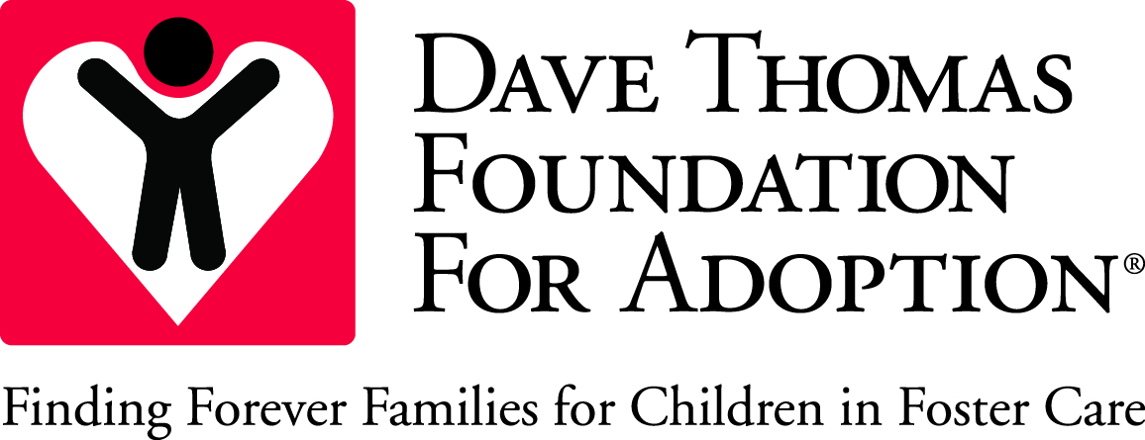

Initial Recruitment Plan

Date:

Child(ren)’s name(s):

Team members
Title | Name | Role in recruitment
Supervisor
Caseworker
Mental Health Provider
CASA / GAL
Caregiver

Have current caregivers been ruled out as an adoptive placement? Yes No
Please explain:

Potential contacts from file review
Name | Relationship | Date of contact | Result

Initial recruitment plan
 | Date completed | Notes/Outcome
Meet with caseworker
First visit with child

Meet with mental health provider
Review file

Meet with caregiver

Contact GAL

Contact friends

Contact CASA/GAL

Complete assessment

Update photo

Create child profile

Contact faith-based connection
Contact school personnel
Meet with recruitment team
Create video bio

Contact mentor

Contact other adoption agencies
Other

Comments

Child-focused planning
How will specific information about the youth be included in the recruitment plan (i.e. his/her strengths, challenges, interests, special needs, medications, school functioning, etc.)?

Child-focused recruitment activities
Activity/idea | Date started | Date completed | Outcome

Caseworker: ____________________________________________ Date: ______________________________

Recruiter’s signature: _____________________________________ Date: _____________________________

QUARTERLY RECRUITMENT PLAN UPDATE

Date: _______________

You may complete the recruitment plan update in narrative format or update the Initial Recruitment Plan.

