Concept Maps

Description

Concept maps are spider web-like diagrams used to organize information about a concept or topic in an hierarchical manner. The concept or topic is written in the center or top of the map and related words or phrases are written on rays extending from the topic. Concept maps also go by the name of clusters and webs.
Purpose

Concept maps are used to organize information either during or after learning has occurred. They are often used to visually depict connections in a unit of study or across curriculum. In writing, concept maps are often used to organize ideas before beginning to write. In a unit of study that extends for a long duration of time, concept maps can be used for note-taking as the connections unfold. For this situation, the teacher may want to provide the map as a graphic organizer and students complete the information as it is learned.

Connection to Inquiry and Standards:

Students process what is learned during and after a unit of study and select important components of the concept or topic to visually represent in the form of a map. Students record their observations and ideas and place them in an appropriate order. Concept maps help students to make sense of phenomena that they encounter during both firsthand experiences and through reading, and place the information in hierarchical order. Pennsylvania Standards for Reading/Writing/Speaking/Listening connections include 1.1 Learning to Read Independently and 1.3 Reading, Analyzing and Interpreting Literature (comprehension and interpretation), 1.5 Quality of Writing (organization), and 1.8 Research (organization).

Materials
Paper or a planned concept map for students to complete and use as a graphic organizer.
Procedure

Write the name of the topic or concept in the center or top circle/box on a sheet of paper. This is called the center circle/box whether it is placed in the center of the map or at the top. Students brainstorm as many words and phrases as they can that relate to the concept. Students select the words and phrases from their list that connect to the concept or other words that were listed. The selected words are written in other circle/boxes that are attached to the center circle/box by rays. Students can branch off of these circles/boxes with more specific words that relate to the concept or topic. The order should go from general in the center of the map to more specific.

Resources

Bromley, K.D. (1996). Webbing with Literature: Creating Story Maps with Children’s

Books. Boston: Allyn & Bacon.

Tompkins, Gail E. (1998). 50 Literacy Strategies: Step by Step. Columbus, OH: Merrill.

Downloaded from http://www.tidyforms.com

5W Map (Who, What, When, Where, Why)
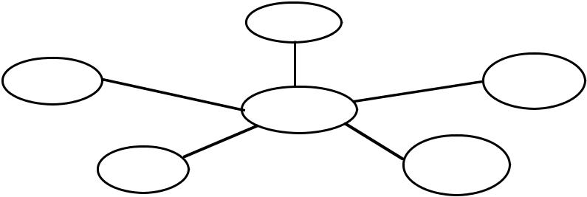

Who |  | Examples:
 |  | inventions/inventors
Why | What | discoveries
Topic |  | space exploration
 |  | scientists/ history
Where | When

Sequential Map
Examples: time lines, schedules, sequence of events or steps
Topic

Cyclical Map
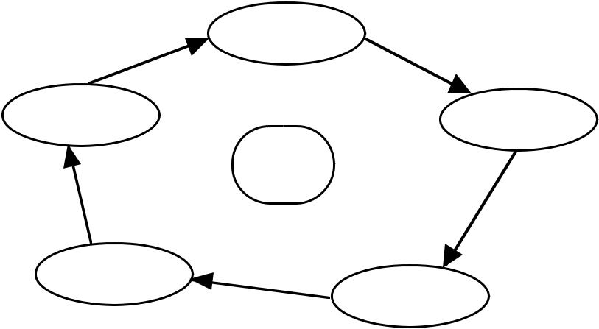
Examples: water cycle rock cycle nutrient cycle

Topic air cycle ecosystems

Hierarchical Map

 |  |  |  |  |  |  | Topic
 |  | Category |  |  |  |  | Category |  |  |  |  |  |  |  | Category
Info. |  | Info. |  | Info. |  |  |  | Info. |  |  |  |  |  |  |  |  | Info. |  | Info.






Examples: food chain, heredity, food pyramid, dichotomous key

Downloaded from http://www.tidyforms.com

Concept Map
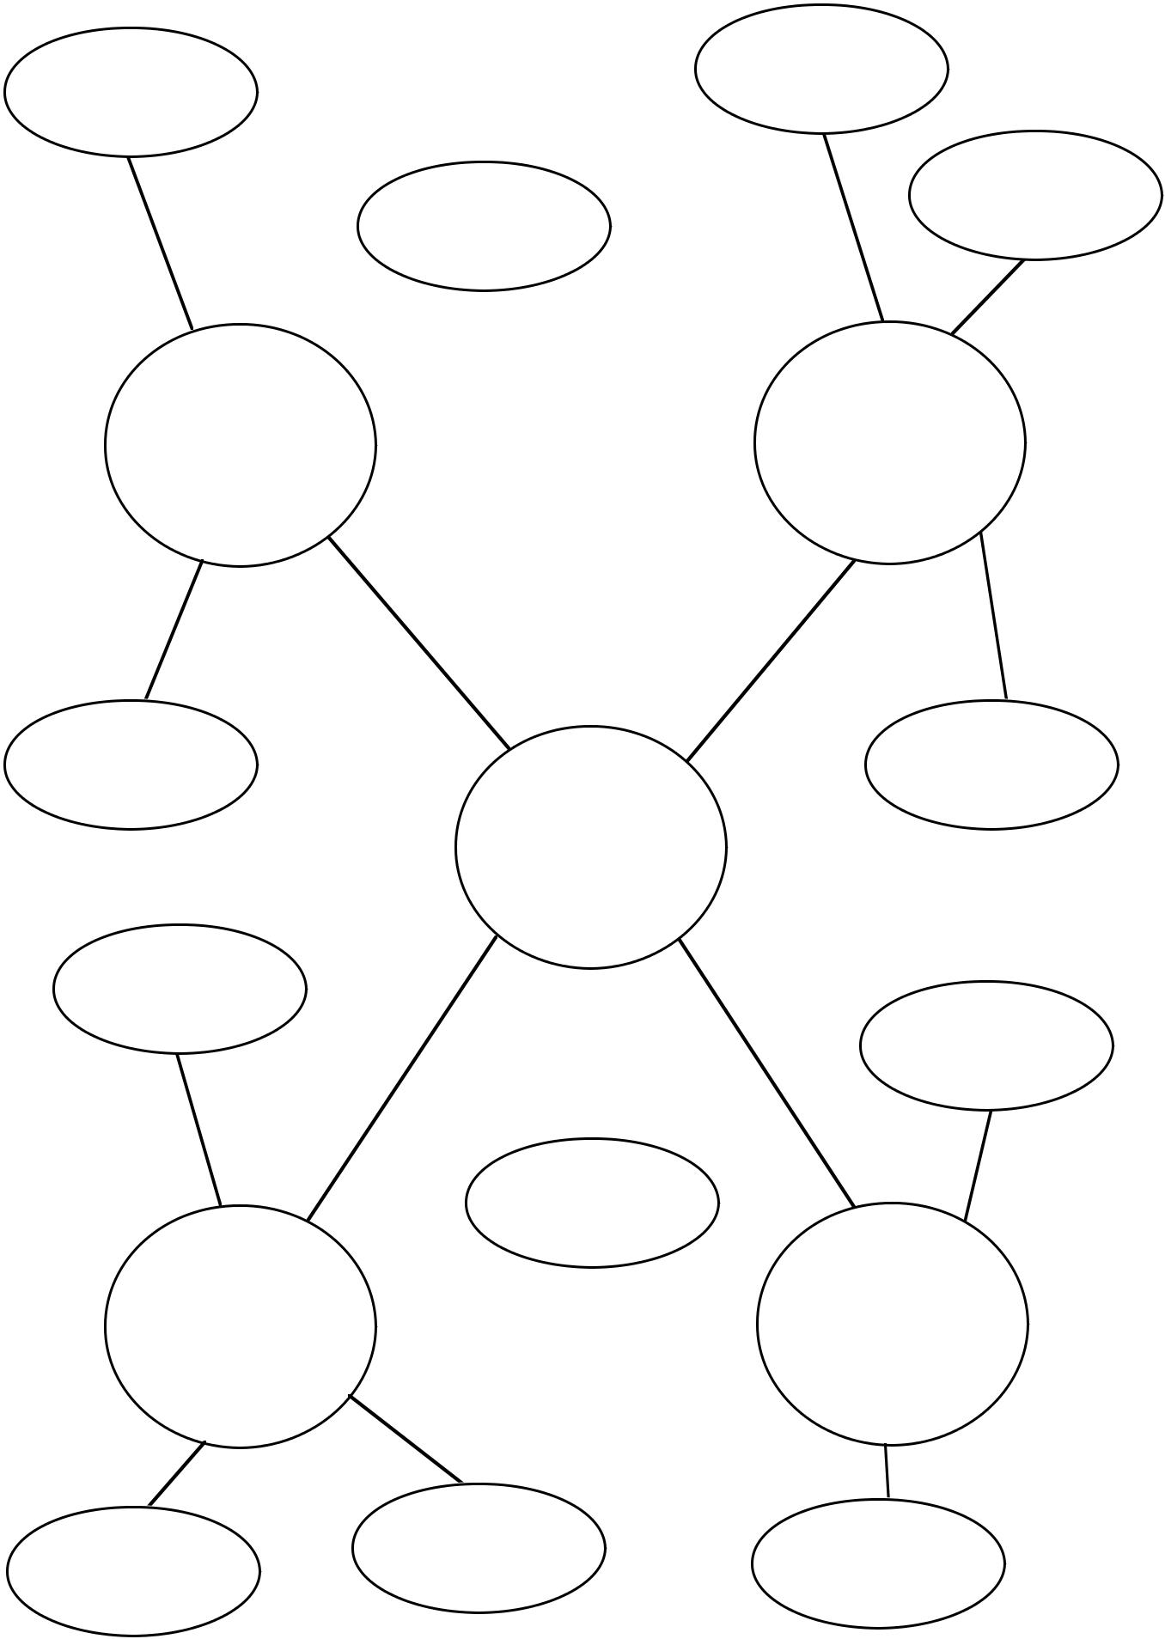

Category 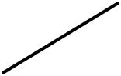 Category

Topic

Category  Category

Downloaded from http://www.tidyforms.com

