Biology Sci-Key Module Yr 2 - 2010 Concept Map
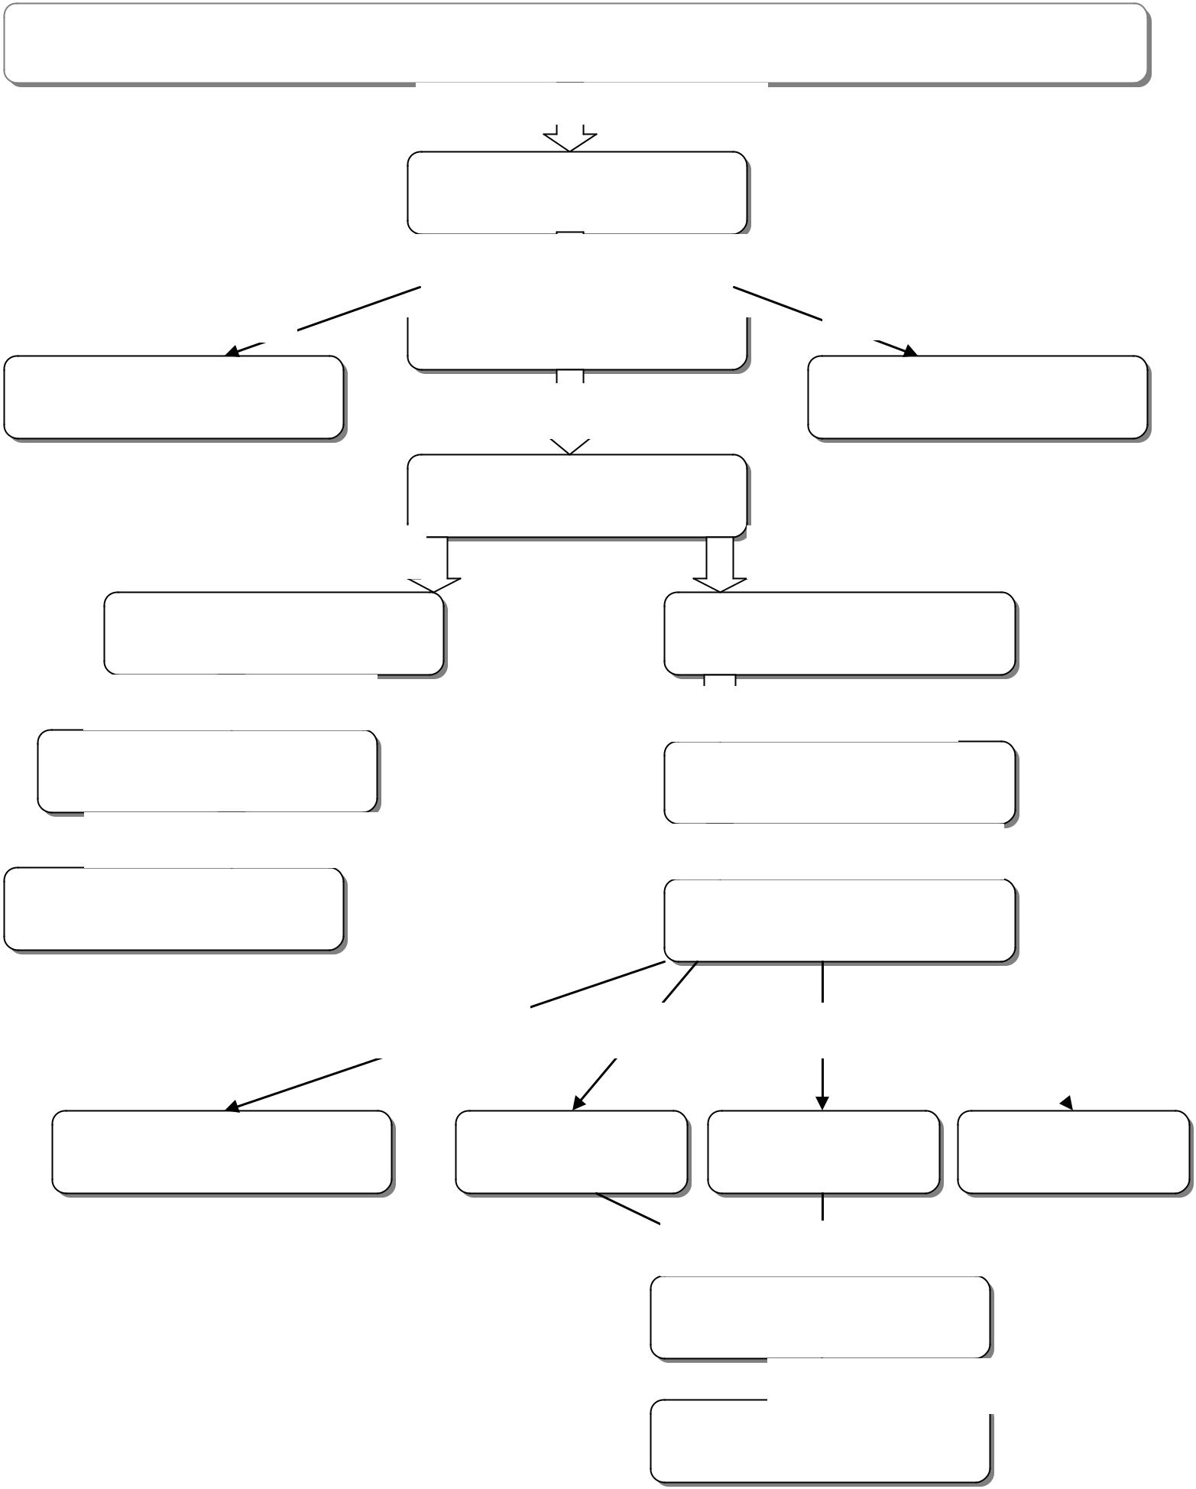

Concept Map

 | Begins with the molecule …
 | Which is broken down during…
Other energy carriers | Net gain of ….
 | Producing….

Occurs if oxygen is not present

One example is…

Which produces…

Which occurs in the...

Occurs if oxygen is present

Begins with formation of ….

Followed by the main phase……

Which produces energy carriers called ….

Used during the ….

To make….

Arkansas Department of Education

