their reporting.

112


Sample
CONCEPT MAPS |  |  | Topic: Daily Activity
 |  | 1 | Today
 |  |  | I played
 |  |  | Dress Ups
with | 2 | I dressed as a 2 |  | and played | 2
Mary and John |  |  | A Queen | Kings and Queens
who dressed as |  |  | and wore | who lived
A King and a Princess |  | A Crown and Robe |  | In a Magic Castle
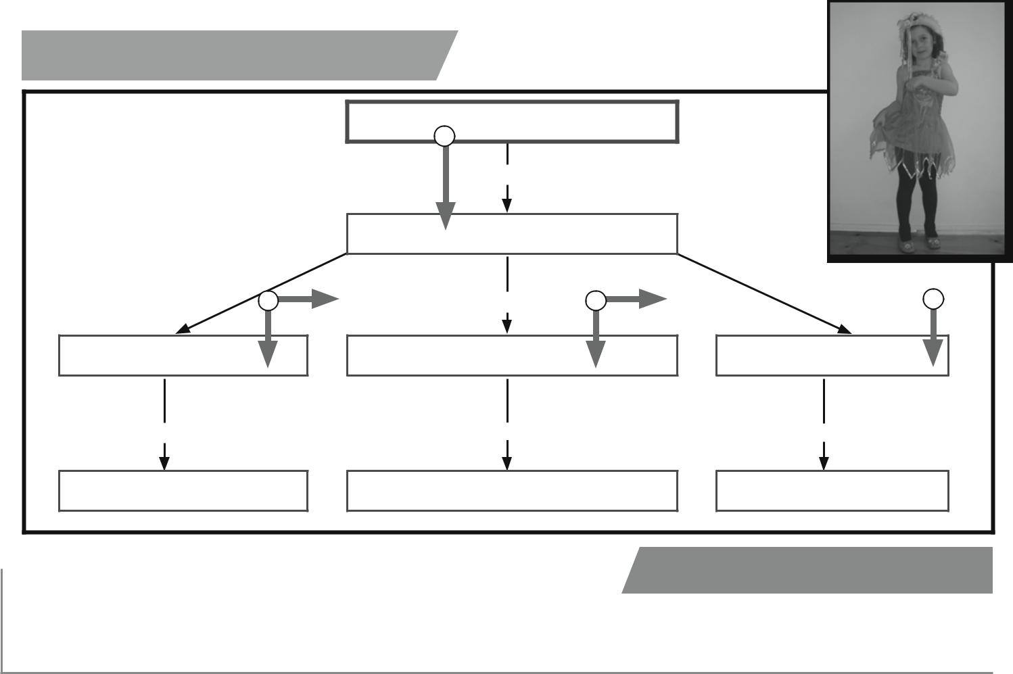

 | Note: The writable template of this cognitive
Observation | tool can be found at www.teacherpd.com.au

Students do not intuitively work well with concept maps, but once they are familiar with the skill it is surprising how effective their work can be.

Acknowledgement: This material has been reproduced with the permission of John Hunt, Senior Lecturer: Adjunct, University of the Sunshine Coast.

© ITC Publications Pty Ltd

Saturday July 7 Sunday July 8

Concept MAPS

Examples

In this example students are searching for shapes in the playground. They spend some time actively searching for shapes and then return to the classroom to report on their findings. The concept map serves as the scaffold for their report and also to link the main feature off the lesson, in this case shapes, to everyday occurrence.
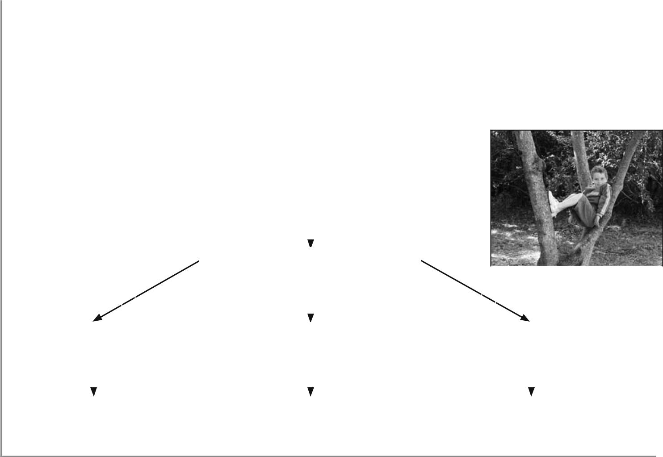
Topic. Shapes (Mathematics Foundation ACMMG009)

The Concept Map is used as a template to guide their report to the class. (ACELY1647 and ACELY 1784)

* | Teacher
* | Student
 |  |  |  |  |  | TODAY
 |  |  |  |  |  | I searched for
 |  |  |  |  |  | Shapes
 |  |  | and | found |  | and |  |  |  | and |  | found
 |  |  |  |  |  |  |  | found
 | A Square |  |  |  |  | A Circle |  |  |  |  |  | A Triangle
 | in the |  | covered area |  |  | in the |  | playground |  |  |  |  |  | tree
 | in the |  |  |  |  | in the |  | playground |  |  |  | in a |  | tree
 | The tale is |  |  |  |  | The sandpit is |  |  |  | A birds nest looked
 | square shaped |  |  |  |  | shaped like a circle |  |  |  |  | like a triangle
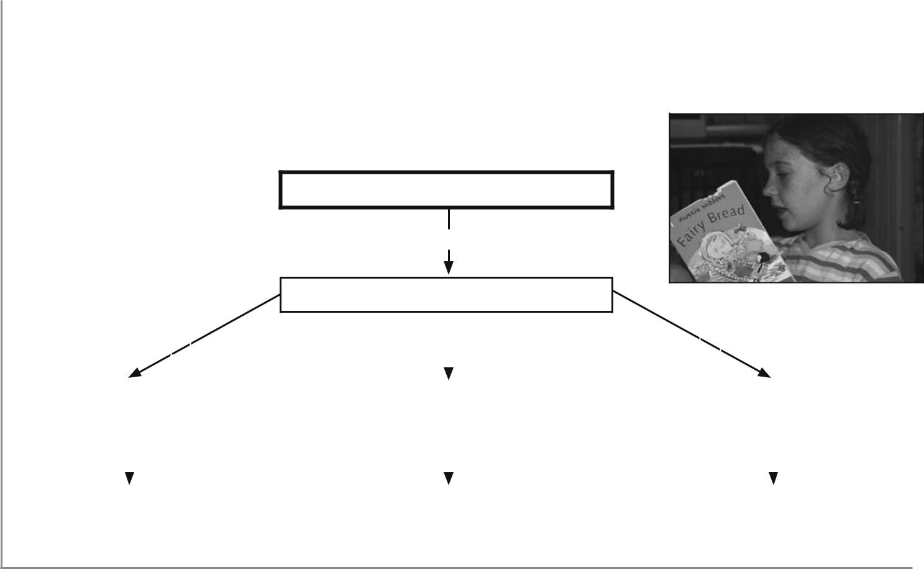

As students writing skills improve they can then begin to fill in the concept map themselves. In this example the concept map is being used as a Framework to help students summarise a recently read book.

Topic: Book Summary (English, Year 1 ACELT1584)

- Teacher
- Student

TODAY

I read

NAME OF BOOK

It was about | (plot) |  | The characters in |  |  | the story were… |  | Each | character did…

 |  | part was… |  |  |  |  |  |  | most was…
The funniest |  | part was… |  | The main character was… |  |  | The one I liked |  | most was…

JULY



© ITC Publications Pty Ltd  113

