**Vehicle Service Inspection Checklist Form**

Key: OK (Passed Inspection)

X (Not Acceptable)

N/A (Not Applicable)

Notes:

PLEASE READ CAREFULLY BEFORE SIGNING: In understand that this checklist reflects the general condition of my vehicle when released to *Dealer Name* Here, Inc. for service but does not include mention of any hidden defects. Should such defects appear/be found during the service of my vehicle, I instruct *Dealer Name* Here, Inc. to contact me, or my representative, for authorization to repair any defect that would affect the proper and safe completion/operation of said service, provided it is in their capacity to repair. My authorization gives *Dealer Name* Here, Inc. permission to make the necessary repairs at my expense. I also understand that these additional repairs may cause some delay in completion of my service. I further understand that some, or possibly all, of the gasoline in my vehicle will be used to move my vehicle in and about your premises for road testing and reasonable additional mileage will be accrued.

Customer/Representative Signature:

Inspector:

Date:

**Page 1 of 3**

Date Mileage In Mileage Out Customer Name Year Make Model

VIN Gas ¼ ½ ¾ F Incoming Inspection By: Outgoing Inspection By:

ITEM

IN

OUT

ITEM

IN

OUT

Battery

Gauges

Brakes

Dash Lights

Front Air Conditioning

Suspension Noises

Rear Air Conditioning

Other Chassis Problems

Heater

Radio

Speakers/Radio

Carpet

Walls

Headliner

Jacks/Tools

Door Locks

Power Window – Driver Side

Power Window – Passenger Side

Sun Visors

Dome Lights

Headlights

Tail Lights

Brake Lights

Directional’s

**Adaptive Equipment:**

Lift

Lift Control

Magnet Entry

Hand Control

Power Door Opener

Power Parking Brake

**List Other Equipment:**

Antenna(s)

Inside Mirror

Aux. Battery

Cell Phone

Vehicle Side Mirrors

Passenger’s Seat

Driver’s Seat

Rear Seat

2nd Row Driver’s Seat

2nd Row Passenger’s Seat

Cargo Door

Wash/Wiper

Spare Tire

Power Steering

Television

Cruise Control

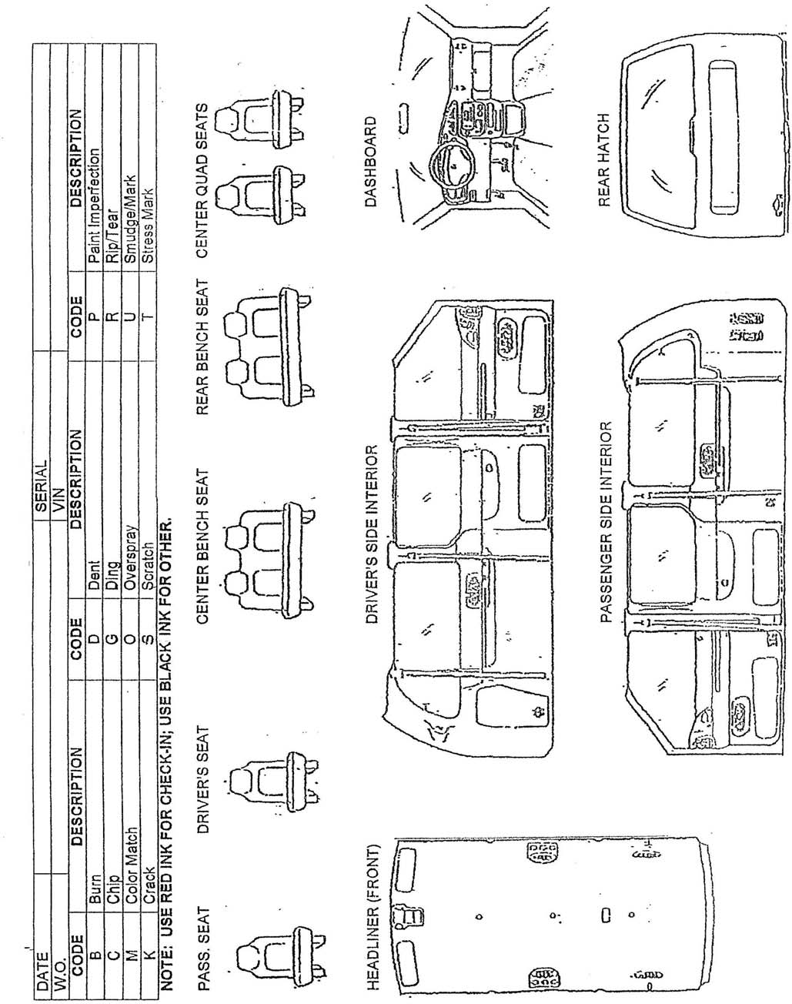

**Vehicle Service Inspection Checklist Form**

**Page 2 of 3**

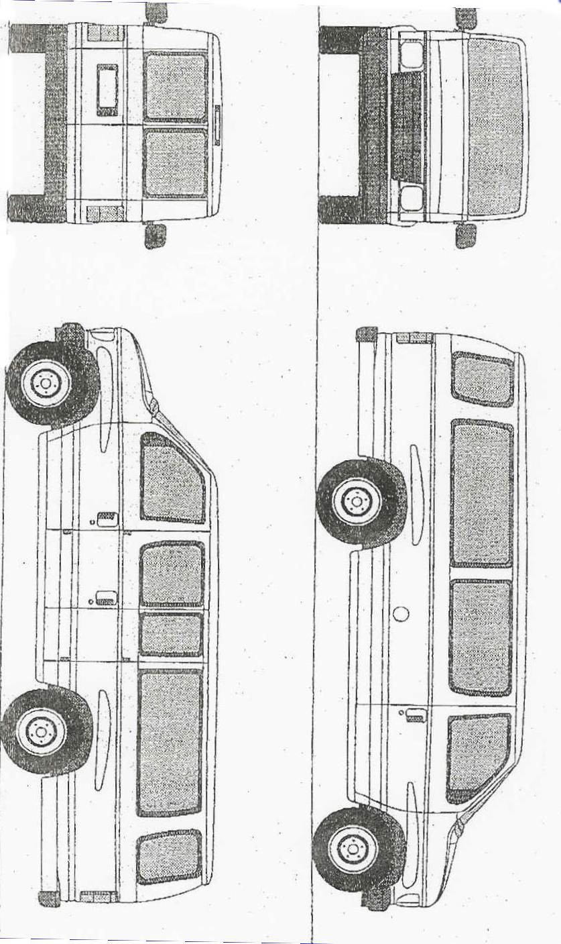

**Vehicle Service Inspection Checklist Form**

**Page 3 of 3**