PRODUCT SALES SHEET

BL0838
Pro-Tec

Features
- Carpet Protectant
- Forms an Invisible Protective Barrier Against Spots & Stains
- Concentrated Liquid
- Covers Up to 200 Sq. Ft./Gl
- Nonflammable

Floor Care

Description
This fluoropolymer protective barrier for textile fibers helps to retard soiling and improve stain resistance to keep carpets, mats and rugs looking cleaner longer. This highly concentrated product is an economical treatment that dries to an invisible transparent film which encapsulates each fiber. Treated areas stay cleaner longer and are free of streaks and spots. The innovative technology outperforms conventional protective products to help provide maximum longevity to valuable textile floor coverings. Water based, this product is virtually odorless and is completely nonflammable.

Label Datecode: 08/09
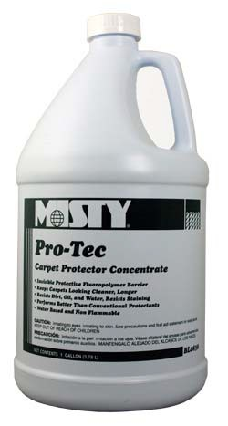

TECHNICAL INFO:
Physical Properties | Appearance | Cloudy Liquid
 | Color | Straw
 | Odor/Fragrance | Sweet
 | pH | 7.0-8.0
 | Freeze/Thaw Stability | Good
Environmental Profile | Glycol Ether Content | None
 | Biodegradability | No
 | Chlorinated Solvents | None
 | Enviro Standard | N/A
 | Recyclable Packaging | Yes
Regulatory Compliance | % VOC By Weight | 2.5
 | VOC Restricted Regions | None
 | Food Processing Suitability | N/A
 | EPA # | N/A
 | Flammability per CPSC | N/A
 | Flash Point | None to Boiling

Packages Available:

990 Industrial Park Drive • Marietta, GA 30062 800-241-7766 • 770-422-2071 • Fax: 770-422-1737

www.amrep.com

