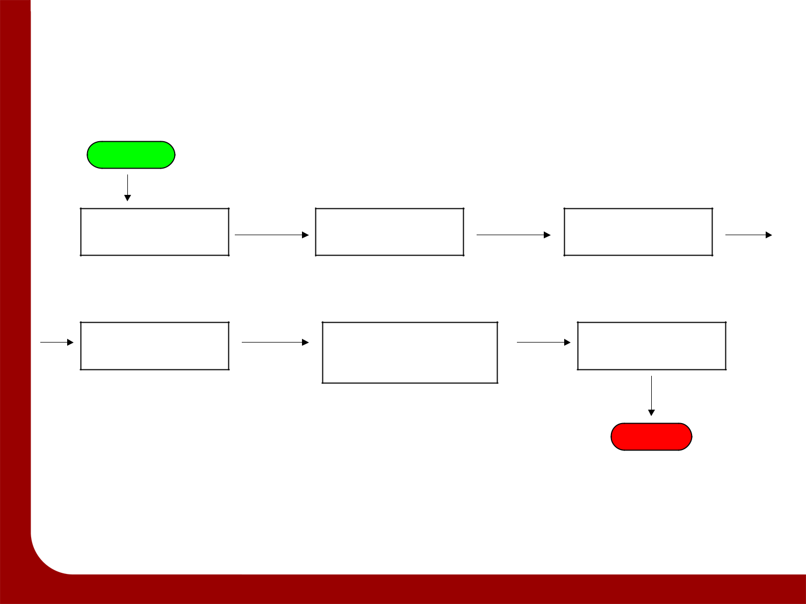
Process Map for _____________

Start

End

