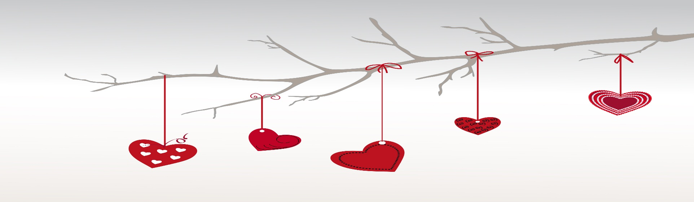

My dear,
I had a long day yesterday. A lot of work, bad traffic and crowds of people everywhere... I was really exhausted by the time I reached the hotel.
I sat down on the bed and wanted to turn on the TV to kill some more time before sleeping, but my mind started wandering.
Then everything just focused clearly. You appeared in front of me. Your angelic presence instantly calmed me down, my tiredness evaporated and my spirits soared turning glum into bliss. Yes, my darling, you do have that wonderful effect on me.
I remembered our first date when everything started. Like a burst of sunshine upon a desolate landscape, like the torrential rain in the dessert, like the first light after months of darkness, that date changed me forever. For better, for much better. It was love at first date. I couldn't think of anything more important than to see you again, to be with you again. Your soft, sweet voice singing to me gently; your radiant smile warming my heart; your exquisite presence mesmerizing me completely.
I also remembered the day we got married. It was pure splendor, elation and happiness. I recalled every single detail of that day as if I was reliving it all over again. How truly blessed I am to have you walk the roads of life with me! I could not imagine my life without you because you mean everything to me. My love for you keeps on going as strong as ever and I know that I will always love you until the day I depart this world.
I turned around to kiss you, only to find an empty pillow there. That's when I realized that I fell asleep and kept thinking, dreaming about you. I smiled.
Soon we will be together again.

I love you so much!

