
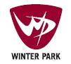

To Whom It May Concern:

This is a letter of recommendation for Mike Lover. I have known Mike for ten years as his co-worker and direct manager. Mike and I worked together at Intrawest Colorado, within the Marketing and Sales department.

Mike is a highly motivated and qualified professional with experience in all aspects of business strategies including sales, operational, and employee relations. Mike was able to transition from the call center/direct sales division to process improvement with our creative agency to revenue management tactics very adeptly. At the time we began working together, I was in charge of our Revenue Maximization department; Mike was the key contact on the Call Center team for all of our sales efforts. Mike has a unique ability to work in the space between sales and customer services. He worked well with all team members. Mike worked well with our corporate offices with his focus always on driving the business he was responsible for.

Mike moved from the Call Center into our Lean Six Sigma program. He quickly became our first Black Belt and a key meeting facilitator across the company. Mike became a very valuable resource within our company and was assigned many different responsibilities. Mike picked up all the businesses we assigned him; retail, rental, golf and food and beverage.

Mike is a results driven professional who drove our strategies into sales like very few I have worked with. As a Vice President of Marketing and Sales of two ski resorts I would happily have Mike back in my organization due to his ability to be a strategist, his attention to the customer needs, his creativity, as well as a manager. He truly has a strong understanding of the hospitality business. I would highly recommend Mike.

Sincerely,

Jesse True

Vice President Marketing and Sales
Winter Park and Copper Mountain Resorts
970-401-0345

PDF created with pdfFactory trial version www.pdffactory.com

February 19, 2009

Dear Sir/Madam,

I am writing to you on behalf of Mike Lover. I have had the opportunity and pleasure to work closely with Mike while he was at Intrawest. Mike successfully completed our Black Belt Certification program and upon completion, Mike and I were assigned to work together on an Accounts Payable improvement project in our Shared Services operation. I was the sponsor of the project and Mike was the Black Belt. Through Mike’s efforts we were able to dramatically improve our AP processes. Not only was Mike able to bring his considerable skills to the task, but probably more importantly great leadership. Working across 21 internal companies across the US was a difficult assignment that Mike was very effective at managing and ultimately getting all constituencies in support of the final solution. Our results on this particular project our AP cycle time from an average of 83 days to 30 days. This new process is still being followed today, almost 3 years later. .

As our company continued to work on improvement projects across our network, Mike and I stayed connected. He was a relentless and passionate advocate for improvement and positive change. Given the magnitude of this initiative across the company coupled with the fact that we are a highly seasonal business with wide fluctuations in business levels, we were constantly reviewing the structure and focus of our process improvement processes. Mike was instrumental in bringing new ideas to the table and working with a small group of fellow black belts to continue to push for positive changes and fight the cultural status quo.

Mike is highly organized, disciplined, and results oriented. He works well in a team environment and can effectively bring a diverse group of people together toward a common solution. I would strongly recommend him to any organization.

Sincerely,

Sky Foulkes

President and COO
Stratton Mountain Resort
SFoulkes@Intrawest.com
802-297-4242

PDF created with pdfFactory trial version www.pdffactory.com
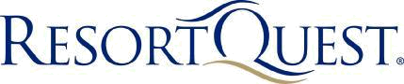

February 22, 2008

Re: Mr. Mike Lover

Personal Letter of Excellence

Greetings;

I first hired Mike Lover as a Reservation Sales Agent for Keystone Resort in October of 1998. I was immediately impressed with his enthusiasm and action oriented approach to the specific questions that were asked of him. Mike was hired and he went on to become the #1 sales agent for a ski-resort which books $75Million in lodging and components annually.

I was thrilled when, after I moved to Copper Mountain Resort to become the Director of Lodging, that Mike was willing to transition to Intrawest with me. I was again confident in his ability to tackle complex sales and hospitality service issues. Mike did not disappoint and proceeded to have a diverse and rewarding career with Intrawest, including making the elite Operational Excellence Team as a lean six-sigma Blackbelt.

Mike has a passion for his life and his work that is rare to find. I recommend him for your organization with my full endorsements. Please feel free to connect with me by phone if you would like additional insight on Mike’s performance attributes.

Kind Regards,


Robert Stenhammer

843-686-8120
General Manager
ResortQuest Hilton Head
MBA-Hospitality & Tourism
rstenhammer@resortquest.com

PDF created with pdfFactory trial version www.pdffactory.com
February 18, 2009

To Whom It May Concern:

Please accept this letter as a personal and professional character reference for Mr. Mike Lover. While working with Mike for the last 9 years, I have grown great respect for the responsibilities he has taken on and the breadth of knowledge he has gained. Mike has taken on substantial professional and personal challenges and has achieved great success. I have watched Mike take Intrawest to new levels of effectiveness through his technical, strategic and business insight.

Over the last 9 years Mike successfully led various Intrawest business areas, always showing a great balance of leadership, technical skills, process improvement and business acumen. Mike’s sharp eye for talent and ability to assemble this talent into a high performing team is indicative of his strong leadership skills.

Mike’s has an envious list of professional and personal accomplishments. Mike’s achievement of Six Sigma Black Belt status empowers him with skills that have greatly benefited Intrawest and would be of tremendous value to any organization. On a personal level, Mike recently completed an Ironman competition. While a great personal achievement, it speaks to Mike’s commitment, diligence, tenacity and competitive drive.

Mike is truly a quality individual with a tremendous work ethic and a passion for quality and excellence.

If I can provide further information please do not hesitate to contact me personally at 604-328-0733.

Sincerely,
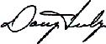

Doug Feely

Chief Information Officer

Intrawest ULC

Suite 900, 900 W. Hastings St.
Vancouver, BC V6C 1E5

604-328-0733

PDF created with pdfFactory trial version www.pdffactory.com

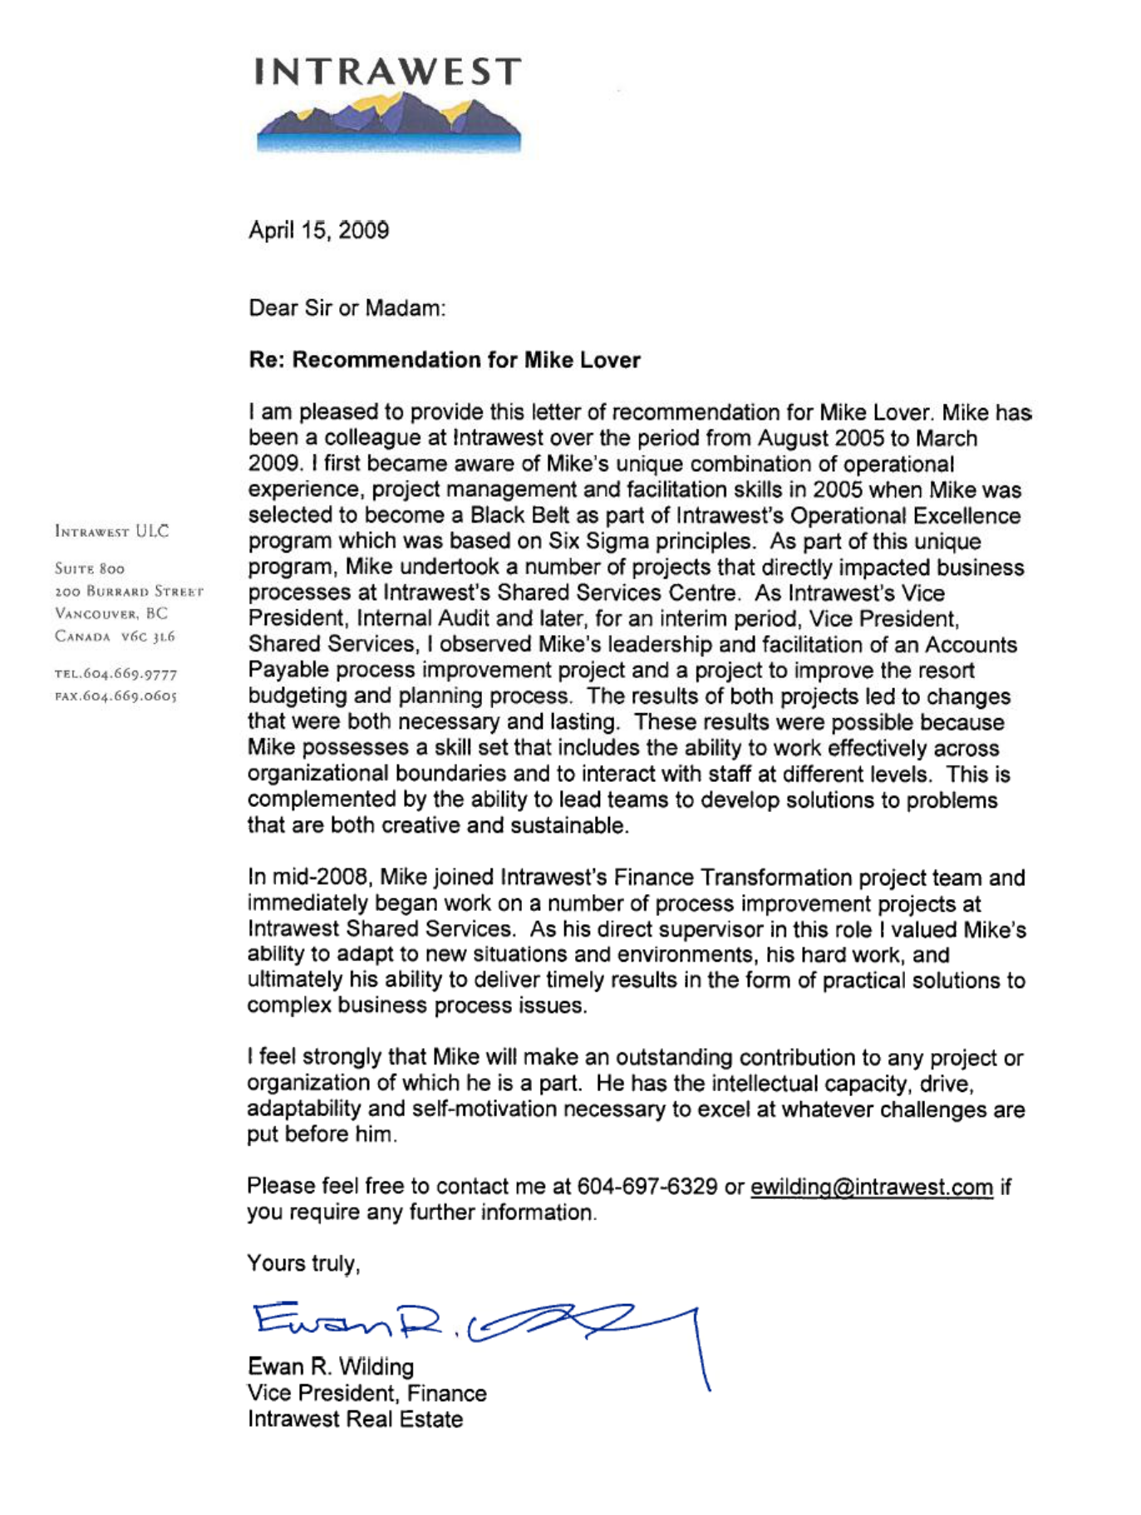

PDF created with pdfFactory trial version www.pdffactory.com

