

ECO-MAP

**Health Care**

**NAME:**

**Social Welfare**

**DATE:**

**Extended Family**

**Work**

**Church**

**Spiritual**

**FAMILY OR HOUSEHOLD**

**Recreation**

**Extended Family**

**Friends**

**School**

**Recreation**

**Understanding the Ecomap:** An ecomap is a structural diagram of a client's most important relationships with people,

groups, and organizations; and identifies resources available in clients’ community. Social workers use this tool to show the coalition of resources that seem likely to affect a client's efforts to achieve personal goals.

**Instructions:** Fill in connections where they exist.

Indicate nature of connections with a descriptive word or by drawing different kinds of line;

for strong; - - - - - - - - - - for weak, / / / / / / / / / / for stressful.

Draw areas along lines to signify flow of energy, resources, etc. → → → → → → → → → →

Identify significant people and fill in empty circles as needed.

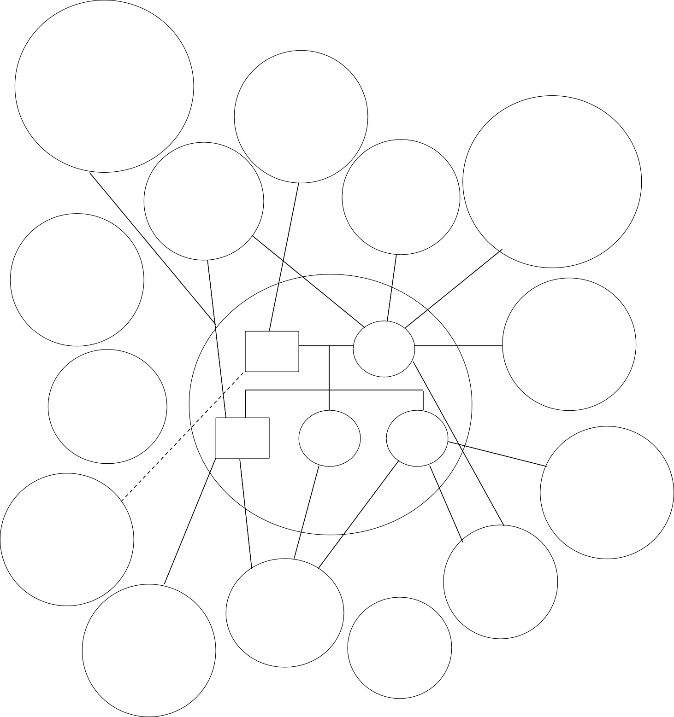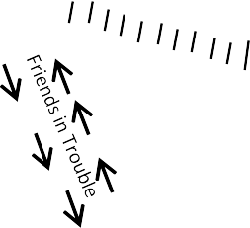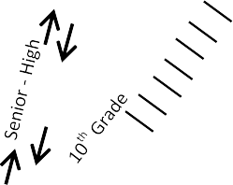

Eco-Map SAMPLE

**Health Care**

City Hospital Clinic John – MS for 10 years

**Social Welfare**

Family has been referred

to counseling around Joan.

**NAME:**

**DATE:**

**Extended Family**

Medicare and A Disabled

**Church**

**Work**

Birth’s mother

demanding – I’ll need financial & emotional support

Both – part time

**Spiritual**

**FAMILY OR HOUSEHOLD**

**Recreation**

Beth involved in

gardening & garden club.

BETH

40

JOHN

42

JOHN

19

GWEN

17

JOAN

15

Court &

Probation Officer (Mia Thompson)

**Extended Family**

Father’s in

Arkansas very little contact

**Friends**

**School**

Joan popular with

“rough crowd”

**Recreation**

John very involved in sports.

Father used to be

**Understanding the Ecomap:** An ecomap is a structural diagram of a client's most important relationships with people,

groups, and organizations; and identifies resources available in clients’ community. Social workers use this tool to show the coalition of resources that seem likely to affect a client's efforts to achieve personal goals.

**Instructions:** Fill in connections where they exist.

Indicate nature of connections with a descriptive word or by drawing different kinds of line;

for strong; - - - - - - - - - - for weak, / / / / / / / / / / for stressful.

Draw areas along lines to signify flow of energy, resources, etc. → → → → → → → → → →

Identify significant people and fill in empty circles as needed.