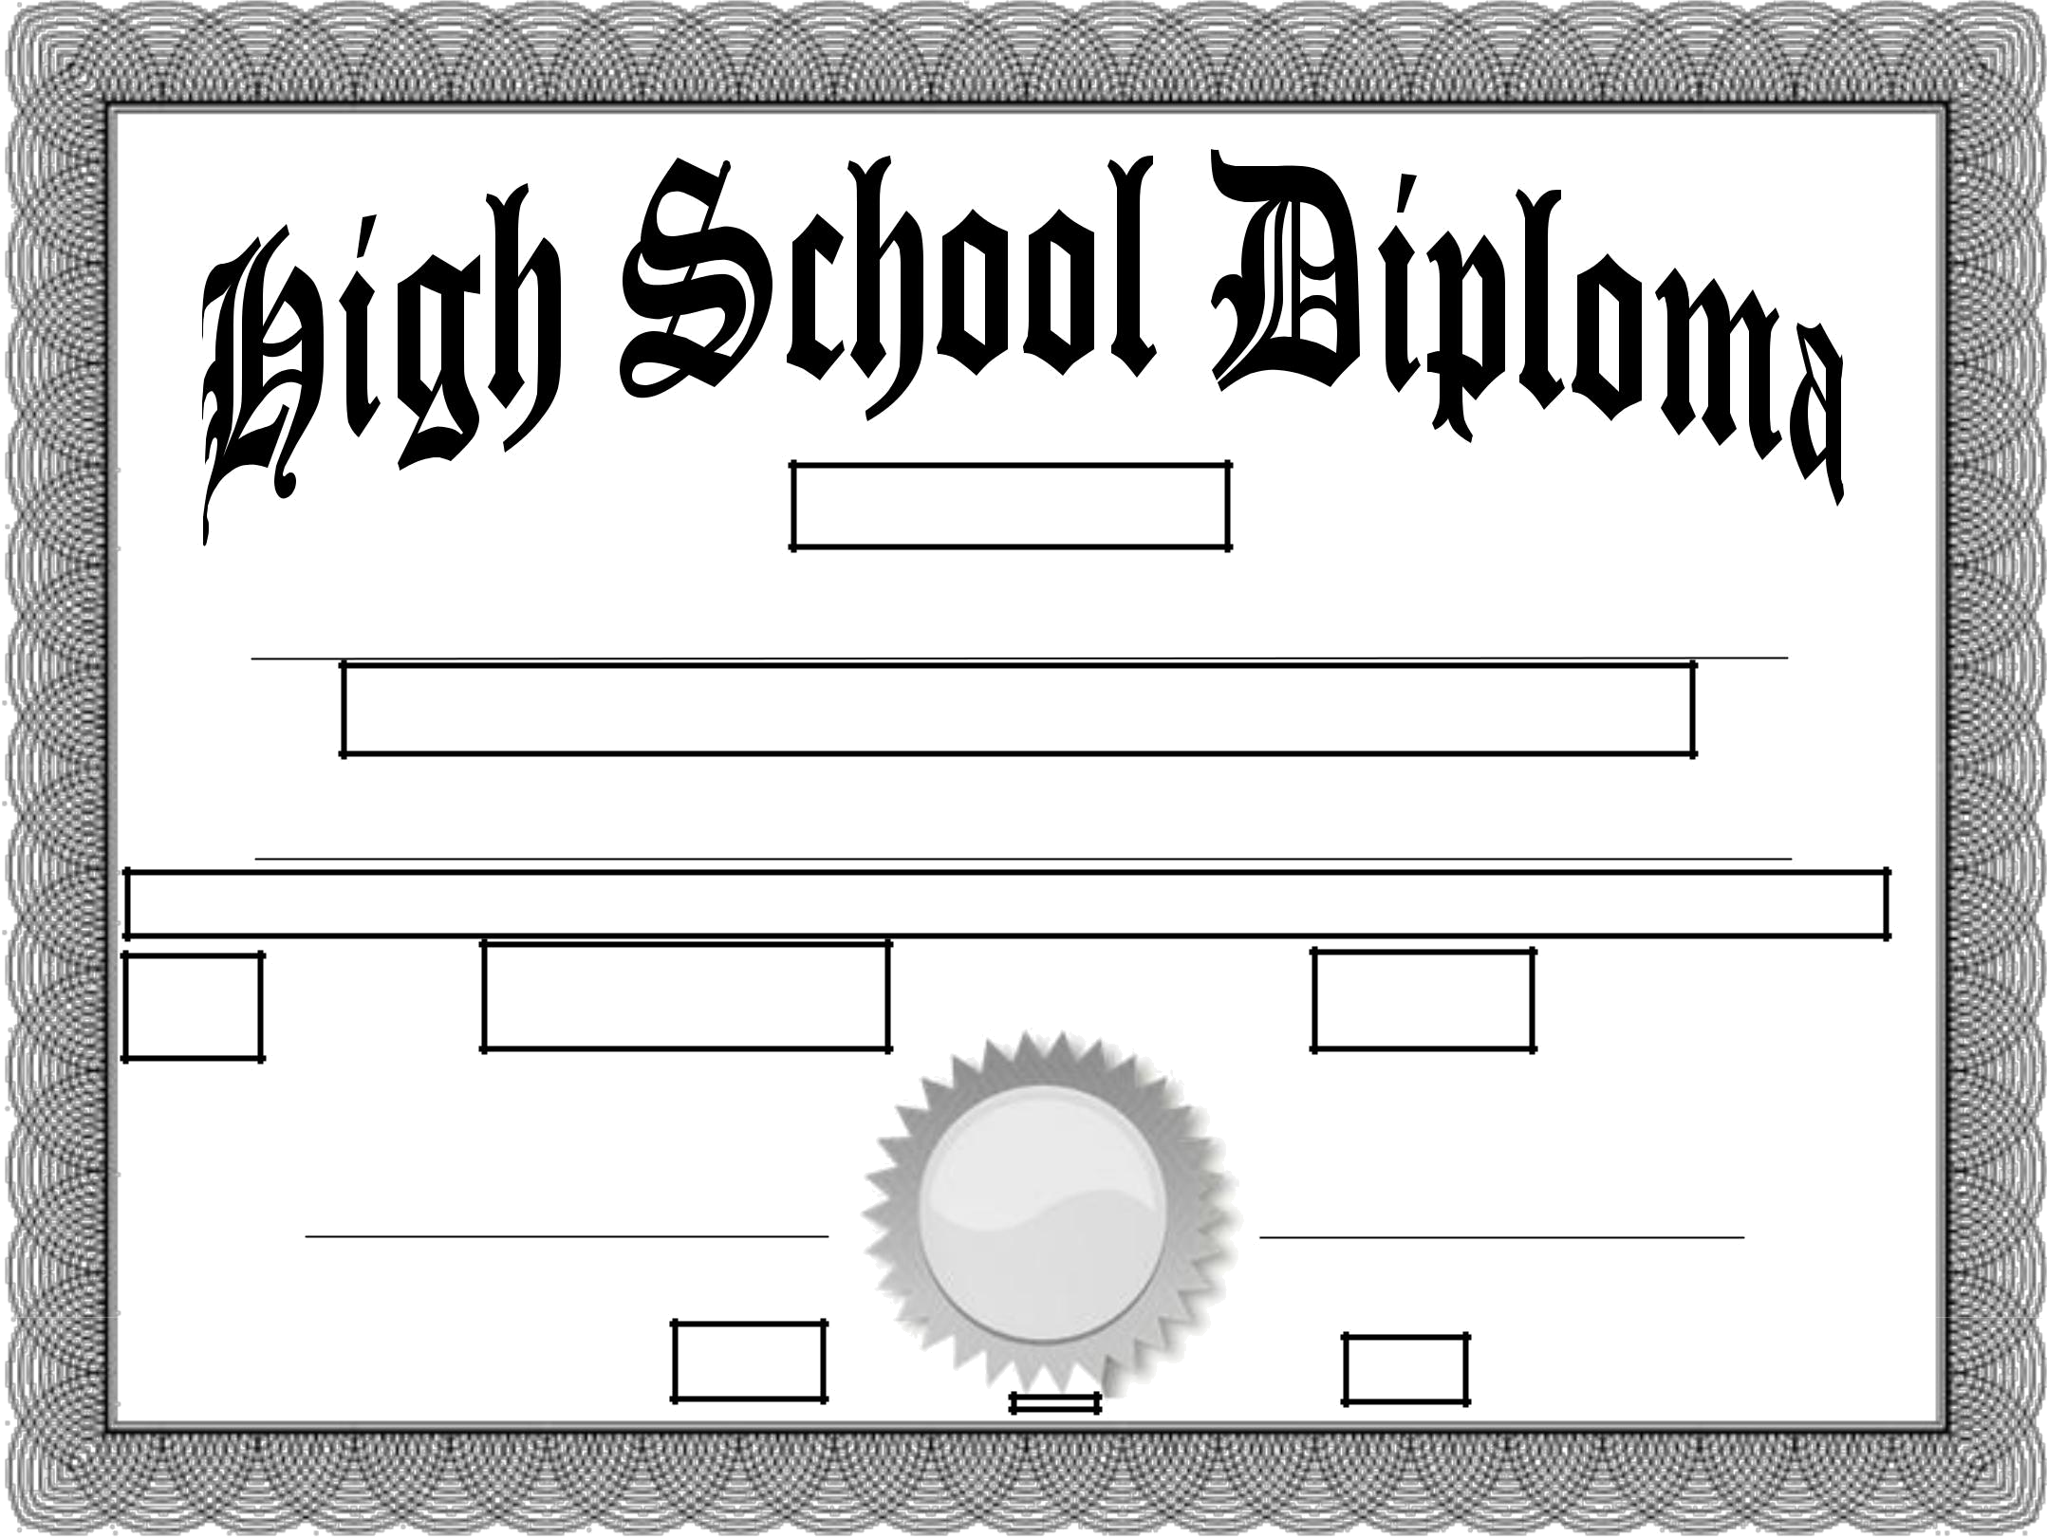

This CertifiesThat

Has completed the Couse of Study prescribed for Graduation by

.
In Testimony, Whereof, this Diploma is conferred, and we have subscribed our names

on the ________day of the month of ________________in the year_____________.

Parent Parent

