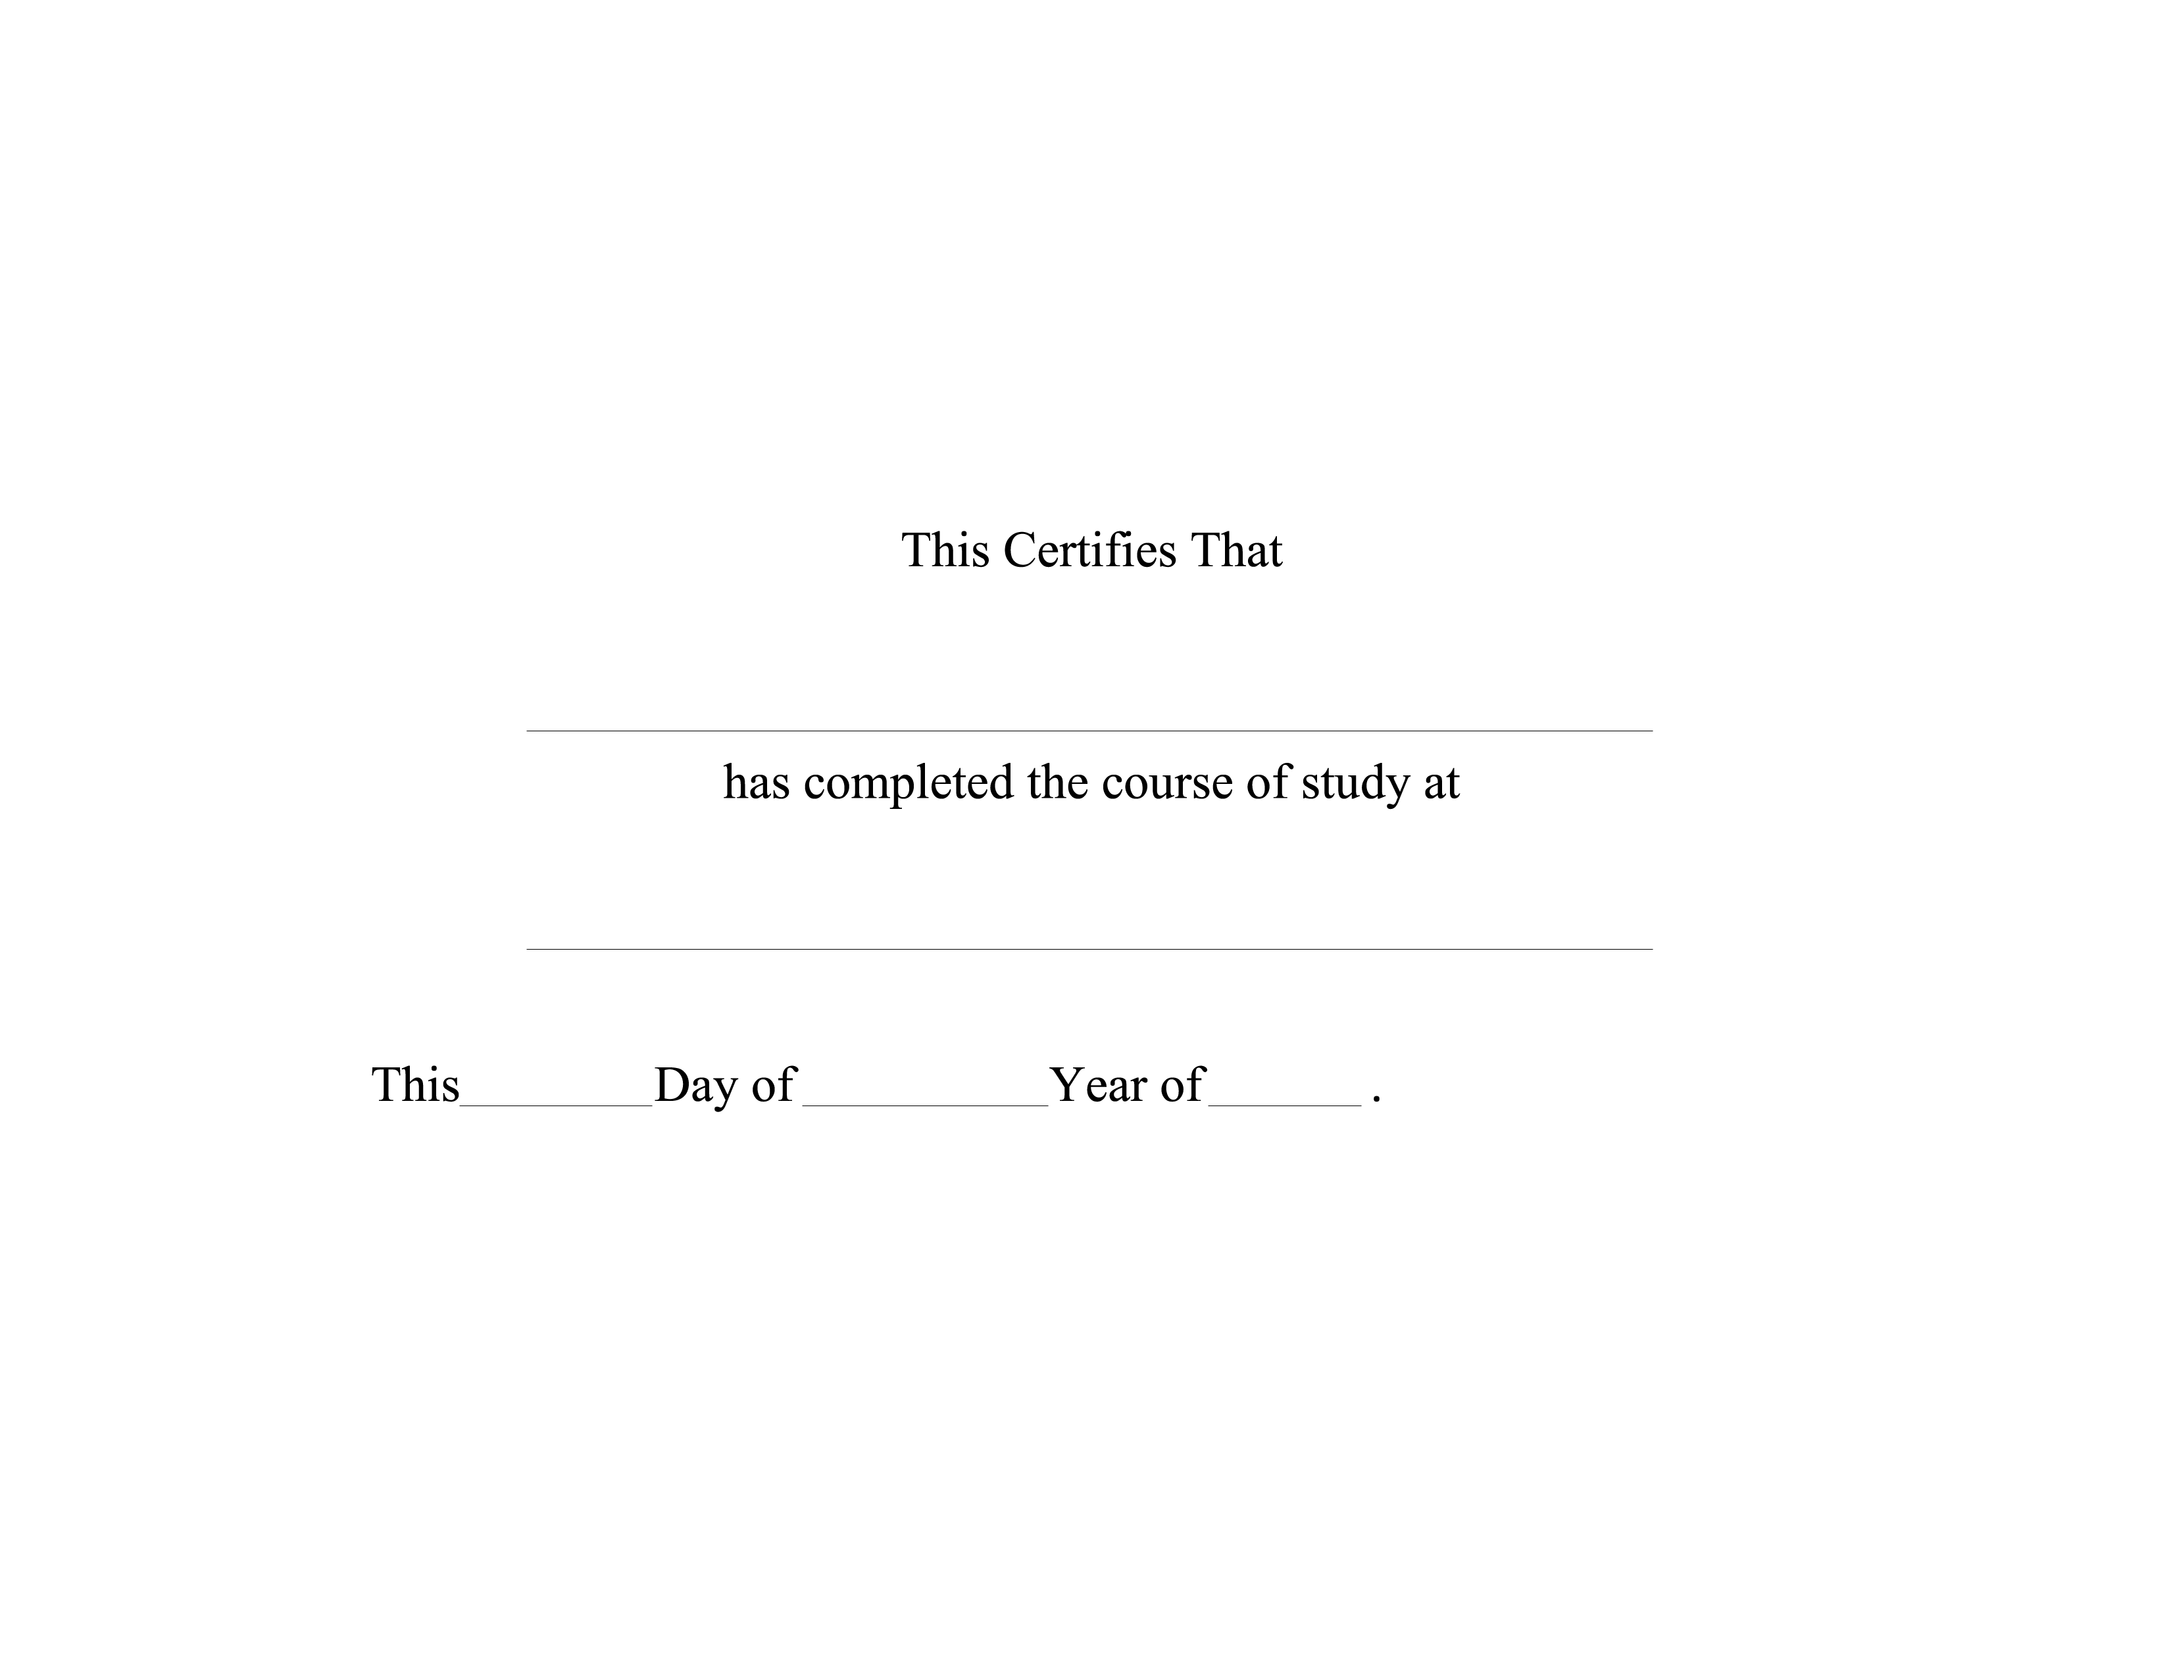

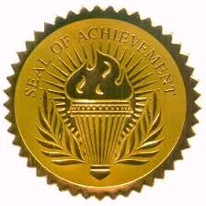
NAME HERE
SCHOOL NAME
2nd
JUNE
2011

