Mega-star Reward Chart

Earn a great treat while you practise using graphs and scales.
What to do
Decide with an adult what you need to do to earn stars. It could be tidying your room, doing your homework, helping clean the house or being kind to someone.
You will need:
- Scissors
- Glue
- Mega-star Reward Chart (page 2)
1.
Agree on the rewards. A daily reward could be a treat to eat or some TV time. A reward at the end of the week could be a trip somewhere, a visit to a special person or a contribution towards something you’re saving for.
2.
Write these on the chart.
Agree how many stars you need to earn in a day and in a week to get your reward.
3.
When you earn a star, cut one out and stick it on your reward chart. (Check with an adult before using scissors.)
4.
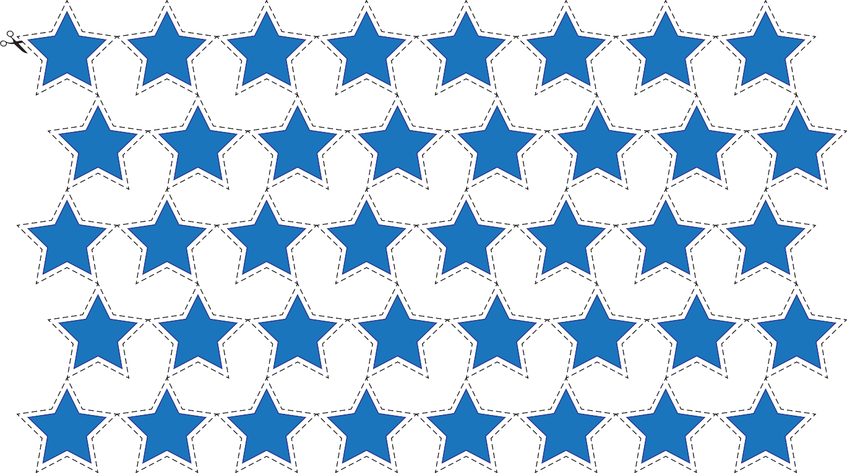

Page 1 of 2 © Oxford University Press 2013
For more support, visit
www.oxfordowl.co.uk

Mega-star Reward Chart
Page 2 of 2 © Oxford University Press 2013
6
To earn stars I will …

4

2

0
For more support, visit
www.oxfordowl.co.uk

Saturday Sunday Monday Tuesday Wednesday Thursday Friday

For or more stars in one day, the reward will be:

For or more stars in one week, the reward will be:

