

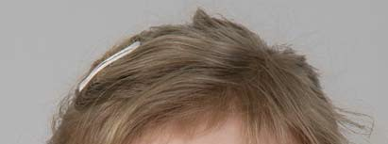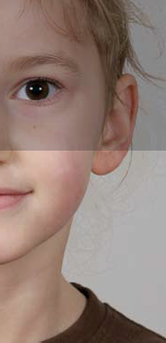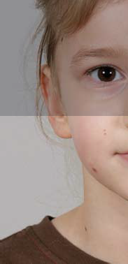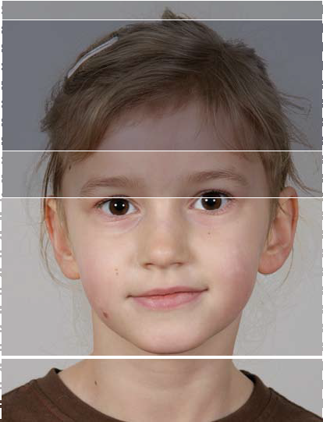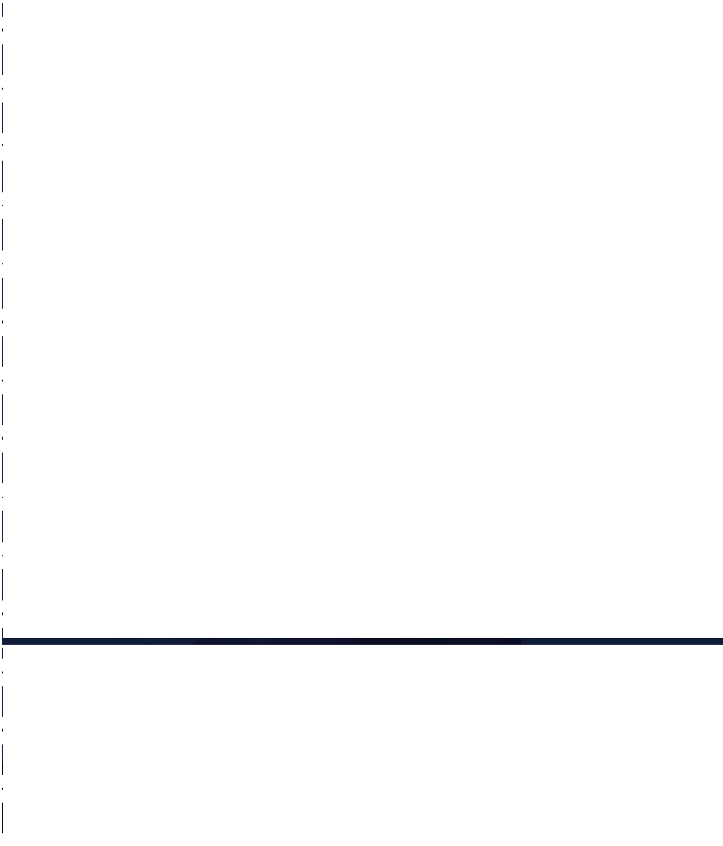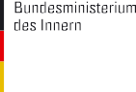

**PASSPORT PHOTO TEMPLATES FOR CHILDREN AGED 6 TO 9**

Step 1

Step 1: example

Maximum height of eyes

Minimum height of eyes

Middle of the nose within dark grey band

Step 2

Step 2: example

Maximum height of face tolerated

Optimal height of face no more than 36mm

Optimal height of face no less than 22mm

Minimum height of face tolerated

Chin line

**Step 1: CHECK EYE AREA**

* Line up template with upper left edge of photo
* Does the photo measure 35 x 45mm?
* Do the eyes lie within the horizontal grey band?
* Are the eyes roughly level?
* Are the eyes open and clearly visible?
* Does the middle of the nose lie within the vertical dark-grey band?

**Step 2: CHECK SIZE OF FACE**

* Move template so that the chin line touches the bottom of the chin
* Does the top of the head lie within the darker grey band (ideal face height)?
* Does the top of the head lie within the lighter grey band (allowable face height)?

**POSITION OF HEAD AND FACIAL EXPRESSION**

* Is the head straight (not tilted or turned)?
* Head and shoulders facing forward?
* Neutral facial expression?
* Mouth closed?

**FOCUS AND CONTRAST**

* Is the photo in sharp focus with proper contrast?

**LIGHTING**

* Are face and background uniformly illuminated (no shadows)?

**BACKGROUND**

* Plain background?

**PHOTO QUALITY**

* Black-and-white or colour photos are acceptable
* With colour photos: does the colour reproduce the natural skin tones?
* Is the photo clean, undamaged and free of creases?

**GLASSES**

* Are the eyes clearly visible and not covered?

**PLEASE NOTE:**

For children aged 5 and under, it is not necessary to capture

a facial biometric. Photos of children aged 5 and under must be 35 x 45mm and fulfil only the requirements for frontal view, focus and contrast, lighting, background and photo quality listed above.