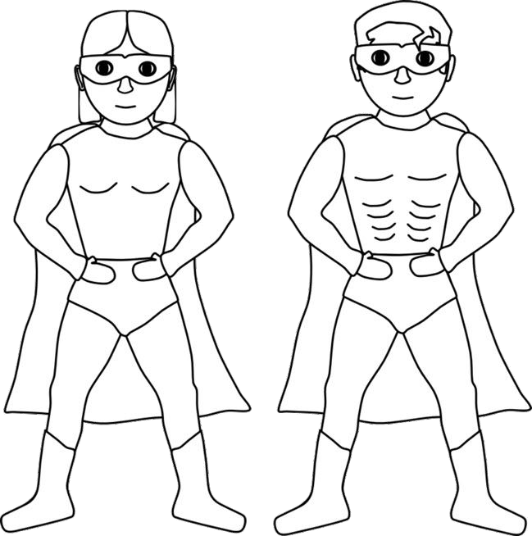

SSPORT >>> PASSPORT >>> PASSPORT >>> PASSPORT >>> PASSPORT >>> PASSPOR PASSPORT >>> PASSPORT >>> PASSPORT >>> PASSPORT >>> PASSPORT >>> PASSP

Superhero Information
SSPORT >>> PASSPORT >>> PASSPORT >>> PASSPORT >>> PASSPORT >>> PASSPOR PASSPORT >>> PASSPORT >>> PASSPORT >>> PASSPORT >>> PASSPORT >>> PASSP

Superhero name: Gender:
Photograph/picture
Age:

Special powers:

Description:

Signature:

