
Eulogy
Planning Guide

Featuring a collection of poems, readings and a eulogy template

POEMS

Remember

Remember me when I am gone away, gone far away into the silent land;

when you can no more hold me by the hand, nor I half turn to go yet turning stay. Remember me when no more, day by day you tell me of our future that you planned: only remember me; you understand

it will be late to counsel them or pray. Yet if you should forget me for a while and afterwards remember, do not grieve: For if the darkness and corruption leave a vestige of the thoughts I once had, better by far you should forget and smile than that you should remember and be sad.

- Christina Rossetti

Funeral Blues

Stop all the clocks, cut off the telephone, Prevent the dog from barking with a juicy bone, Silence the pianos and with muffled drum Bring out the coffin, let the mourners come. Let aeroplanes circle moaning overhead Scribbling on the sky the message ‘He is Dead’. Put crepe bows round the white necks of the public doves,

Let the traffic policemen wear black cotton gloves.

He was my North, my South, my East and West, My working week and my Sunday rest,

My noon, my midnight, my talk, my song; I thought that love would last forever: I was wrong.

The stars are not wanted now; put out every one,

Pack up the moon and dismantle the sun,

Pour away the ocean and sweep up the wood;

For nothing now can ever come to any good.

God’s Garden

God looked around his garden And found an empty place,

He then looked down upon the earth And saw your tired face.

He put his arms around you And lifted you to rest.

God’s garden must be beautiful He always takes the best.
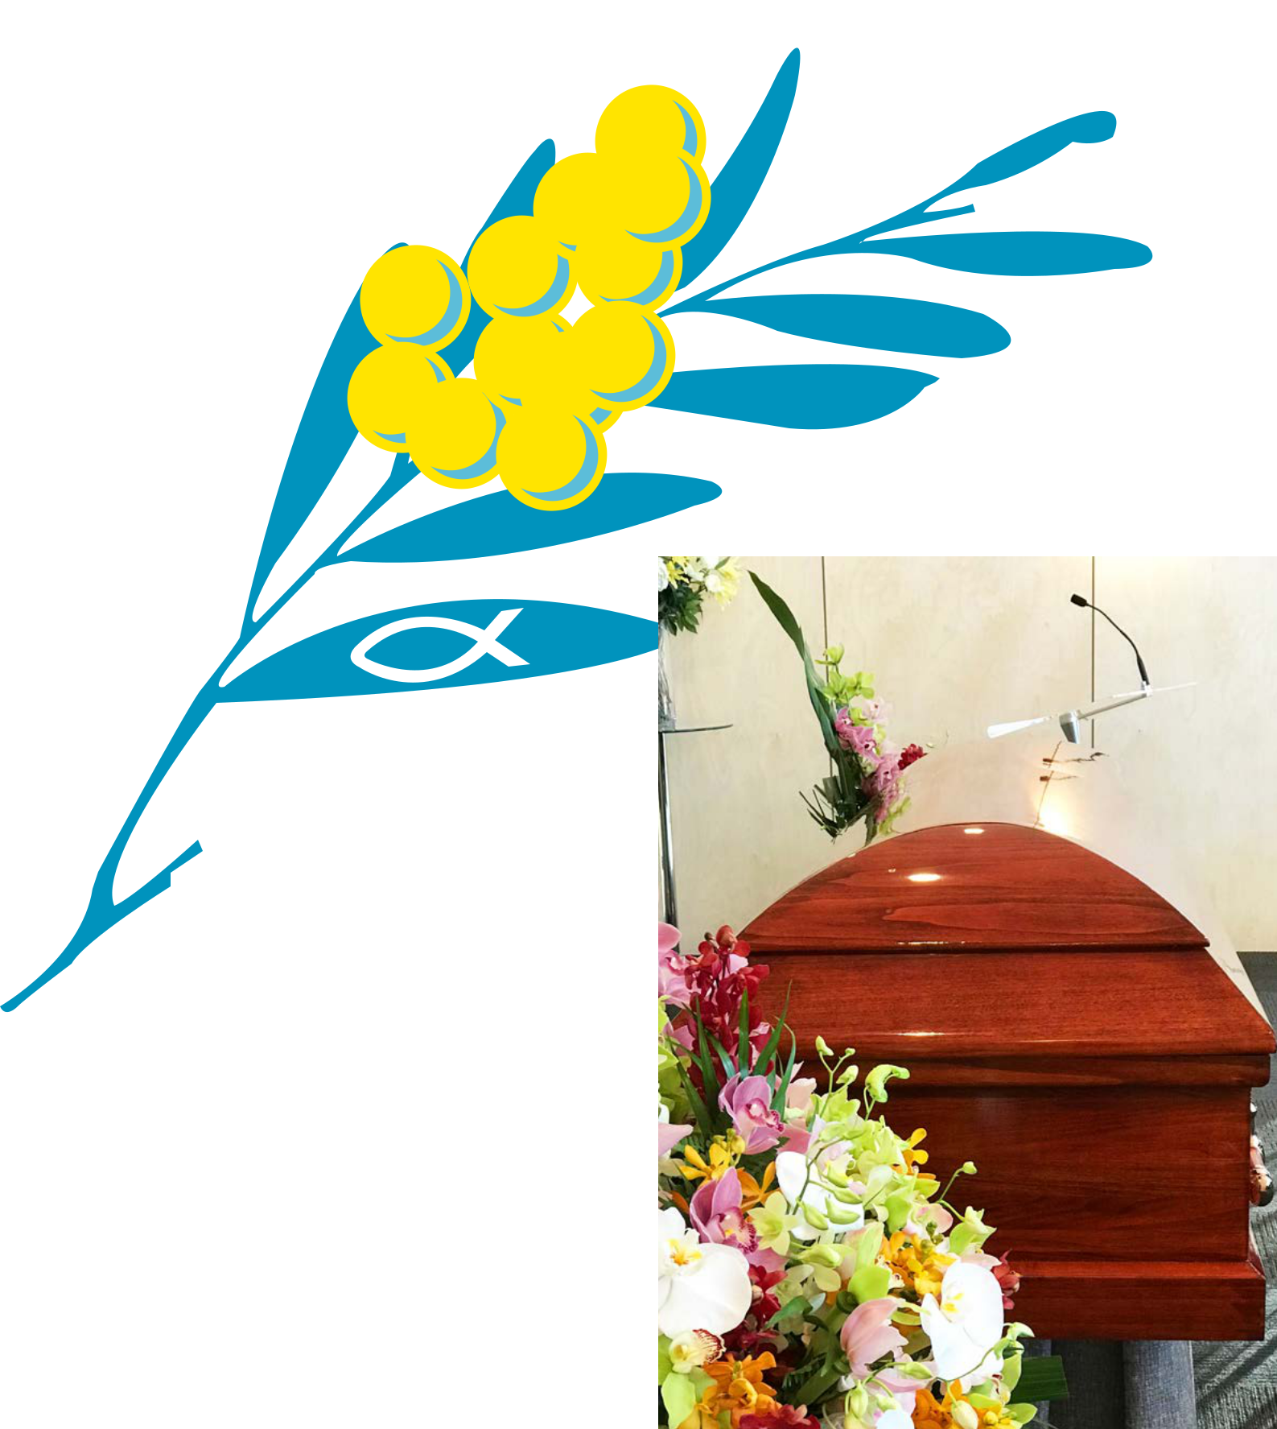
He knew that you were suffering He knew you were in pain.

He knew that you would never Get well on earth again.

He saw the road was getting rough

And the hills were hard to climb.

So he closed yourweary eyelids

And whispered, ‘Peace be thine’.

It broke our hearts to lose you

But you didn’t go alone,

For part of us went with you

The day God called you home.

- Anonymous

- W H Auden

Afterglow

I’d like the memory of me to be a happy one. I’d like to leave an afterglow of smiles when life is done.

I’d like to leave an echo whispering softly down the ways, Of happy times and laughing times and bright and sunny days.

I’d like the tears of those who grieve, to dry before the sun; Of happy memories that I leave when life is done.

I’d like the tears of those who grieve, to dry before the sun; Of happy memories that I leave when life is done.

- Helen Lowrie Marshall

I’m Free

Don’t grieve for me, for now I’m free

I’m following the path God laid for me.

I took His hand when I heard him call;

I turned my back and left it all.

I could not stay another day,

To laugh, to love, to work or play. Tasks left undone must stay that way;

I found that place at the close of the day.

If my parting has left a void,

Then fill it with remembered joy.

A friendship shared, a laugh, a kiss;

Ah yes, these things, I too will miss.

Be not burdened with times of sorrow

I wish you the sunshine of tomorrow.

My life’s been full, I savoured much;

Good friends, good times, a loved ones touch.

Perhaps my time seems all too brief;

Don’t lengthen it now with undue grief.

Lift up your heart and share with me,

God wanted me now, He set me free.
Until We Meet Again

Each morning when we awake we know that you are gone.

And no one knows the heartache As we try to carry on.

Our hearts still ache with sadness and many tears still flow.

What it meant to lose you, No one will ever know.

Our thoughts are always with you, your place no one can fill.

In life we loved you dearly, In death we love you still.

There will always be a heartache, and often a silent tear,

But always a precious memory Of the days when you were here.

If tears could make a staircase,

And heartaches make a lane,

We’d walk the path to heaven

And bring you home again.

We hold you close within our hearts, And there you will remain,

To walk with us throughout our lives Until we meet again.

Our family chain is broken now,

And nothing will be the same,

But as God calls us one by one,

The chain will link again.

- Unknown

- Janice M. Fair-Salters
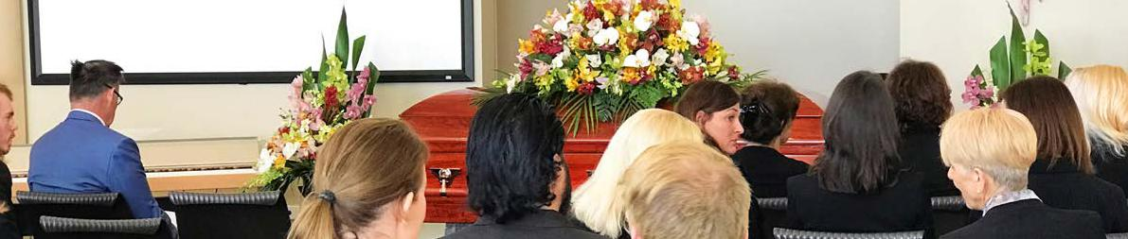

READINGS


A Prayer for the Deceased

Receive in tranquillity and peace, O Lord, the souls of your servants who have departed this present life to come to you.

Grant them rest and place them in the habitations of light, the abodes of blessed spirits.
Give them the life that will not age, good things that will not pass away, delights that have no end, through Jesus Christ our Lord. Amen.

- Saint Ignatius of Antioch

Turn! Turn! Turn!
(To Everything There is a Season)

To everything, turn, turn, turn There is a season, turn, turn, turn

And a time for every purpose, under heaven A time to be born, a time to die

A time to plant, a time to reap A time to kill, a time to heal

A time to laugh, a time to weep

To everything, turn, turn, turn

There is a season, turn, turn, turn

And a time for every purpose, under heaven

A time to build up, a time to break down A time to dance, a time to mourn
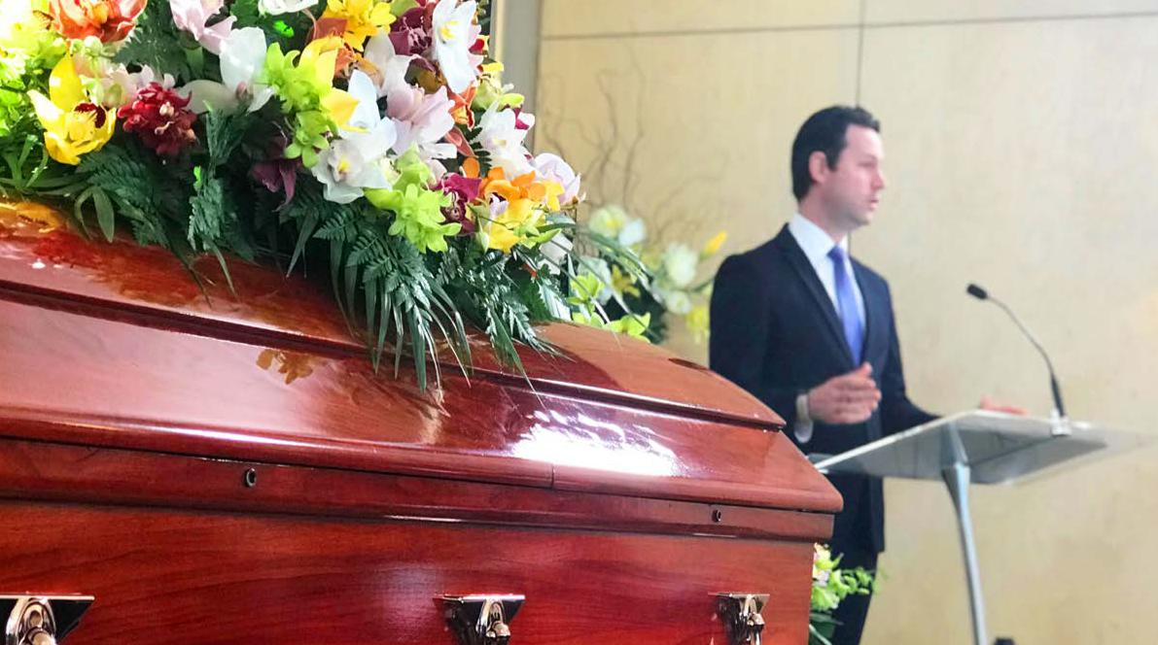
A time to cast away stones, a time to gather stones together

To everything, turn, turn, turn There is a season, turn, turn, turn

And a time for every purpose, under heaven

A time of love, a time of hate

A time of war, a time of peace

A time you may embrace, a time to refrain from embracing

To everything, turn, turn, turn There is a season, turn, turn, turn

And a time for every purpose, under heaven A time to gain, a time to lose

A time to rend, a time to sew A time to love, a time to hate

A time for peace, I swear it’s not too late

- The Byrds
No Matter What (an excerpt)

“Does love wear out,” said Small, “does it break or bend? Can you fix it, stick it, does it mend?” “Oh help,” said Large, “I’m not that clever. I just know I’ll love you forever.”

Small said: “But what about when you’re dead and gone – would you love me then, does love go on?” Large held Small snug as they looked out at the night, at the moon in the dark and the stars shining bright.

“Small, look at the stars – how they shine and glow. Yet some of those stars died a long time ago. Still they shine in the evening skies… love, like starlight, never dies”.

- Debi Gliori

My Work is Done

The cares of the world concern me no longer

I have completed this life

My work is done,

My family is happy and healthy in their pursuits

I have loved much and well

To those I leave behind

I hope I will remain in their hearts as they will in mine Thank you for taking such good care of me

And all of you who have been my friends, thank you for teaching me about life and about love.

- Unknown

But Not Forgotten

I think, no matter where you stray,

That I shall go with you a way.

Though you may wander sweeter lands,

You will not soon forget my hands,

Nor yet the way I held my head,

Nor all the tremulous things I said.

You still will see me, small and white

And smiling, in the secret night,

And feel my arms about you when

The day comes fluttering back again.

I think, no matter where you be,

You’ll hold me in your memory

And keep my image, there without me,

By telling later loves about me.

- Dorothy Parker

SCRIPTURE READINGS

John 14:27

Peace I leave with you; my peace I give you. I do not give to you as the world gives. Do not let your hearts be troubled and do not be afraid.

John 14:1-3

Jesus Comforts His Disciples

- “Do not let your hearts be troubled. You believe in God; believe also in me.

- My Father’s house has many rooms; if that were not so, would I have told you that I am going there

to prepare a place for you?

- And if I go and prepare a place for you, I will come back and take you to be with me that you also may be where I am.

2 Corinthians 1:3-5

Praise to the God of All Comfort

- Praise be to the God and Father of our Lord Jesus Christ, the Father of compassion and the God of all comfort,

- who comforts us in all our troubles, so that we can comfort those in any trouble with the comfort we ourselves receive from God.

- For just as we share abundantly in the sufferings of Christ, so also our comfort abounds through Christ.

Matthew 5:4

4. Blessed are those who mourn, for they will be comforted.

Psalm 23

A psalm of David.

- The LORD is my shepherd, I lack nothing.

- He makes me lie down in green pastures, he leads me beside quiet waters,

- he refreshes my soul. He guides me along the right paths for his name’s sake.

- Even though I walk through the darkest valley,[a] I will fear no evil, for you are with me; your rod and your staff, they comfort me.

- You prepare a table before me in the presence of my enemies. You anoint my head with oil; my cup overflows.

- Surely your goodness and love will follow me all the days of my life, and I will dwell in the house of the LORD forever.
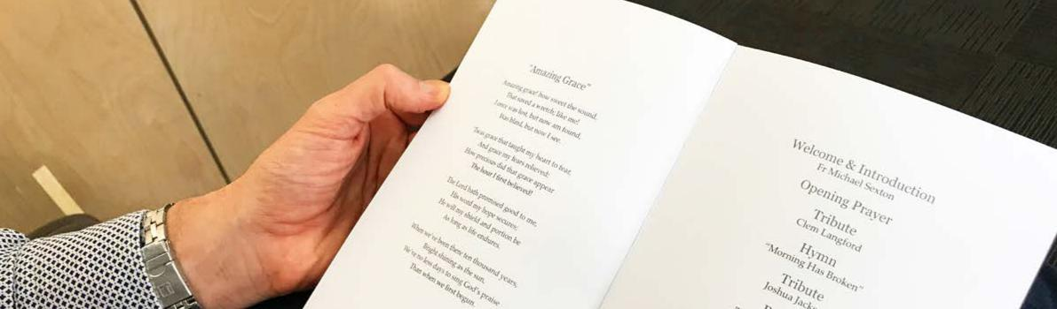


EULOGY EXAMPLE

Below is an example of the structure of a Eulogy.

In providing this, we aim to spark your creativity in writing part of the life story of your loved one.

Start off with what is provided below. On the following page you will find a blank template for your to fill in the blanks. Insert the details in brackets of your loved one and add as much extra detail as you like. The short sections provided are launching points to get you going in the right direction.

You may also like to begin or end with one of the scriptures, poems or readings from above.

INTRODUCTION

Today we gather to honour, remember, and say goodbye to (name).

Taking the words of a famous writer: “We make a living by what we get, we make a life by what we give”. If that is true, then (name of deceased) made a great life. They were the most generous person I’ve ever known. I know many of you would agree judging from the nodding heads around the room.

CHILDHOOD

Our lives have all been touched by (name) in some way, but you may not have known some details of their earlier life. (Name) was born (full birth name) on (their birth date) in (city). He/She was the (first, second, only) child of (name of loved one’s father) and (name of loved one’s mother). They lived in (city) from (year) to (year), and later moved to and (town).
EDUCATION & CAREER

(Name) went to (school) and (name of schools) and graduated with (name of degree or training). While studying at (school) (name) was able to achieve (list achievements or awards). During this time (name) became good friends with (list of friends names) and they remained good friends to this day.

He/She then went to work for (name of company) as a (name of postion). Over the years, (name) also worked for (company), (company) and (company) OR also worked in (type of job). While working for (company) (name) was able to achieve (list achievements or awards).

FAMILY

In (year) (name) met (name of spouse) and they were married (number) years later. Eventually they had (number) children (names of their children). Last year, (name) and (spouse’s name) celebrated their (number, e.g. 50th) wedding anniversary.

HOBBIES

(Name) was very active in the (church, community, local theatre, quilting, volunteer firefighting). He/She devoted many hours to (hobby or service) and was known for (what person was known for in the hobby or service, e.g. her exquisite quilt designs; always being ready with a helping hand; always having a positive attitude).

COMMEMORATIONS

I asked family and friends to tell me what they remember most about (name). There are so many good memories. (List 5 or 6 memories in short sentence form, e.g. Playing music together. Fishing. His big hearty laugh. The time we went to Italy). One that I remember in particular is the time when (tell a longer story that illustrates your loved one’s personality – this can be a heart-warming story or a humorous story).

CONCLUSION

(Name) was a remarkably (an adjective, e.g. good; thoughtful; hardworking; fun-loving) person. He/She was a person of great (two words that describe the person’s character, e.g. devotion, integrity, love, compassion, service, humour).

Above all, (name) believed in (the person’s highest value, e.g. family, faith, hard work, independence, community, compassion). He/She always said (a common saying that illustrates the person’s highest value, e.g. “family is the most important thing in life”; “you get out of life what you put into it”; “life is short, so enjoy it while you can!”).

Those are words of wisdom that I will always cherish.

In closing, I would like to share this poem with you:

<Use a poem, reading or scripture from above>

(Name), thank you for being part of our lives. We are all going to miss you deeply.
EULOGY TEMPLATE

INTRODUCTION

_________________________________________________________________________________________

_________________________________________________________________________________________

_________________________________________________________________________________________

_________________________________________________________________________________________

_________________________________________________________________________________________

CHILDHOOD

_________________________________________________________________________________________

_________________________________________________________________________________________

_________________________________________________________________________________________

_________________________________________________________________________________________

_________________________________________________________________________________________

_________________________________________________________________________________________

_________________________________________________________________________________________

_________________________________________________________________________________________

EDUCATION & CAREER

_________________________________________________________________________________________

_________________________________________________________________________________________

_________________________________________________________________________________________

_________________________________________________________________________________________

_________________________________________________________________________________________

_________________________________________________________________________________________

_________________________________________________________________________________________

_________________________________________________________________________________________

FAMILY

_________________________________________________________________________________________

_________________________________________________________________________________________

_________________________________________________________________________________________

_________________________________________________________________________________________

_________________________________________________________________________________________

_________________________________________________________________________________________

_________________________________________________________________________________________

_________________________________________________________________________________________
HOBBIES

_________________________________________________________________________________________

_________________________________________________________________________________________

_________________________________________________________________________________________

_________________________________________________________________________________________

_________________________________________________________________________________________

_________________________________________________________________________________________

_________________________________________________________________________________________

_________________________________________________________________________________________

COMMEMORATIONS

_________________________________________________________________________________________

_________________________________________________________________________________________

_________________________________________________________________________________________

_________________________________________________________________________________________

_________________________________________________________________________________________

_________________________________________________________________________________________

_________________________________________________________________________________________

_________________________________________________________________________________________

CONCLUSION

_________________________________________________________________________________________

_________________________________________________________________________________________

_________________________________________________________________________________________

_________________________________________________________________________________________

_________________________________________________________________________________________

_________________________________________________________________________________________

_________________________________________________________________________________________

_________________________________________________________________________________________

_________________________________________________________________________________________

_________________________________________________________________________________________

_________________________________________________________________________________________

_________________________________________________________________________________________


MITCHAM | CARRUM DOWNS | BRISBANE
Office & Chapel | Office & Chapel | Office & Chapel
2d Cochrane Street, | 620 Frankston-Dandenong Road, | 2998 Logan Road,
Mitcham VIC 3132 | Carrum Downs VIC 3201 | Springwood QLD 4127
03 9873 8866 | 03 8787 7255 | 07 3219 9333
info@bethelfunerals.com.au | info@bethelfunerals.com.au | infoqld@bethelfunerals.com.au

www.bethelfunerals.com.au

