
CONSTRUCTION SCHEDULE TEMPLATE

SDOT Project # _________________________________

Project Address: __________________________________________

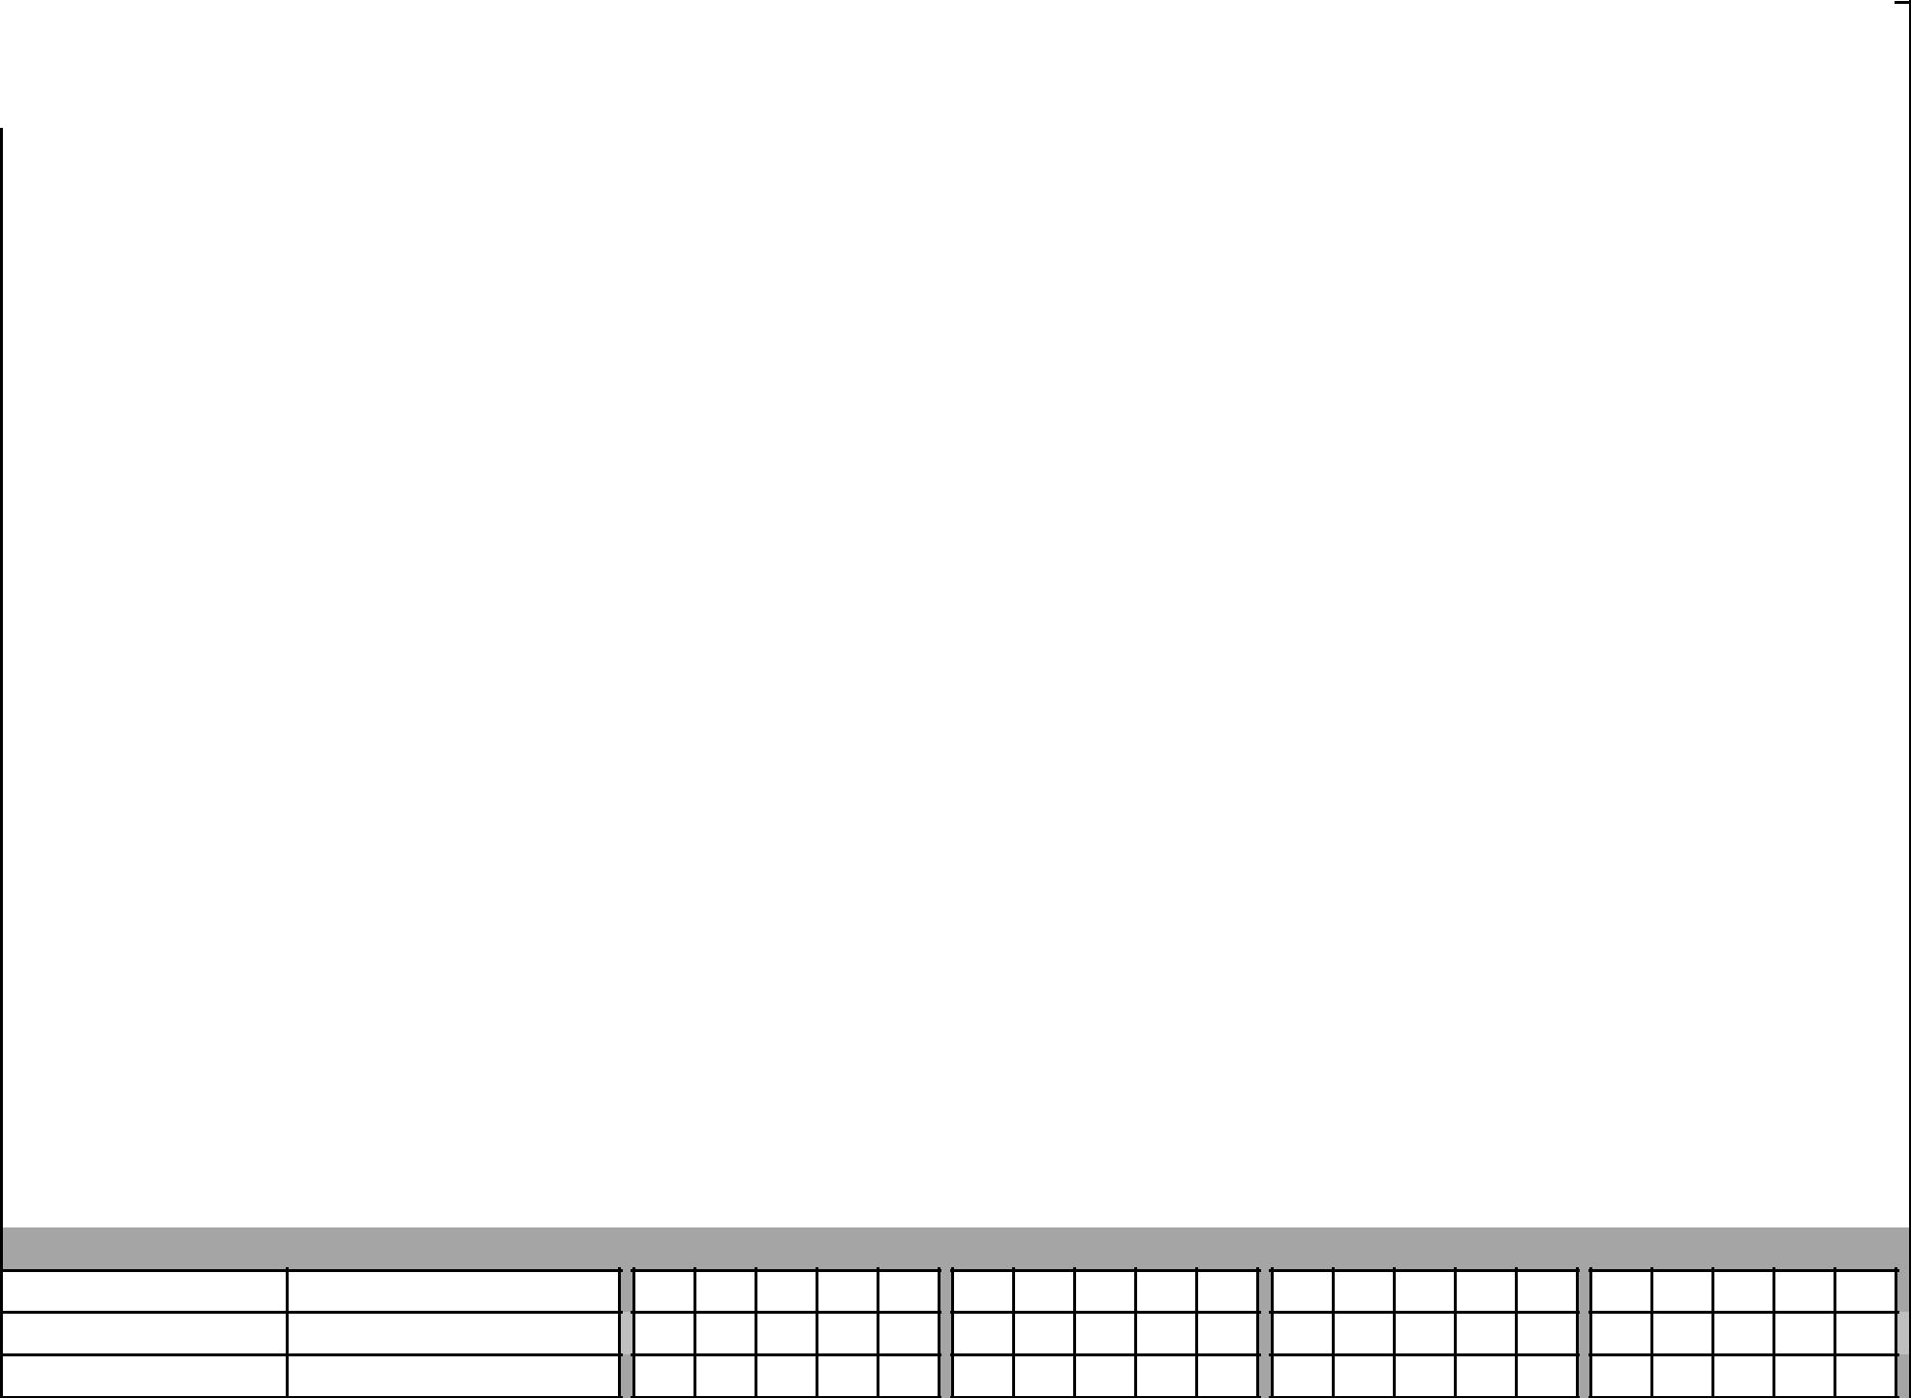
 |  |  |  | Week ________ |  |  |  |  |  | Week ________ |  |  |  |  |  | Week ________ |  |  |  |  | Week ________
 |  |  |  | M | T | W | TH | F |  | M | T | W | TH | F |  | M | T | W | TH | F | M | T | W | TH | F
 | Curb/Sidewalk/Paving
 | Curb | ____ number of pours
 | Curb and Gutter | ____ number of pours
 | Monolithic Curb and
 | Sidewalk | ____ number of pours
 | Extruded Curb
 | Sidewalk | ____ number of pours
 |  | ____ number of days of
 | Walkway - asphalt | paving
 |  | ____ number of ramps
 | Curb Ramp | installed per day
 | Driveways | ____ number of pours
 |  | ____ number of days of
 | AC Pavement | paving
 | AC Pavement | ____ number of days of
 | (overlay) | paving
 | PCC Pavement | ____ number of pours
Storm /Sewer/Water

Storm Mains

Sewer Mains

Culverts
 |  |  | Week ________ |  |  |  |  |  | Week ________ |  |  |  |  | Week ________ |  |  |  |  | Week ________
 |  |  | M | T | W | TH | F |  | M | T | W | TH | F | M | T | W | TH | F | M | T | W | TH | F
Manholes - Saddling
new on existing
main
Manholes - brand
new on new main
Manholes - replace
existing with new
Catch Basin
Inlet
Junction Box
Pipe Connections -
non main (Runs and
connections)
Flow Control
Structures
Detention System
Hydrants
Street Lighting
Street Light/Ped
Foundation
Street Light/Ped
Pole
Street Light/Ped
Luminaire
Street Light /Ped
Wiring

 |  |  | Week ________ |  |  |  |  |  | Week ________ |  |  |  |  | Week ________ |  |  |  |  | Week ________
 |  |  | M | T | W | TH | F |  | M | T | W | TH | F | M | T | W | TH | F | M | T | W | TH | F
Temporary Lighting
Conduit | ____ LF per day
 | ____ hand holes
Hand Holes | installed per day
Vaults - SDOT St
Lighting/DOIT
Traffic Signal Elements
Temporary Signal
Temporary
Detection
Pole Foundations
Signal Cabinet
Foundations
Signal Cabinet
Installation
Signal Controller
Relocation
Signal Cabinet
relocate\ cut
over\turn on
Pedestrian Signal -
transfer (from one
pole to another) | ____ transfers

 |  |  | Week ________ |  |  |  |  |  | Week ________ |  |  |  |  | Week ________ |  |  |  |  | Week ________
 |  |  | M | T | W | TH | F |  | M | T | W | TH | F | M | T | W | TH | F | M | T | W | TH | F
Pedestrian Pedestal
and foundation with
displays
Push Button Post
Vehicle Signal -
Transfer
Intersection
Wiring/Spans
Interconnect
Sensys Detection
Video Detection
Loops Detection
CCTV Cameras new
or relocated
Wood Signal Strain
Pole
Traffic Signal Steel
Strain Poles
METRO
Metro Strain Poles
Tree Preservation
Tree protection
measures
Tree Removal

 |  |  | Week ________ |  |  |  |  |  | Week ________ |  |  |  |  | Week ________ |  |  |  |  | Week ________
 |  |  | M | T | W | TH | F |  | M | T | W | TH | F | M | T | W | TH | F | M | T | W | TH | F
 | # of day of demolition
 | and forming within drip
Existing Trees | line of existing trees
Landscape Construction
Tree pit
Trees
Shrubs /
Groundcover
Misc & Encroachments
Signs
Illuminated Signage
Retaining Walls per
standard plan | ____ number of pours
Retaining Walls - not
per std plan | ____ number of pours
Stairways | ____ number of pours
Hand Rails
Bollard
Fencing
Interlocking Pavers
Guardrail

 | Week ________ |  | Week ________ |  | Week ________ | Week ________
 | M T W TH F |  | M T W TH F |  | M T W TH F | M T W TH F
Traffic Barrier | ____ number of pours
Bus Shelter Pad
Misc Street
Furniture

