

Christmas Tree Decorating Competition 2018

Application Pack and Design Submission

If you would like to take part in the competition, please complete this form and up to three design pages (you may also submit additional pages if you need more space).

Please return your application by email to learning@rhs.org.uk with ‘Christmas Tree Competition’ as the subject by 5pm on Thursday 18 October 2018.

Name of school:

Full address of school:

Contact name:

Contact telephone number:

Contact mobile number:

Email address:

Age category:

Primary (aged 5-11)

Secondary (aged 11-16)

Christmas Tree Design Template

School name:

Age category: Primary |  |  |  | Secondary
Design number: | of
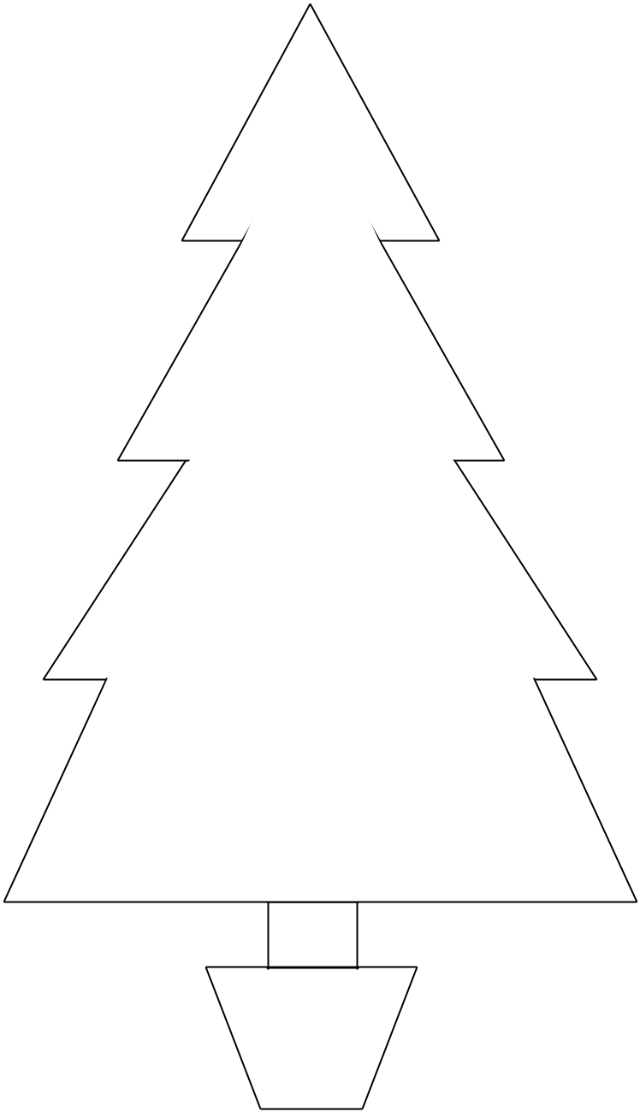

Please note that the Christmas tree outline is not to scale: if your design is chosen, the tree you are allocated may differ slightly in size and shape, but it will be between 6 and 7ft tall.

