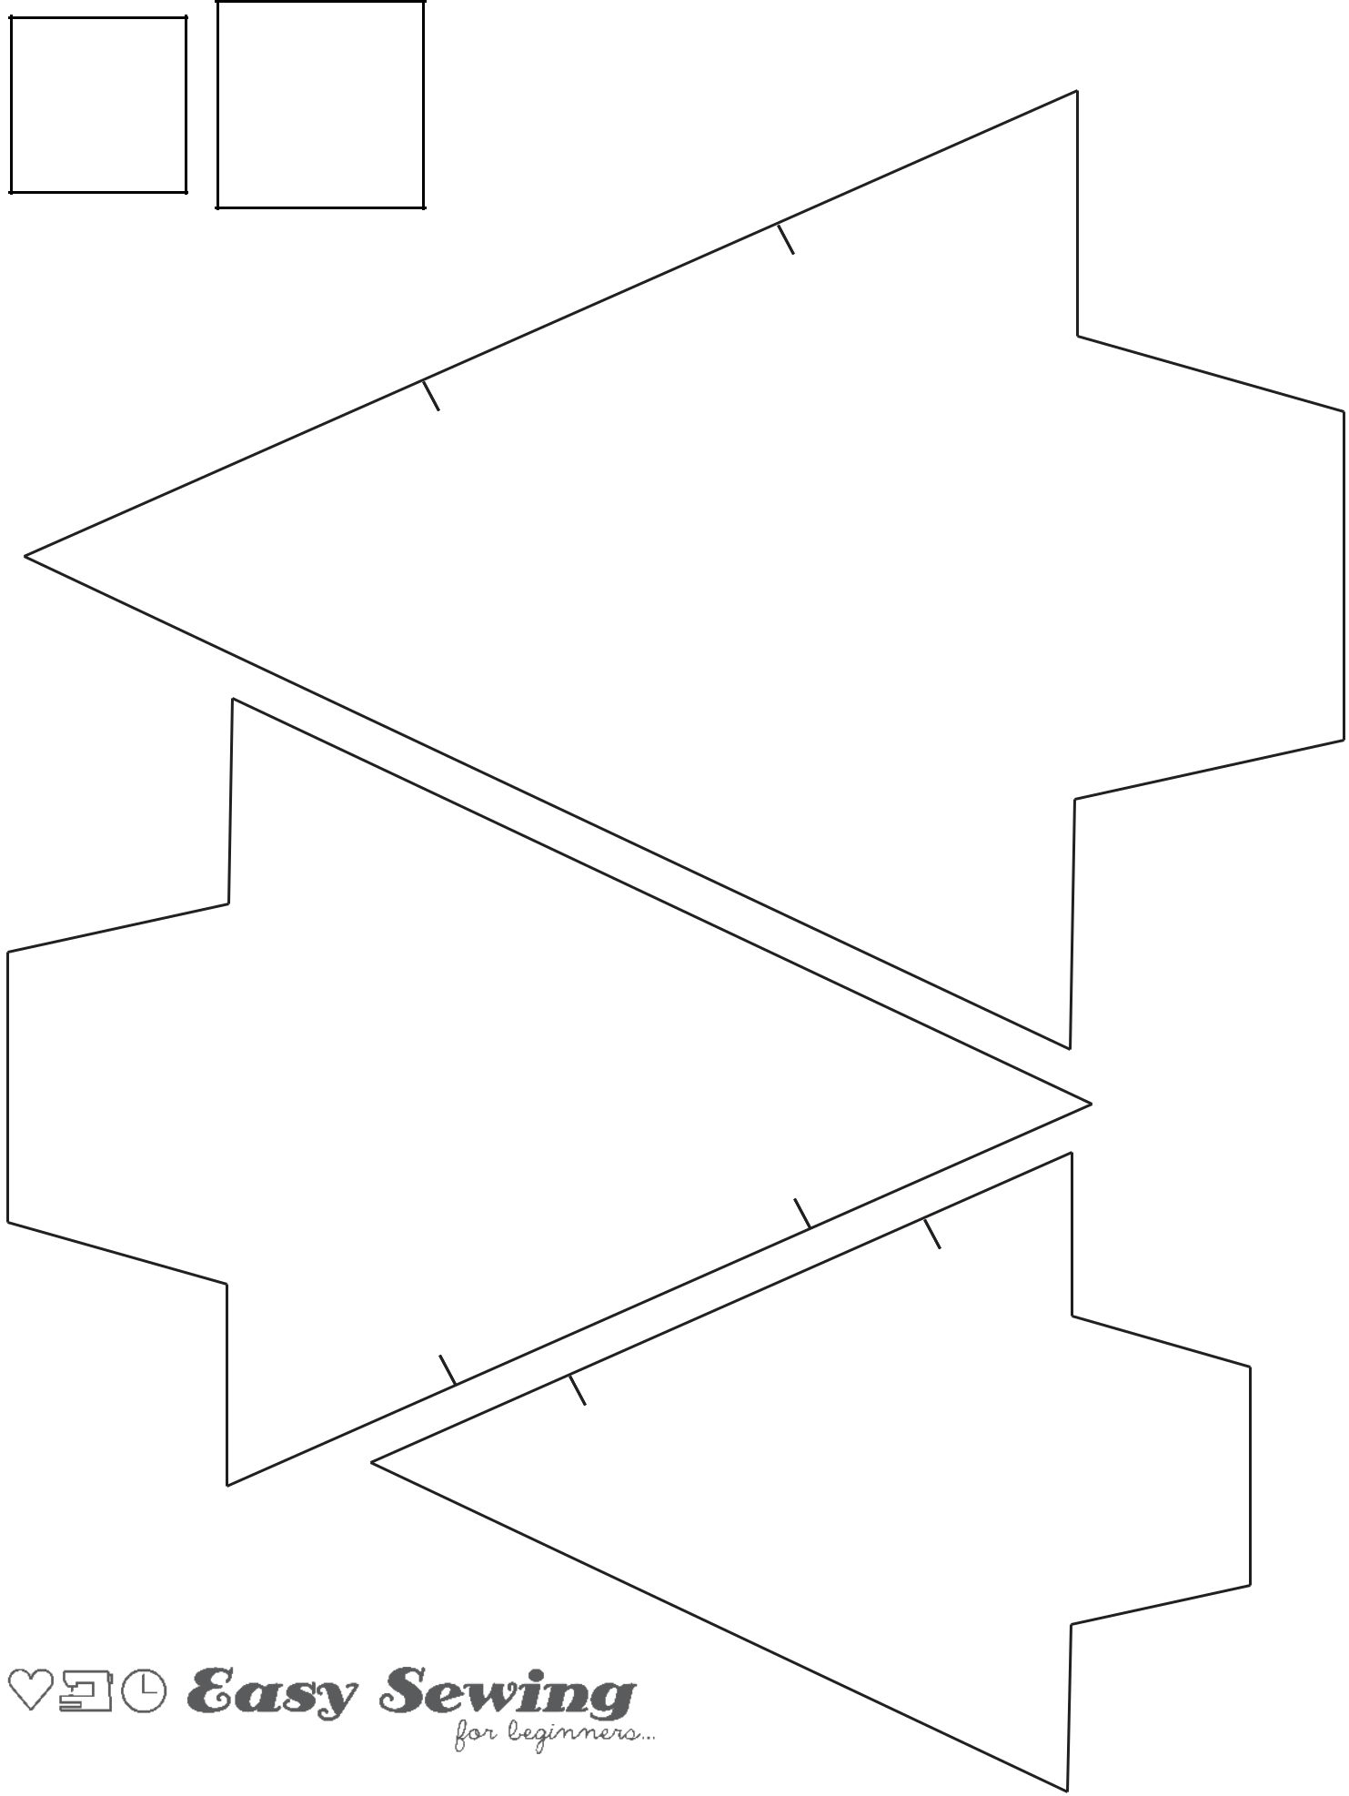
Ensure print scale is set to 100%

^{1”} 3cm
^{Square} Square
It is illegal to distribute this pattern electronically or in

hard copy without my permission. Please respect my hard work and refer your friends and family to download their own copy at www.easysewingforbeginners.com. Thank you.

Leave

Open
for

Turning

Coaster Template

1/4” seam allowance included

1/4” seam allowance included

Template

OrnamentTree |  | Turning
 |  |  |  | Leave
 | for |  | Open
 | Open
Leave | Open |  | for
Leave | Turning |  |  | Gift TagTemplate

1/4” seam allowance included

This pattern is Copyright © Domenica Tootell 2019.

