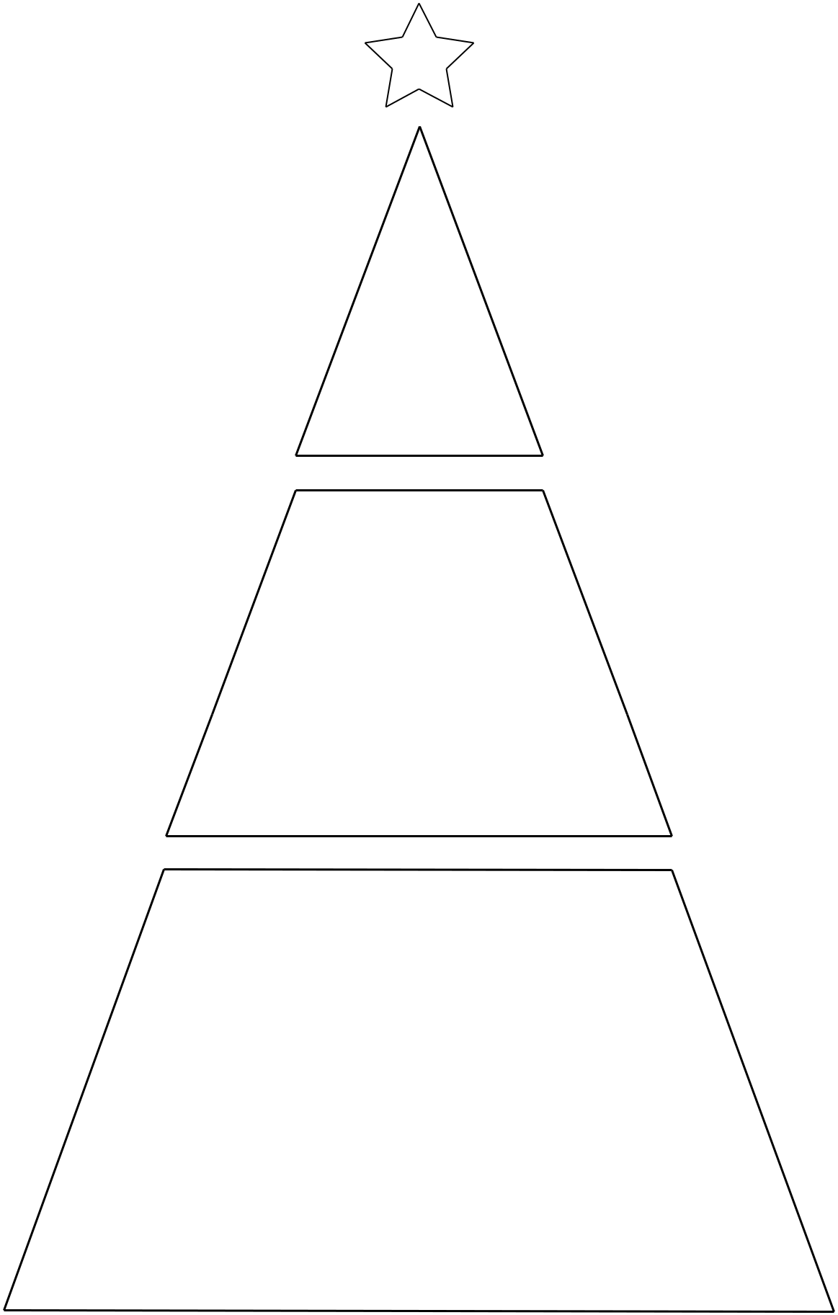

SUSTAIN my Craft Habit

