Medication Log

Last Updated: _______ / _______ / ________

Name: __________________________________________________ Birth Date:______ / _______ /________

Emergency Contact: _________________________________________ Phone: _________________________
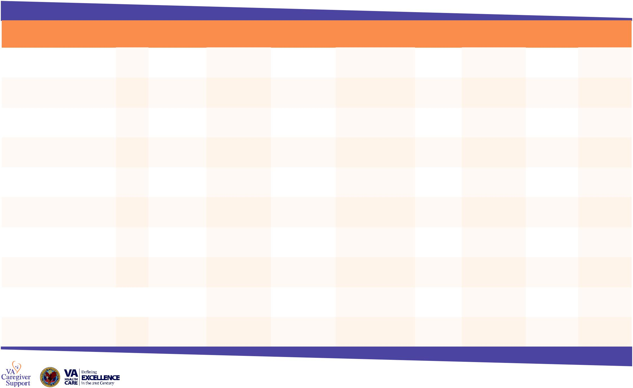

VA Caregiver Support Line
1-855-260-3274 toll-free

Monday through Friday, 8:00 am – 11:00 pm ET Saturday, 10:30 am – 6:00 pm ET

MEDICATION LIST

Name of Medication* | Dosage | What medication | What medication is | When and how to | What NOT to do when | Prescribed by | Pharmacy that | Prescription | Date started/
 |  | looks like | treating | take medication | taking medication |  | filled prescription | number | Date ended

www.caregiver.va.gov

DISPLAY THIS FORM PROMINENTLY IN YOUR HOME IN CASE OF EMERGENCY.

MEDICATION LIST

Name of Medication | Dosage | What medication | What medication is | When and how to | What NOT to do when | Prescribed by | Pharmacy that | Prescription | Date started/
 |  | looks like | treating | take medication | taking medication |  | filled prescription | number | Date ended

www.caregiver.va.gov

Medication Log

REACTIONS

Drug Allergies and Other Significant Reactions

Prescription Name Reaction

Recent Medications that Caused Problems or Did Not Work

Prescription Name Problem

PHYSICIANS
Primary Care Physician

Phone: | Address:

Specialist

Phone: | Address:

Specialist

Phone: | Address:

Specialist

Phone: | Address:

NOTES:

________________________________________________________________________

________________________________________________________________________

________________________________________________________________________

________________________________________________________________________

________________________________________________________________________

________________________________________________________________________

________________________________________________________________________

________________________________________________________________________

________________________________________________________________________

REACTIONS

Drug Allergies and Other Significant Reactions

Prescription Name Reaction

Recent Medications that Caused Problems or Did Not Work

Prescription Name Problem
PHYSICIANS
Primary Care Physician

Phone: | Address:

Specialist

Phone: | Address:

Specialist

Phone: | Address:

Specialist

Phone: | Address:

Specialist

Phone: | Address:

NOTES:

________________________________________________________________________

________________________________________________________________________

________________________________________________________________________

________________________________________________________________________

________________________________________________________________________

________________________________________________________________________

________________________________________________________________________

________________________________________________________________________

