
Medication List

My Medication List

Include your over the counter medicines |  |  |  | Remember to fill your prescription.
Medications |  | Taken for | Dose | Frequency |  | Times Taken |  |  | Date
Medications |  | Taken for | Dose | Frequency |  |  |  |  | Stopped

Sentara Healthcare Wants You to be Safe!

How to Use This Form:

- Carry this list of medications with you at all times.

- Update and change this list as your medications or dosages are changed.

- Show this list to your health care providers, and pharmacist with each visit or when admitted to the hospital.

- If you have any questions about your medicine contact your health care provider or pharmacist.

- If you have difficulty buying or getting your medications, check with your health care provider.

Medication Facts:

- Up-to-date lists of your current medications help prevent dangerous errors.

- It is hard to remember all the medicine you take.

- Many foods, supplements and other medications might cause harmful reactions with other medications so having an up-to-date list will keep you safe.

- In case of an emergency, it is very important to have an updated list.

 |  |  |  | My Medication List
Name:
Doctor: |  |  |  |  | Phone:
Pharmacy: |  |  |  |  | Phone:
Allergies:

Immunizations (record the date/year of last dose taken, if known)

Tetanus:

Pneumonia vaccine:

Flu vaccine:


Month: My Target Weight is:

Please complete the calendar:

- Write in the month above

- Insert the date in the smaller boxes

- Write in your weight in the space provided every day

Remember to bring in your weight log when you have your next follow up appointment.

Call your healthcare provider if your weight gain is more than 3 pounds in 1 day or 5 pounds in 1 week.
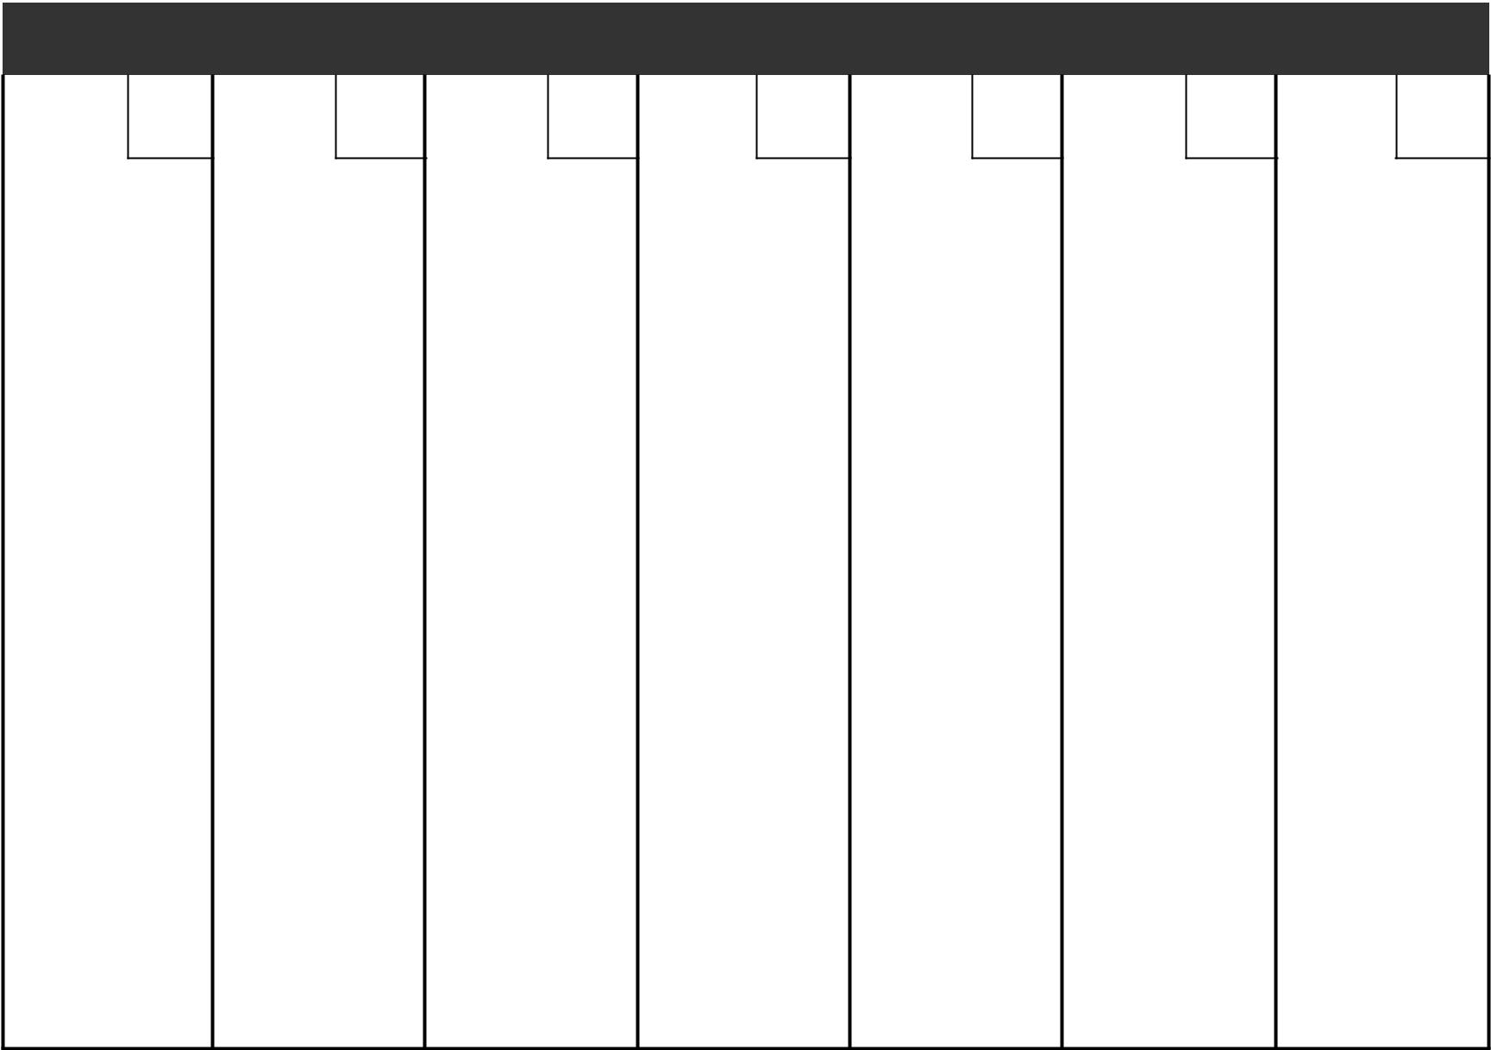

Sunday | Monday | Tuesday | Wednesday | Thursday | Friday | Saturday

Weight: |  | Weight: |  | Weight: |  | Weight: |  | Weight: |  | Weight: |  | Weight:
Weight: |  | Weight: |  | Weight: |  | Weight: |  | Weight: |  | Weight: |  | Weight:
Weight: |  | Weight: |  | Weight: |  | Weight: |  | Weight: |  | Weight: |  | Weight:
Weight: |  | Weight: |  | Weight: |  | Weight: |  | Weight: |  | Weight: |  | Weight:
Weight: |  | Weight: |  | Weight: |  | Weight: |  | Weight: |  | Weight: |  | Weight:

My health care provider phone number is:


www.sentara.com/rehab

Your community, not-for-profit health partner

