Medication List

List ALL medicines currently used, including: prescription medicines, over-the-counter medicines, herbal and natural medicines. Medicines come in many forms, including: tablets, liquids, inhalers, drops, patches, creams, suppositories and injections.

My name: |  |  |  |  |  | Date to have all my medicines reviewed:
Name of medicine |  | Strength |  | What is the medicine for? |  | How much do I use and when? |  | Special instructions or comments |  | Date |  | When to stop
Active ingredient or brand name |  |  |  |  |  |  |  |  |  | started |  | or review
e.g. Active ingredient: |  | e.g. 500 mg |  | e.g. Pain from arthritis |  | e.g. 2 capsules, every 6 hours |  | e.g. Doctor recommends taking regularly, |  | e.g. |  | e.g. June 2014
paracetamol. Brand: Parease |  | capsules |  |  |  |  |  | rather than as needed for pain |  | 19.11.13
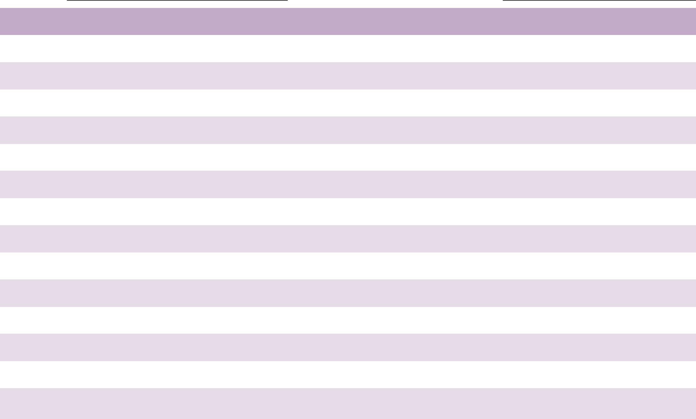

If you need more space to write your medicines, visit our website at www.nps.org.au/medicineslist to print more Medicines List pages or to order extra copies. Keep all your pages together.

