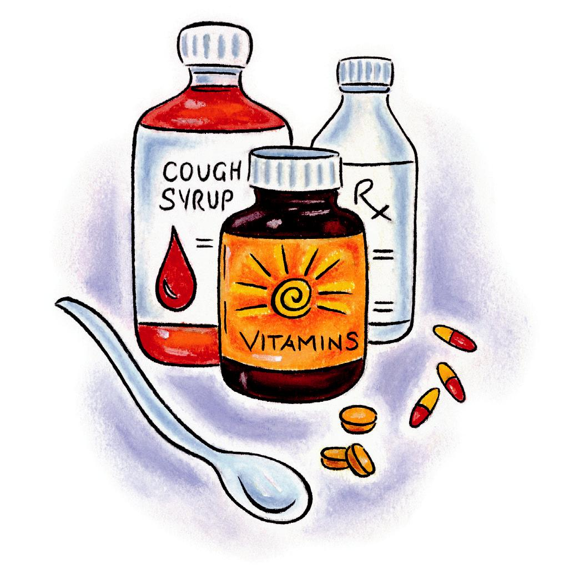
MEDICATION LIST

Your Medication Allergies | Reaction

Please fill out this form.

Your name:

Please list ALL your medications such as pills, inhalers, eye drops, patches, injections, creams, and so on. Also include any medications you buy over the counter such as herbal products and vitamins.

Your Pharmacy: | Your Family Doctor:
Medication Name & Strength | Dose | Directions
 | (How much do you take?) | (How often do you take it?)

List reviewed/updated by (initial the actual change):

Print Name | Relationship | Date/Time
Additional Comments:

Please keep this form updated as your medications change.

12HPE15-33324

